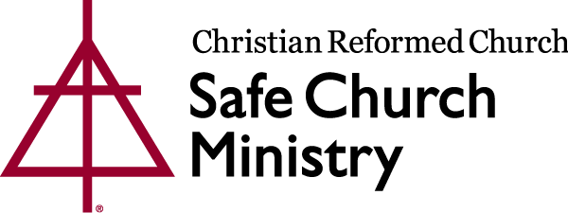
May, 2019

Hello Fellow CRC Churches,

As a member of the CRCNA Safe Church Advisory Committee, a previous Sunday School Coordinator and a busy parent of five children, it is my privilege to bring your attention to the annual September Safe Church Abuse Awareness Sunday, where we can pause and focus on ways to make our churches safe spaces for all ages.

Today I would like to introduce a valuable tool for children and youth at your church, the Circle of Grace program. Historically abuse prevention had its beginning with building protocols for the protection of children and youth. While it is always the adult’s responsibility to keep kids safe, Circle of Grace educates and empowers children and youth to actively participate in maintaining a safe environment for themselves and others.

The Circle of Grace program addresses 3 of the 5 goals of Safe Church Ministry, teaching respect and healthy relationships, giving opportunity for children and adults to discuss abuse issues freely and finally having church leadership committed to also promote the importance of safe church ministry.

Each lesson is age appropriate for children preschool through grade 12. Its basic philosophy being one in which children learn that because God loves us and has created each one of us unique, we are meant to respect ourselves and others.

Personally, our church has used this program in Sunday school for preschool-grade 6, as well as in our youth groups. Our teachers have found this program very easy to lead and engaging for the students. It firmly links the protection of children with God’s will and provides a valuable vocabulary for discussions. After the first session the leaders’ first question was,
“When can we do this again?”

Parents are aware of lesson content through take home letters and are encouraged to discuss the lessons at home. This faith based program gives children a framework and language to communicate with trusted adults when they feel unsafe. It helps them navigate the many issues they face in today’s culture while reinforcing God’s presence in their real life struggles.

Our church included the whole congregation by introducing Circle of Grace through a short video shown during the offering.

The program is very cost effective and simple to use with 2-3 lessons per year. The underlying theme of Circle of Grace can easily be incorporated into your regular lessons as well.

Curious, need more information, want to see the congregational promo video, view a lesson, find out how to order – visit https://www.crcna.org/SafeChurch/circle-grace. Please pass this link to your children’s ministry leadership, safe church team, youth leaders and maybe even include the parents!

I hope you will strongly consider taking this opportunity to give your children the faith based tools that will equip them and their parents to battle the ever present power imbalances they encounter every day at home, school and church.

Hablas Espanol? The Circle of Grace program is also available in Spanish!

Blessings on your continued work in providing a safe space for all ages,
Carmen Voogd, Edmonton, Alberta; Canada
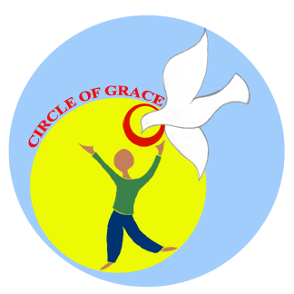
On behalf of the Safe Church Advisory Committee:
Bill Padding, Grand Rapids, MI; USA
Sarah Cook, Ottawa, ON; Canada
Mike Vander Laan, Kamloops, BC; Canada
Vanessa Ogaldez, Chicago, IL; USA
Ken Krause, Big Rapids, MI; USA
Bonnie Nicholas, Safe Church Director
Eric Kas, Safe Church Associate

