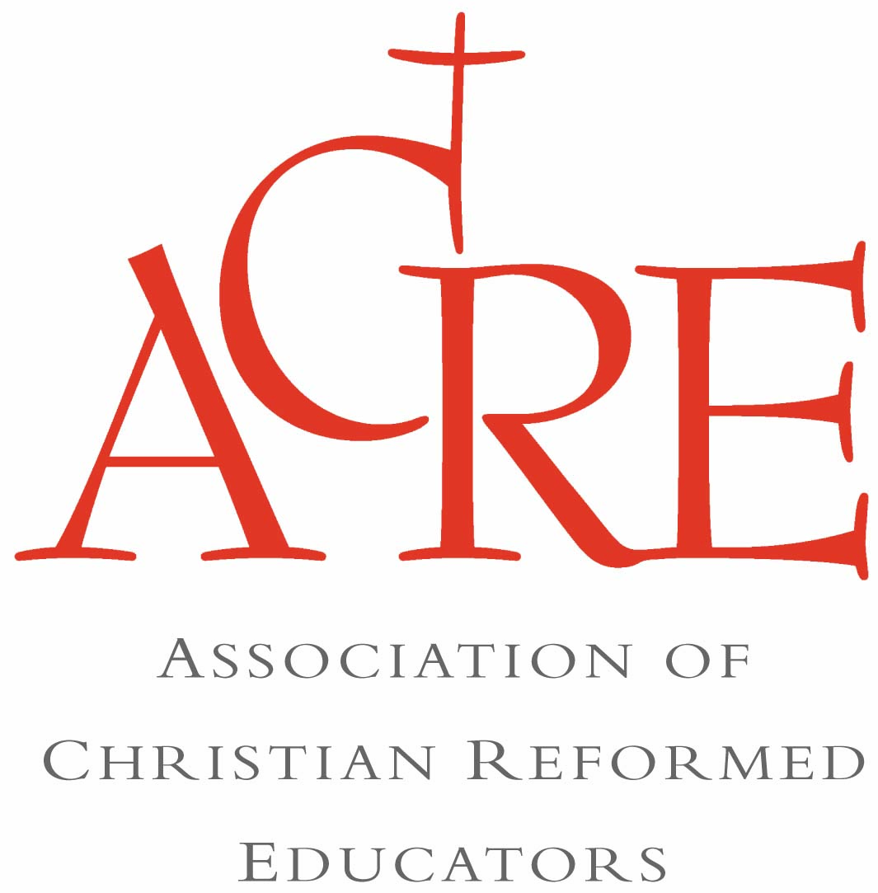

The annual cost of membership is $56 for volunteer educators and $66 for professional educators. The membership year is from Jan. 1 through Dec. 31. Please make checks payable to Faith Alive Christian Resources with ACRE written in the memo line. Mail to:

ACRE c/o Faith Alive Resources or ACRE c/o Faith Alive Resources (GR)

2850 Kalamazoo Ave. SE, PO Box 5070

Grand Rapids, MI 49560 Burlington, ON, L7R 3Y8

**ACRE Membership Benefits**

* Two or more newly published resources from Faith Alive sent to you at no charge.

(est. value $50)

* Full membership in the Association of Presbyterian Church Educators (APCE), (value $66)
* A subscription to the *Advocate*, APCE’s quarterly educator’s journal.
* A discount on the registration fee for APCE’s Annual Event Conference.

**ACRE Registration**

Name:

Church name:

Mailing address (indicate home or church):

City:

State/Province:

Zip/Postal Code:

Phone (office):

Phone (home):

E-mail:

Your ministry position:

___ Volunteer ___ Paid staff

___ Part time ___ Full time

ACRE is source of enrichment and encouragement for people leading educational ministries within the Christian Reformed Church. ACRE offers access to new resources, a quarterly journal, and educational/enrichment opportunities to strengthen your ministry throughout the year.

**We invite you to join ACRE today.**

# **ACRE — A Place for YOU!**

**A**dvocating for educators

**C**onnecting with each other

**R**esponding to shared needs

**E**ncouraging and supporting