

**Spring 2022 │ Young Adults With Disabilities**

About 1 in 8 young people 15-30 lives with a disability. In this issue, several young adults with disabilities, ranging from tumors and limb differences to processing disorders and lupus, tell their stories of what it has been like for them.

**Finding My Way Living with NF**

**by Susan Geelhoed**  
Sherman Street CRC, Grand Rapids, MI

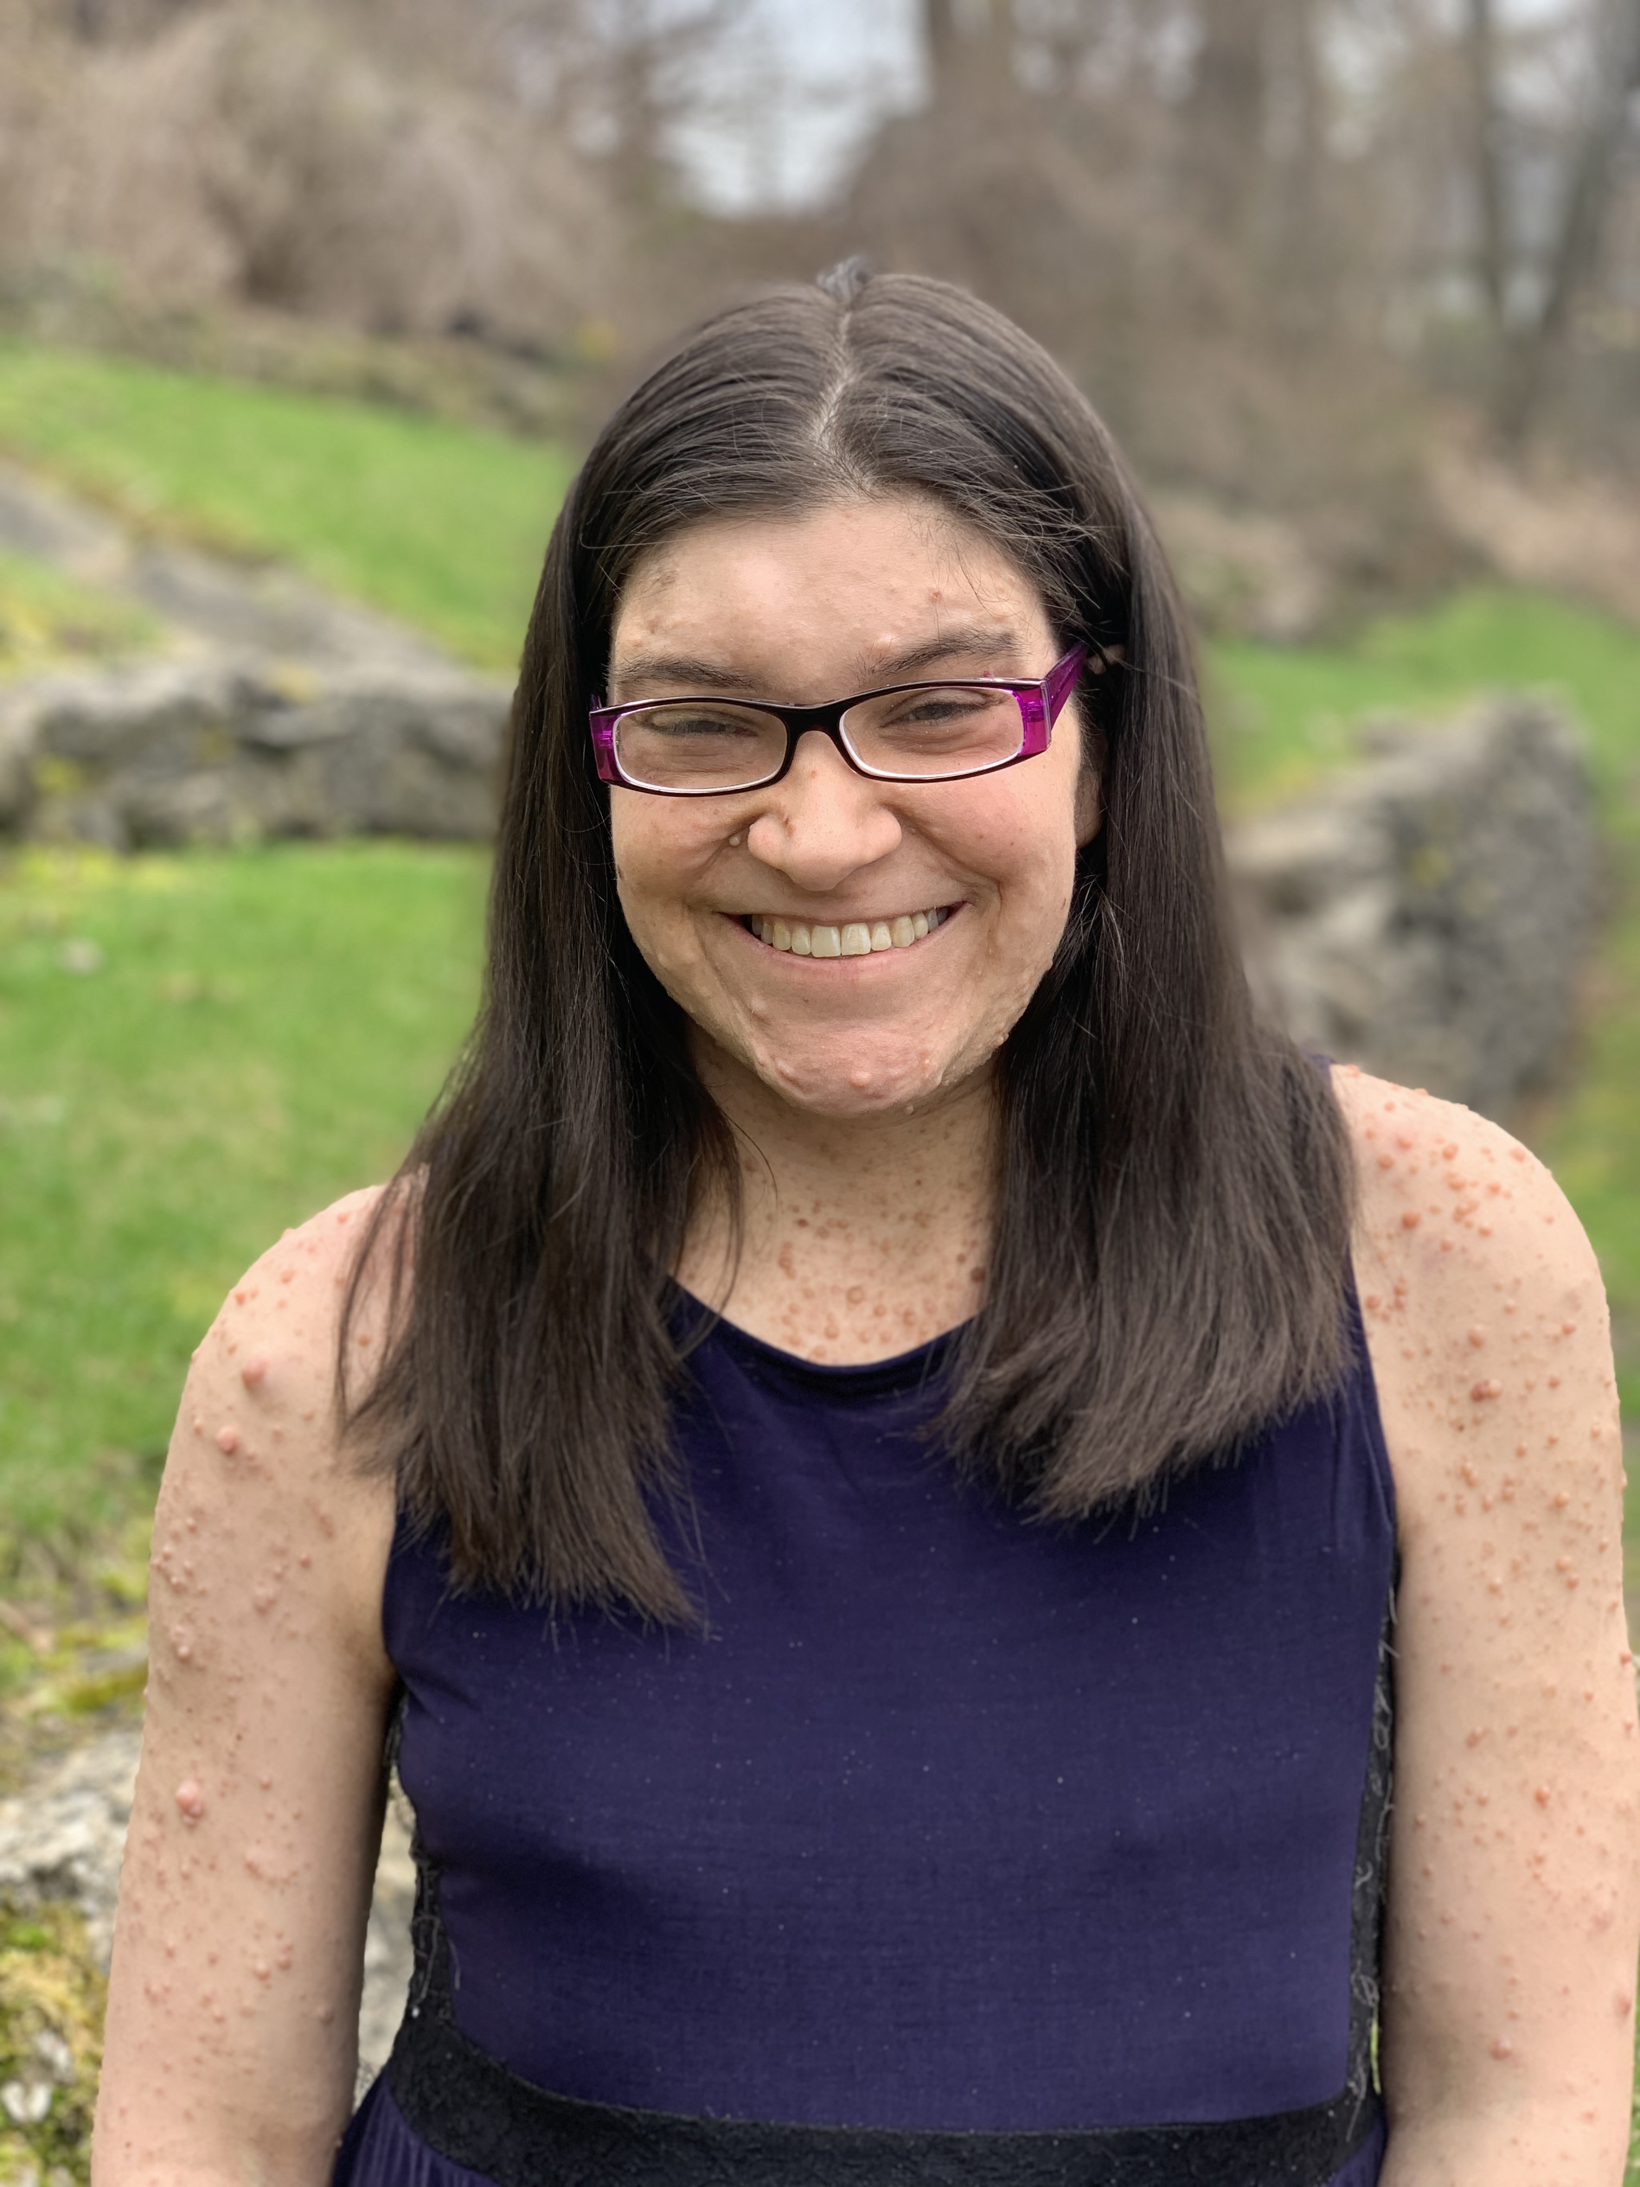

I was born with neurofibromatosis (NF) and found growing up with it was never easy. In particular, high school was hard because I felt so different from my friends and classmates. That was most true during my junior year when I had to go to a program at the Kent Transition Center, which was designed for people who wouldn’t be going to college.

The medical issues that come with NF have been hard, too. NF is a genetic disorder of the nervous system. It mainly affects how nerve cells form and grow. It causes tumors to grow on nerves. I have had quite a few MRIs, which require sedation since I am claustrophobic. I also had two surgeries due to NF. The biggest surgery I had was for a neurofibroma that was pressing down on my spine, making my right foot drag. If I didn’t have the surgery, I wouldn’t be able to walk again. It was a long recovery that had me in and out of the hospital.

Everyone who has NF experiences it differently. For example, I have some bumps on the surface of my body but others might have a lot more. NF can also cause scoliosis, which curves the spine. In my case, I have a lot of pain if I stand up too long.

I do little jobs like babysitting and serving as the disc jockey (DJ) for the Calvin College men’s hockey teams and the Grand Rapids Christian High School team. It’s a lot of fun because I get to play music while watching my favorite sport.

I started liking hockey in seventh grade when my older brother played. When I went to high school, my friends played hockey and I’ve loved it ever since. My senior year was the best. We had a very good team, and on senior night I got the number one fan award, flowers, and a candy necklace. My picture from that night was in the school yearbook. One year for my birthday I got an old Calvin College jersey with my last name on it. I’ve been wearing it to DJ hockey games ever since.

**Differences, But ‘Perfectly Imperfect’**   
**by Irina Bird**

Chapel Pointe, Hudsonville, MI

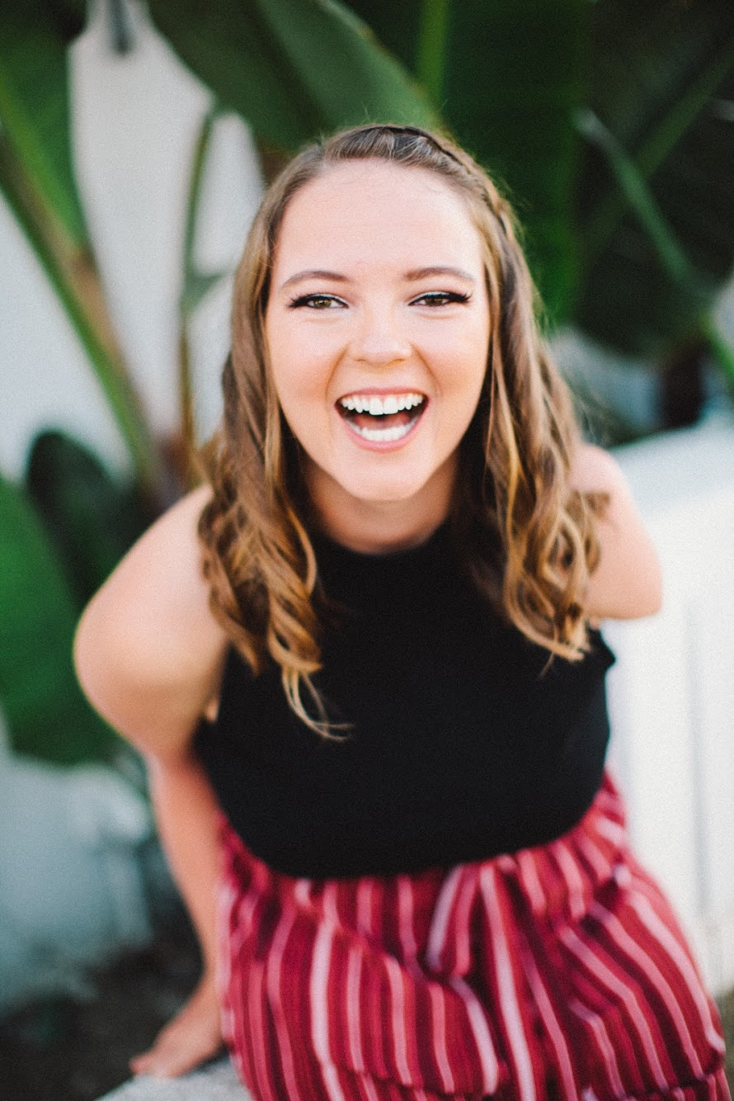

I’m 25 years old and am just like you in many ways. I have family, friends, and pets. I have gone to school, church, and enjoy many things in life, such as good food. But when people see me, they see my differences, not our similarities. I am created in the image of God like everyone else, even though I don’t look the same as most other people do.

I was born with a rare condition called Phocomelia syndrome, which causes limbs to be malformed. For me, this means no left arm, a right elbow that’s fused, and having legs with only tibia bones (no femur bones), making me only four feet tall. Growing up, there was a lot of trial and error as I didn’t know anyone with my condition, which meant there was no one to learn from.

My relationship with the Lord was challenging in the beginning because I questioned why I was so different from everyone else and why I had to have these differences. Looking back now, I am discovering what God may be doing through this rare birth defect. First, I am a very determined person. I work hard for what I want and what God wants for my life. I’ve also met so many amazing people in my life that would not have happened without my differences, including Bethany Hamilton, the 13-year-old surfer whose left arm was bitten off in a 2003 shark attack. I have been fortunate to travel a lot and meet so many people; an opportunity provided by the RCA allowed me to spend a summer in San Francisco working with the homeless population.

Everyone faces difficulties in life. When people see me, they often feel they can relate to me because they assume that I have struggled also. I believe there can be joy from struggle—the true joy that comes from God. My relationship with the Lord is very strong. I have learned to say I’m “perfectly imperfect,” meaning that while I’m human, make mistakes like everyone else, and have these physical differences, I’m perfect in God’s eyes, and that’s what matters.

**Connecting Diagnosis and Faith**  
**by Anne Elzinga**

Central Reformed Church, Grand Rapids, MI

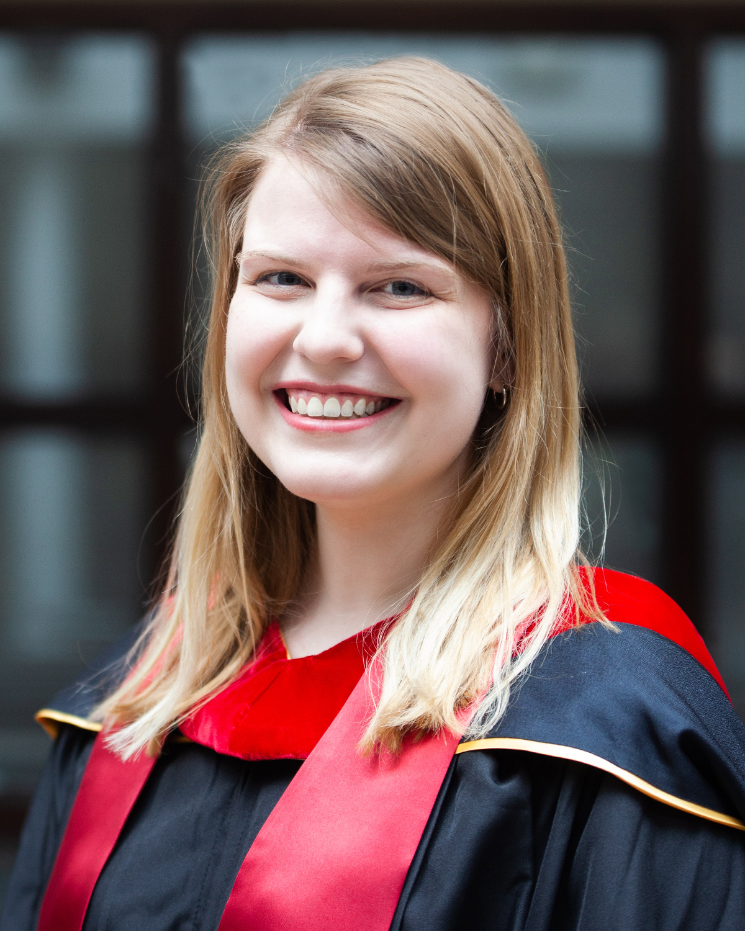

I have always valued being seen as reliable and indispensable. During college I was in as many extracurricular activities as I could to show how much I cared about causes and other people. Being an advocate with/for people is a good and beautiful thing, but there is a point that it becomes unhealthy. In late high school and most of my time in college, I hit that unhealthy breaking point. For six years, I was slowly burning out.

Then, in May 2018, two weeks after I graduated from college, I was diagnosed with lupus. This diagnosis helped me recognize many of my unhealthy tendencies around caring for others and forgetting my own needs. That first year was the hardest point of my life because I had to change my entire outlook about how I engaged socially and in work environments. In those first few months, I experienced horrible pain while trying to fight my physical limitations. When I started going to therapy and realized that I needed to acknowledge my needs, limitations, and become an advocate for myself—not just with and for others—it shook my entire world. I had to reorient my whole way of thinking and being by facing that I was ableist toward myself and that there was ableism all around me.

I still struggle with these things to some degree. I have to be very intentional with things like self-care and surrounding myself with people who will hold me accountable. I have also been overwhelmed by how ridiculously expensive medicines and procedures cost. I have come to accept that I need more rest than most people do. With all of that, I realize that my limitations contribute to who I am, and I am grateful. I am grateful that I am now a more confident advocate for myself, and therefore with and for others. I am more aware of ableism and different forms of accessibility, of intersectionality, and of individual stories and corrupt systems. I also hope that lupus will help me flourish in ministry and help me show up to others in an authentic and empathetic way.

Since the onset of my invisible disability, there has been grief because I had to change so much about my current life and my future expectations. Being diagnosed at 22 also came with other complications: I experienced not knowing where I “fit”; I get told, “you’re young, so you wouldn’t understand chronic pain”; or I have to be different from my other 20-something, normative-bodied friends who still see themselves as invincible. With this, I have had to practice self-disclosure and have become more and more comfortable doing so.

Over the last few years, my faith journey has centered around my diagnosis of lupus and my work in seminary. Experiencing both of these simultaneously has been a gift. I have been surrounded by theologies of illness, disability, and suffering, and by caring people in all contexts of my life. Thoughtful pastors, professors, and theologians have helped me process my diagnosis and how it connects to my faith. Studying Reformed theology while coming to terms with a chronic condition has helped me appreciate the gift of God’s grace that meets us where we are through a communion of saints that exceeds our imagination.

**Design and Beauty**  
**by Wesley Sullivant**

The Reformed Church of Kinnelon, Kinnelon, NJ

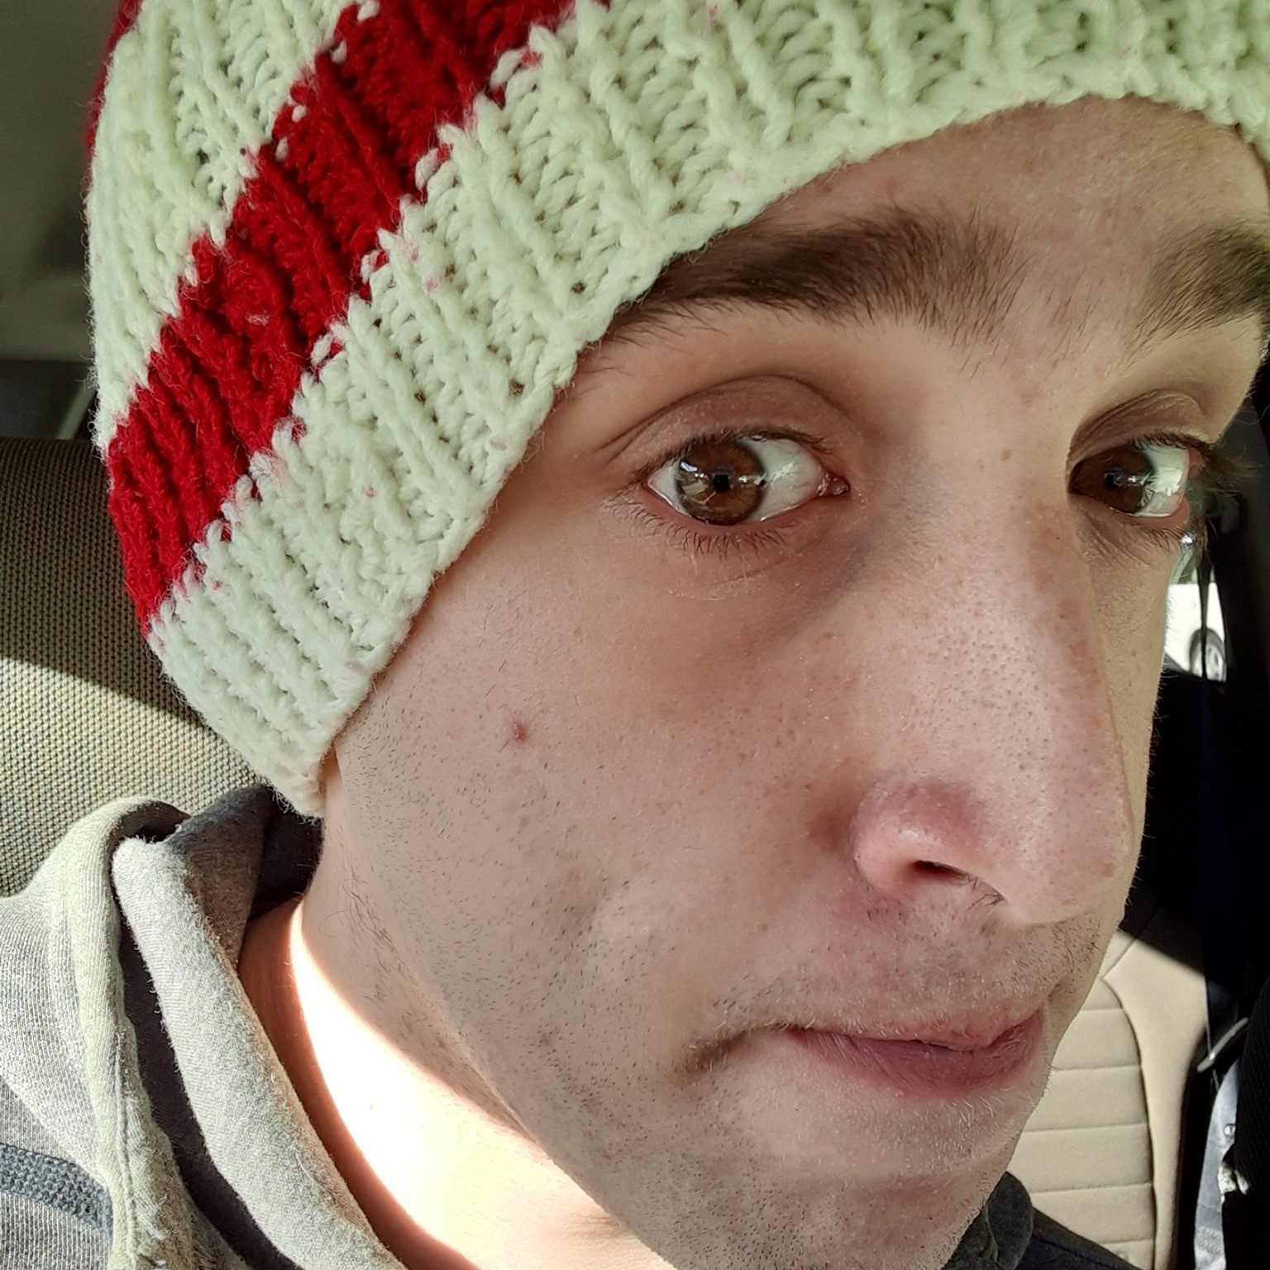  
A disability isn’t something that’s wrong with a person; it’s a different type of design. My abilities are slightly different, but I’m not unable.

One textbook defines “disability” as a disadvantage, as if there’s something you can’t do or feel, dictating limitations. That’s a very negative viewpoint. It’s also a very negative view that I’ve carried for most of my life. The stigma—even putting the actual disabilities aside—has made me feel as if I wasn’t allowed to be a part of social groups and activities that interested me. I felt like I wasn’t allowed to be who I wanted to be because I had to be the disabled kid. What I’ve always wanted is to feel normal and accepted, especially in the eyes of others. But as long as I was disabled, I was different. This made me feel like I was broken, even though I don’t think of myself that way.

I have an information processing disorder and weak muscle tone, and I live with depression and anxiety. For a long time, I saw these things as proof that I’m defective, that I needed to be fixed or cured. But these things aren’t a disease, not even the depression. I see these as different schematics, ways I’m created differently from others. Some people don’t like seafood, some people are allergic to dogs, and some people practice their faith differently; there’s nothing wrong with any of those things. In fact, this diversity enriches our human experience.

By giving me my differences, God helps me to bring new perspectives, new ideas to the table. I may need help sometimes, but that doesn’t mean I’m broken. My disabilities are unique qualities, and those qualities can help others learn and grow in their own journeys. My information processing disorder could help uncover a better way of teaching information, and my depression can give others new perspectives. The ways I’m different may actually help others improve their lives.

My abilities are different from other people’s abilities; that is a beautiful part of God’s creation.

**Editor’s Note**

**Celebrating Our Gifts**  
One place I found community in high school was a Wednesday morning prayer group and a weekly Bible study. My friend Doug was in both. The joy of the Lord bubbles up out of Doug. His friendly spirit led him to start each morning at school by holding the door open and greeting each person. He made every person feel seen and noticed. Doug’s deep faith was a steady presence in my teen years and his kindness a model for all of us to aspire to.

Most of the time, the fact that Doug has cerebral palsy didn’t cross my mind. But I do remember a Bible study retreat we took camping at Hoffmaster State Park in Muskegon, MI. That experience made me realize that Doug faced some unique challenges. We were spending time on the beach and playing in the water. Doug wasn’t going in the water. He admitted that even though he lived close to Lake Michigan, he’d only been in it a couple of times because his cerebrel palsy made it difficult and potentially dangerous.

I don’t remember the details about how it all happened, but pretty soon Doug was arm and arm with Kyle and Tyson as the three of them waded into the waves. I remember Doug’s laughter in that moment and the deep joy we all experienced. Doug glowed for the rest of the day, so thrilled that he had jumped in the waves.

Like Doug, we each have gifts to offer and, like Doug, we each have our own challenges. My hope is that churches aren’t waiting for teens and young adults to get older to serve the community. Instead, it’s good to celebrate the gifts that each brings to our community and hold each other up when life is challenging.

*— Lindsay Wieland Capel*

**Upcoming themes**

**Summer 2022—Acquired Disability**   
Most people with disabilities remember a time when they did not have their disability. How has your disability—acquired through stroke, accident, illness, aging—affected you, your relationships, your work, your spiritual life? What have you lost, and what have you gained? Please tell us a story (up to 400 words) about your acquired disability by **June 15, 2022**.

**Fall 2022—“Too Disabled”**

Many people with disabilities have gotten the message from others that their disability is too limiting, making them unfit or incapable to do something—even before getting the opportunity to prove otherwise. If you’ve ever been told or gotten the impression you were considered “too disabled” for a task, role, or job you wanted to take on, and knew you possessed the needed qualifications, please tell us your story (up to 400 words) by **August 1, 2022**.

Email: lcapel@crcna.org • tdeyoung@rca.org

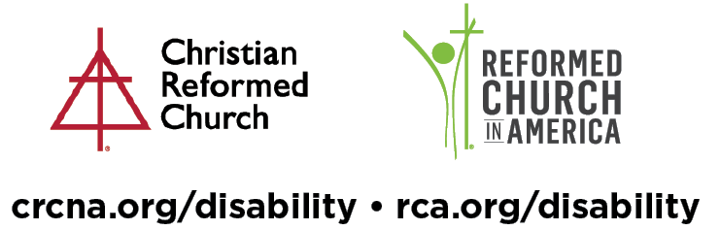

© 2022 Disability Concerns ministries of the Christian Reformed Church in North America and the Reformed Church in America. Breaking Barriers is published quarterly by CRC Disability Concerns, 1700 28th St. SE, Grand Rapids MI 49508-1407, and P.O. Box 5070, STN LCD 1, Burlington ON L7R 3Y8; and by RCA Disability Concerns, 4500 60th St. SE, Grand Rapids MI 49512-9670. Lindsay Wieland Capel, director of CRC Disability Concerns (888-463-0272; lcapel@crcna.org), and Terry DeYoung, coordinator for RCA Disability Concerns (616-541-0855; tdeyoung@rca.org), edit Breaking Barriers together. Permission is given to make copies of articles as long as the source is recognized.

A collaborative disability ministry of the Christian Reformed Church in North America and the

Reformed Church in America

www.crcna.org/disability • www.rca.org/disability