Search Committee Contact:
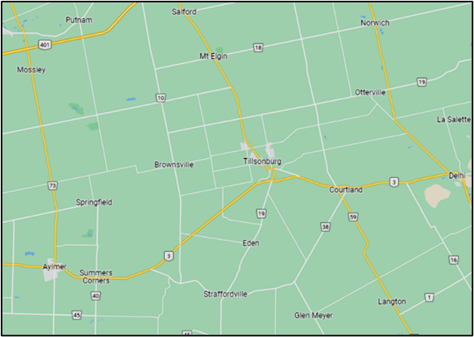
Harry Dykxhoorn
search@crosspointtillsonburg.com
Cell: 1-519-859-7946

Community Setting:
Location: Small Town
Function: Industrial, Bedroom Community
Growth: Growing
Population: 18,600 in Census 2021

Vision: A church and community knowing and embracing Jesus as Lord.

Mission: To gather for passionate worship, to nurture each other in faith and to care for our community.

We are open to Male and Female Pastors.
Current staff positions at Crosspoint:
- Administrative Assistant
- Caretaker
- Co-pastor
- Co-pastor (vacant)

The co-pastor position is new and we hope to fill it in Summer 2024. It is a full-time position and is not bi-vocational.

General position description:
Crosspoint Community Church, located in the rapidly growing town of Tillsonburg in southwest Ontario, is seeking an individual to join our ministry team as co-pastor. This individual will serve alongside our current Pastor, focusing on making more and better disciples of Jesus Christ. We are looking for a person of prayer, who looks forward to intentionally developing personal relationships within and outside of our church family with the intent of helping all to grow in faith, and to help lead the various ministries of our church.
Preferred ministry experience: 1-10 years.
Required language: English

Crosspoint’s Demographics:
Average Sunday Attendance: 100
Active Adult professing members: 80

Profile of church members:
18% 0-11 | 6% 12-18 | 9% 19-24 | 13% 25-34
9% 35-49 | 23% 50-64 | 22% 65
Age:

Occupations  10%Business | 4% Professional | 12% Trades | 7% Stay-at-home-parent
19% Agriculture | 24% Retired | 8% Student | 16% Other

Percentage of members belonging to the congregation:
Less than 5 years 32%
5-10 years 14%
10 or more years 54%

Racial/Ethnic composition of congregation and surrounding community:
2021 Census date for Tillsonburg: 6% visible minority
Crosspoint 3-4% visible minority

Composition of congregation: mono-cultural

Worship:
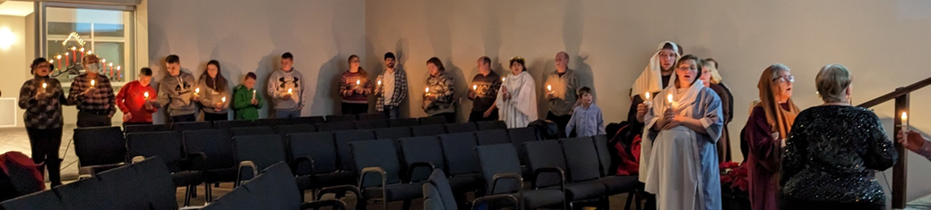

How are members involved in planning and participation in the liturgy/worship?
Generally, a team of 3 worship planners take turns in planning the songs and responsive readings in each worship service on Google Docs in collaboration with the preacher, guided by the theme of the sermon provided by the preacher. Preachers are expected to provide a preaching theme or Scripture text 3-4 weeks in advance. The goal is to have a complete draft of the worship service prepared 10 days in advance of the worship service.

Describe the discipleship practices in your church for all ages of members and attenders:
Along with weekly worship services and pastoral care, Crosspoint offers the following:

222Disciple is a program for mentoring using online videos and one-on-one conversations for people to grow in their faith and to become comfortable explaining the gospel in a clear, coherent, comprehensive way. It takes a year-long commitment to spend an hour each week meeting with a mentor.

Alpha runs 2-3x/year as needed.

A Calvin College seminary student was hired for the summer of 2023.

Bible Camp was a goal for Summer 2023. Crosspoint planned to hire 2 college students to coordinate growing the Bible camp from 1 week to 3 week-long Bible camp sessions. A week long Bible camp was coordinated with other local churches at Crosspoint, ending with a multi-church service in a local park. The summer student employed at Crosspoint arranged a week-long cooking camp meeting daily at Crosspoint. It ran twice and involved 22 middle-school children.

Bible Studies: Last spring 2 groups of adults studied Mark 1-9, using the Discover Your Bible material. Last summer one of the summer students Crosspoint hired instigated a College & Careers Bible study group involving young adults from Crosspoint and neighbouring churches.

Cadets is a group of 9 boys in Grades 4-8, led by 6 dedicated counsellors. They gather on Thursday evenings to study the Bible and pray, learn practical skills and teamwork, participating in the Huron Council activities.

Catechism Classes: On Wednesday nights preteens and adults gather to pray and study the Heidelberg Catechism with the pastor. The class is deliberately intergenerational.

Daily Bible Readings: are published each weekday and are distributed in print, through email, and via the CRCNA’s Bridge App. The pastoral staff prepares a Bible reading, a brief commentary, and prayer suggestions building towards the coming Sunday worship service.
GEMS currently has 20 girls, the majority of them are not affiliated with any home church. On Thursday evenings, they gather to sing and study the Bible, do artwork, and play games with 9 leaders.

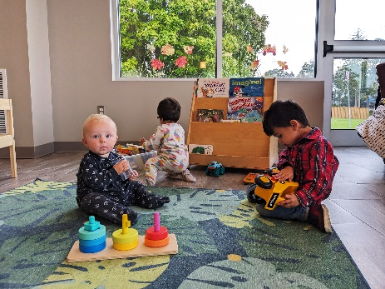
Jack & Jill is a drop-in ministry for caregivers and young children drawing 30-40 people each week. Many of the caregivers are moms, but there are dads, nannies, grandparents, and aunties who bring infants, toddlers, and preschoolers to play and socialize for 90 minutes each Thursday morning. None of the activities are explicitly Christian, but in the past year several people have come to faith and begun worshipping Jesus Christ as Lord at Crosspoint.

Kentucky Trip: Annually for 15 years, a group of leaders and youth drive south to Frakes, Kentucky to volunteer at Henderson Settlement for a retreat and to replace leaking and damaged roofs, over March Break. It is a great opportunity for teens and adults to grow in their faith through devotions and service.
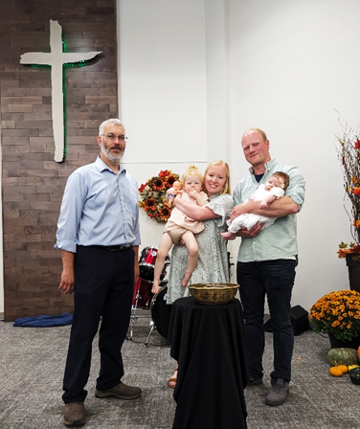
New Members’ Class: Last year, we ran a new members’ class in the summer and again in the fall for those who are new to Crosspoint or are considering profession of faith. In 2023, 9 people made profession of faith, including 2 adults, new to faith, who were baptized.

Office-bearer mentoring: Incoming elders and deacons are mentored by another office-bearer for an hour each week for 6 months to gain proficiency in explaining the gospel, praying, and discussing other aspects of serving as an elder or deacon at Crosspoint.

Building/Financial:

Present annual budget: $ 387,000
Last year’s annual budget: $ 287,000

Percentage of financial obligation met
(last complete year reported):
Budget: 100+
Denomination Ministry Shares 100+
Classical Ministry Share: 114

Amount contributed above budget and ministry shares $94,000; with an additional $376,000 specifically to pay off mortgage.
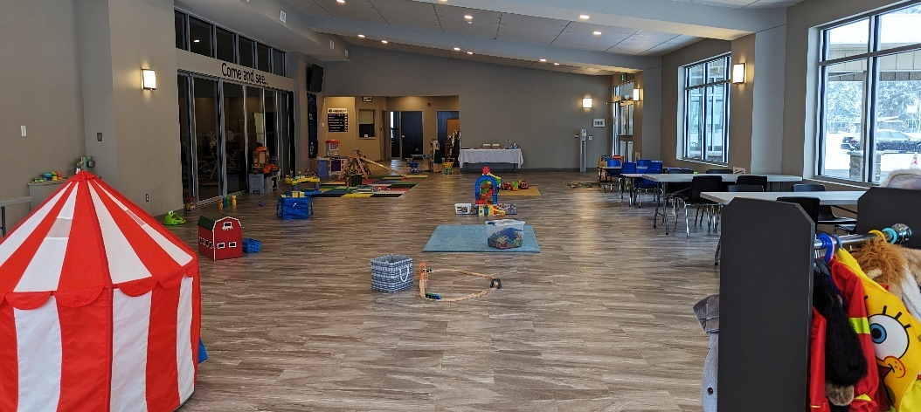
Facilities:
Describe facilities:
Renovated in 2020, Crosspoint boasts a friendly new fellowship hall, refreshed auditorium, new childcare suite, four new accessible classrooms with BIG windows, kitchen servery, new pastors' studies, and new accessible washrooms.
Are your buildings adequate for your ministries? Yes
Is a building program projected? No
Does the church own a parsonage? No
Location of office or study: In church building

Compensation:
The salary range we are prepared to offer our new pastor is based on the CRC Ministry Compensation Survey for Classis Ontario Southwest.
The average annual increase for the current pastor’s salary is 4%.
Housing: housing allowance

Benefits and expenses:
- Pension
- Medical Insurance
- Life Insurance
- Canada Pension
- Mileage
- Continuing Education funds
- Continuing Education time allotted
- Sabbatical Policy in place
- 4 weeks annual vacation

Church Characteristics
Presently, the focus of our Crosspoint’s ministry is:
 | Community Exclusively | Community primarily | Community & current members/ participants equally | Current members/ participants  Primarily | Current members/ participants exclusively
External |  |  |  |  |  | Internal

At Crosspoint, the worship service is designed for:
 | Designed for unchurched | Emphasis on unchurched | Unchurched and believers | Emphasis on believers | Designed for believers
Unchurched |  |  |  |  |  | Churched

At Crosspoint, the style of music used in the worship service is:
 | Contemporary | Mostly contemporary | Blended | Mostly Traditional | Traditional
Contemporary |  |  |  |  |  | Traditional

At Crosspoint, leadership is generally provided by the:
 | Predominately lay leaders | Frequently by lay leaders | Lay leaders & pastoral staff share leadership | Lay leaders function under pastoral staff | Predominately pastoral staff
Congregation members |  |  |  |  |  | Pastoral staff

Crosspoint seeks to encourage spiritual growth through:
 | No specific ministries | Ministries for a few groups | Ministries for selected groups | Ministries for most groups | Ministries for all groups
Informal |  |  |  |  |  | Formal

At Crosspoint, evangelism strategies and methods are:
 | Predominantly unplanned | Generally unplanned | Equal emphasis | Generally planned | Predominantly planned
Unplanned |  |  |  |  |  | Planned

Crosspoint is representative of the economic diversity of Tillsonburg:
 | Strongly | Mostly | Moderately | Mildly | Weakly
Highly representative |  |  |  |  |  | Weakly representative

Crosspoint is representative of the ethnic diversity of Tillsonburg:
 | Strongly | Mostly | Moderately | Mildly | Weakly
Highly representative |  |  |  |  |  | Weakly representative

Crosspoint’s response to compassion, mercy, and justice needs is:
 | Committed to church-based action | Encouragement of church-based action | Church based and personal action | Encouragement of personal action | Committed to personal action
Churched based |  |  |  |  |  | Personal

Crosspoint’s missional focus is:
 | All local | Mostly local | Equally local and global | Mostly global | All global
Local |  |  |  |  |  | Global

Narrative:
In what ways does Crosspoint participate in ecumenical activities?
Tillsonburg has an active Christian Ministerial Association, meeting regularly for prayer and mutual encouragement, setting up prayer-partnerships between pastors for a season, and hosting weekly Wednesday noon worship services during Lent. Crosspoint's pastor regularly participates in ministerial activities.

For the past 3 years, Crosspoint collaborated with 4-5 other Christian churches for a week-long Tillsonburg Kids' Bible Camp. In 2023, Crosspoint hosted the camp with 40+ leaders and roughly 200 participants.

Reflect on Crosspoint’s strengths and gifts as a church.
Crosspoint's congregation is generous with their volunteering, their skills, and their financial support. In general, our gatherings are full of joy. People seem happy to gather for worship and ministry.

In the past 5 years, Crosspoint has grown into a congregation that is quick to pray and dependent on talking with our heavenly Father as a congregation and as leaders about the joys we celebrate and the challenges we face. It has become an important part in our worship services. In addition to corporate prayer, we have seen individuals develop faithful habits of prayer, interceding for our congregation and community.

As a result of nearly 20 people being mentored one-on-one using 222Disciple materials and the training people receive during new members' classes, there is a solid core of believers who are ready and willing to explain the gospel as appropriate in a clear, comprehensive, yet complete way. As a pastor, I hear thrilling accounts of people taking advantage of the opportunities the Holy Spirit gives them to explain the gospel. We celebrate those opportunities and particularly those times the Spirit stirs someone to respond to the gospel with faith!

Informal counting at recent worship services reveals that roughly one third of those who gather for worship on a given Sunday are new to Crosspoint in the last 5 years. Some of them are new to Christianity.

Because Crosspoint is intentionally oriented towards the community and unchurched neighbours, gospel-telling is an integral part of each sermon.

Reflect on Crosspoint’s passions:
Ministry is exciting at Crosspoint because we have seen God use Crosspoint's ministries to help people come to faith and grow in faith. Because we see it happen in the past few years, the congregation and leaders expect and pray for opportunities to make more disciples and better disciples who influence our community for the Kingdom of God. The leaders in are particularly passionate about and committed to connecting with our community and praying that God will continue to use Crosspoint to advance his kingdom.

There are people who are passionate about a particular ministry or other and (thankfully) there is diversity in those passions. We do note that many people are using their individual gifts, skills, experience, and interests within Crosspoint for the benefit of the congregation.

List specific problems with which Crosspoint struggles:
Our church struggles to recruit leaders who are spiritually mature for key roles. One result of the growth in our congregation is the time it takes for a new or renewed believer to mature enough in their faith to serve as a teacher, ministry leader, deacon, or elder. GEMS, for example, has more adult "helpers" than "counsellors."

We have struggled to find leaders for a high-school discipleship program beyond the annual March Break trip to Kentucky. When we have run a program for high schoolers, some teens are reluctant to participate.

There are some members who have found the changes of the past 5-10 years difficult. They grieve what they gave up for Crosspoint to take risks and become more community oriented. The process of Church Renewal required them to stretch further than they felt comfortable doing. Thankfully, most remain committed to the mission of the Church despite the regret they experience over some of the changes.

Do you have a recently articulated mission/vision for ministry? Yes (See first page)
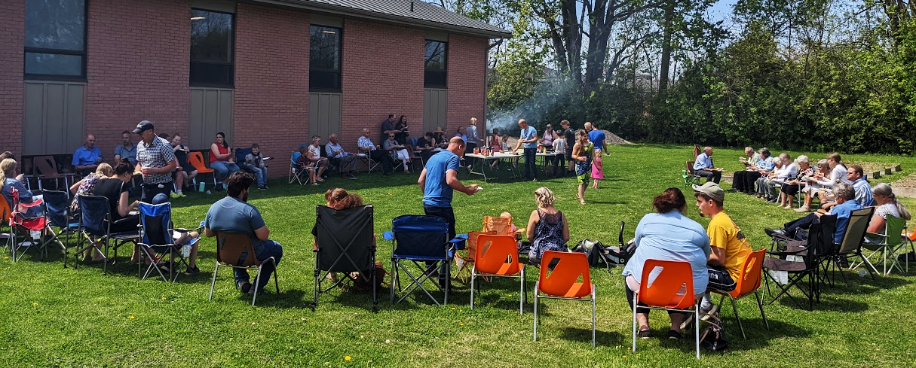
What has been the most interesting and challenging event in the life of Crosspoint in the last three years?
As in most churches, the Covid pandemic was challenging for our congregation. While there were not divisive arguments about masks or gathering limits, the whole community was stressed by the pandemic and the fact we were unable to gather for worship services for a prolonged season. Giving remained steady, daily devotionals and worship services were available via the internet, and leaders tried to stay in contact with the congregation. Council received feedback afterwards that the pastor and elders should have given more pastoral care during the pandemic.

List major goals that Crosspoint has set or opportunities the congregation anticipates:
In 2024, Crosspoint increased our staff. The administrative assistant position was increased from 15 hours/week to 20-25 hours/week. The contract custodian position was changed to a full-time caretaker position which was filled on January 1. We have committed to hiring a student from Calvin Theological Seminary for a summer internship for the second summer in a row. We hope hire two college or university students (up from 1 in 2023) to serve as ministry coordinators in June, July, and August. AND Crosspoint decided to call a co-pastor to work alongside the current pastor. By increasing Crosspoint's staff, we hope to widen the opportunities to connect with our community and our ability to make more and better disciples for Christ.

Thanks to a generous donation, Crosspoint has an agreement to purchase a 20' x 120' piece of land to make a sidewalk from our property to Hemlock Dr. to the north where new houses are being built. We hope neighbours will take advantage of this sidewalk to use our green space and the planned playground equipment for recreation as a blessing to the community.

In 2023, God blessed our congregation with 9 adults publicly professing faith, 2 of whom were baptized. We're asking God that even more people can come to faith and grow in faith in 2024.

Describe what being Christians of Reformed accent means at Crosspoint:
Crosspoint has good relationships with neighbouring Christian churches. We are glad to run Kids' Bible Camp with them and gather for an ecumenical service with 1000+ people. Yet differences in theology and church leadership prevent us from uniting together as one big congregation. We regret the divisions in the church yet find compelling reasons in Scripture to maintain our understanding of baptism for believers and their children, church government, the Lord's Supper, end times, and other gifts from the Reformed theological tradition. We're thankful for the shared ministries and mutual support and encouragement of Classis Ontario Southwest and the Christian Reformed Church of North America.

Describe your understanding of the relationship between Crosspoint and the Christian Reformed denomination:
We are thankful that the denomination and Classis Ontario Southwest are here to support local congregations and allow us to work together on projects like training church leaders, local and global outreach and relief, church polity, and studies of theology and ministry.

As a Council, we lament the struggles in the CRCNA over the Human Sexuality Report but are encouraged by the decisions at Synods 2022 and 2023 in defining "unchastity" in Heidelberg Catechism Q&A 108 and encouraging pastoral care in a culture where we are bombarded by discordant message about identity and sexuality.

Identify some of the cultural challenges facing Christians and Christian churches today:
We recognize in church and society that there are challenges in passing leadership from one generation to the next. The differences between Boomers, GenX, Millennials, and GenZ are well documented. We recognize the need to solicit the leadership skills and insights of each generation.

As documented in the Human Sexuality Report, Christians face difficulties in discerning the differences between leadership from the Bible and leadership from culture in our thinking, attitudes, and behaviours. We recognize the pastoral sensitivity required to engage in discussion and discernment together.

What have been the three most important events in the history of your church?
- In the late 1970s and early 80s, when discerning where to build, the leaders of our congregation felt called to build on Concession St. W. because housing development was planned for this area. We have benefitted from their foresight. Crosspoint's campus is currently surrounded by new housing and construction. 1300 housing units are planned directly across the street from Crosspoint. We are excited to see how God will use Crosspoint to connect with our neighbourhood.

- Roughly around 2013-2014, an Interim Pastor and a Go Local mentor helped the congregation to the sobering realization that unless things changed, Tillsonburg CRC was going to dwindle and die. During a season of prayer, discussion, and discernment, the congregation decided that our ministry should become community-focussed instead of inward-focussed. Church Renewal is hard work, but with God's help the congregation has persevered. Adopting the name "Crosspoint Community Church" has been helpful internally and externally to mark the change in ministry focus. We are surprised how many people moving into the neighbourhood have felt comfortable visiting their local "community church." Some have made it their church home!

- In 2019, Crosspoint began $2 million renovation of our forty-year-old building, as described earlier. The goal of the renovation was to make the building a better tool for ministry. By year-end 2022, the building costs were repaid and Crosspoint is mortgage-free. More importantly, our building is being regularly used for ministry, worship services, and for community activities. We are delighted to see how our building is being used for ministry and hospitality and when we hired summer staff in 2022, we were excited by the innovative ministry ideas they developed. We're looking forward to new opportunities in the future.

