Pursuing God’s Will Together Concerning the Future of our Church

A model for discussion in a retreat format

Written by: Martin Contant, Regional Leader for CR Home Missions, Western Canada

Ministry Leaders Retreat for CRC
Date:

Friday Evening

Prayer
Welcome
- Introductions - role in church, in the wider community (work, volunteer, family)
- “What has been one significant decision you have had to make recently in which you struggled to find a clear answer?”

A DEFINITION
Discernment is the pro-active capacity to recognize and respond to the presence and activity of God, both in our ordinary moments and the larger decisions of our lives. (Ruth Haley Barton)

To discern means to sort out, sift through, distinguish, to tell the difference, recognize, discriminate, determine.

A THEOLOGY OF DISCERNMENT
Friends, do not believe every spirit, but test the spirits to see whether they are from God.
(I John 4:1)

Be transformed by the renewing of your minds so that you can discern what the good, acceptable and perfect will of God is. (Romans 12:2)

…to another is given the gift of distinguishing between spirits … (I Cor. 12:10)

No one knows the thoughts of God except the Spirit of God. And we have received the Spirit of God that we may understand what God has freely given us. (I Cor. 2:11)

My sheep hear my voice… (John 10:27)

The Holy Spirit will teach you all things and remind you of everything I have said.
(John 14:26)

Spiritual leadership is distinguished primarily by a commitment to discerning God’s will, naming what God is up to in the midst of our human situation, so we can align ourselves with God. If we call ourselves a management team, a board or cabinet, that will be what we will get; a method of governing basically secular in orientation. It takes something of a conversion for church leadership groups to see themselves as being a spiritual community rather than a board of directors/governors. (Ruth Haley Barton)

REFLECTION
- Any thoughts or reactions to some of the above texts which give a biblical basis for the need for, the posture of, spiritual discernment.
- Reactions to the Barton quote “it takes something of a conversion…” really???
- Would you describe yourselves (as Council) as a spiritual community?

DWELLING IN THE WORD
John 9 -- “Learning to See”

An example of why discerning the will of God is not so easy. In John 9 we read a disturbing story of a group of very religious people who are so unable to see what God is doing in their midst that they try to thwart it. Every character sees the same thing - a healed man. But each has some level of blindness toward the evidence in front of them and difficulty naming it as a work of God. (Barton)

Jesus: While walking together along the road, Jesus saw a man blind from birth (verse 1)

Discernment:

Disciples: Teacher, who is responsible for this man’s blindness? This man? Or his parents? Verse 1

Missing the Point:
Jesus: Neither. His blindness cannot be traced to any particular person’s sins. He is blind so the deeds of God may be put on display…verse 3

Discernment:

Neighbors: Isn’t this the man we see every day sitting and begging in the streets?....no, he only looks like him. Verse 8

Missing the Point:
Pharisees: God can’t possibly be behind this man because he is breaking the rules of the Sabbath. …verse 16

Missing the Point:
Parents: He is our son and we know he was born blind. But his new sight is a complete mystery to us. Why don’t you ask our son? He is old enough to speak for himself. Verses 20-21

Scared of the Point:
The healed man: I am the man!...a man made some mud and applied to my eyes…that man is a prophet…I only know one thing: I was blind and now I see….do you really need me to say it again? Are you thinking of becoming His follower? It is ironic that you, our religious leaders don’t know where he comes from yet he gave me sight! This Man must come from God…I want to believe…Lord I believe. (Verses 9, 11, 17, 30, 33, 38)

Small Group Reflection:
With whom do you resonate in the story of the blind man?
  - The disciples who ask the wrong questions?
  - The neighbors whose paradigm is too small for miracles to happen?
  - The Pharisees who want to protect their own system?
  - The parents who are afraid to be expelled from the community for speaking the truth?
  - The blind man who follows the truth where it leads him

WHY DISCERNMENT IS SO DIFFICULT TO PRACTICE

- We only see as much as we expect or want to see.

Most people do not see things as they are.
They see things as they are. (Richard Rohr)

- Our reliance on human wisdom is deeply rooted.
- Measuring success with secular standards is common in the church.
- Our rational, linear thinking, where we argue our positions to the point where there are winners and losers (majority wins) is common in the church, rather than living together as the community of Jesus with mutually influencing relationships.
- We have a difficult time with some of the values of discernment: kindness, vulnerability, patience, truth-telling, listening.
- Our first impulse as leaders is “we need to make a decision – now, so let’s strategize how to make that decision” vs. first practicing some deep listening to the Spirit within us and among us.
- Discernment requires some new practices, and also requires us to let go of some old practices.
- Discernment as leaders is a humbling process.

“Spiritual discernment is the prayerful, informed, intentional effort to distinguish God’s voice and Spirit from other voices and spirits, and to choose companionship with the Spirit in order to participate in God’s larger action.” (Grounded in God p. 1)

Applying Discernment to our current situation as the church

LIFE CYCLE OF A CHURCH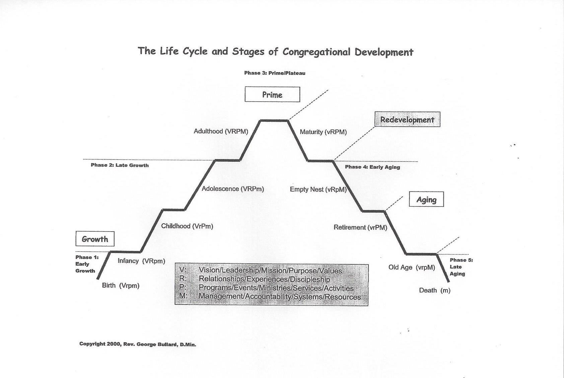

List some reasons/issues that have caused a number within leadership to conclude that ________CRC is perhaps in its last chapter of life as a church:
a.
b.
c.

Thom Rainer in his book, Autopsy of a Deceased Church lists 10 reasons why churches decline and eventually close:
- Slow erosion as evidenced by…..
- Our best days are behind us and we’d like to recapture the past.
- The community around the church changed but we didn’t change with it.
- Our budget is focused mostly inward, on our own needs.
- We don’t practice the Great Commission.
- Our preferences (worship, activities, programs, and staff) serve mostly ourselves.
- Pastoral tenure decreases.
- Meaningful prayer for the life and vitality of our church rarely happens.
- We have no clear vision and lost sight of our purpose as a church.
- We are focused mostly on the building as a church.

REFLECTING ON THE PAST FIVE YEARS
- What “spirit(s)” has been prevalent in our congregation during this period of time?
- What feelings do you have in relationship to being a member and leader at ______CRC right now?
- What can we celebrate?
- What do we need to repent of?
- What lessons have we learned (or do we still need to learn) to inform our future?
- What concerns you most about our church right now?

Pay attention to what is stirred up inside of you as we look back:
Desolation: (sense of sadness, discouragement)
- What fears do you have about where we find ourselves as a community?
- What sadness do you notice in you?
- What sense of loss and grief stirs up for you?

Consolation: (sense of hope, anticipation of the future, gratitude)
a. What are you specifically grateful for?
b. What is generating a new sense of hope, courage and confidence for the future in you right now?
c. What has happened in the last 5 years that has renewed a sense of God’s presence for you personally?

Consolation and Desolation are often both present in our lives… but which one seems to be most dominant for you as you think about _____________CRC?

Saturday Morning
HOW DO WE PRACTICE SPIRITUAL DISCERNMENT TOGETHER AS CHURCH LEADERS?

Discernment and strategic planning are different steps in a process. They are not diametrically opposed to each other, as much as they are a polarity to be managed. They are two important dimensions but the order of the steps matter!

“This is a defining characteristic of any spiritual community –the shared commitment to move forward as we are led by the Spirit, not by our own thinking and planning. We are not opposed to planning; in fact it is an important second step. But we are committed to discernment--listening deeply for God’s direction-as a precursor to any plans we make. And we are committed to continue listening as we move forward with those plans.” Barton, 99

ENGAGING AN ACTUAL DECISION
The more complex the decision facing us, the more we move beyond externals to considering inner dynamics, to listening to the stirrings of desire, to consolations and desolations, hard as that can be to notice and interpret. (RHB)

- Clarify the question
Paul and Barnabas reported all God had done with and through them, how God had welcomed outsiders through the doorway of faith…however, certain Judeans, came with this teaching, “Unless you are circumcised according to Mosaic custom, you cannot be saved.” Paul and Barnabas argued against this teaching and debated with the Judeans vehemently. (Acts 14:27- 15:2)

Not all decisions need group discernment.

Include in your questions, “What is the mind of Christ in the matter of…” or “What seems good to the Holy Spirit and to us in the matter of…..” (Acts 15:28)

- Listen to the question requiring discernment
Listen to all pertinent facts and information
…background information, financial reports, stats, actual proposals, expert advice
Listen to the voices from the community
…those who will be affected by the decision
…those with a special gift or anointing, the community ’sage’.
Listen to scripture
…its broad themes and specific passages
Listen to the life of Christ
Listen to the mission statement of your church
Listen to Consolations and Desolations
…what brings the deepest sense of life, peace, freedom, wholeness?
…what brings confusion and distress?
Listen to Tradition
…is there a guiding principle of deep wisdom contained in tradition (scripture, denomination, local community)
Listen attentively, with times of silence
….that allows an opening of the way to happen, esp. if there is confusion.
....Even if confirmation is emerging, silence is appropriate for affirmation.
…silence exposes our limits and creates room for God to work.

Total Listening (Farnham, Chapter 2)
Discernment Listening Guidelines (Appendix 1 –Farnham)

- Putting ourselves in a position to be led
- Reaffirm our guiding values -esp. if the issue is quite contentious
- Prayer for indifference- (ask God to make us indifferent al all but his will)
- Prayer of indifference- (not my will, but yours be done.”
This is difficult to achieve, many have strong opinions, and things get emotional. Prayer of indifference asks God for an environment where it is safe to say what needs to be said, without the need to win!

SCENARIOS OF CHOICE: (List all the possibilities open to _______CRC and its future)

1.
2.
3.
4.
5.
Prioritize the top 3 scenarios that at this time you as leaders believe need to be subjected a period of prayer, discernment, and conversation with the congregation.

Some guiding questions . . .
- What is it that God may be inviting us to grow and develop?
- How does our past history shape our future?
- What specific ministry directions/initiatives do you sense we should explore and possibly develop?
- Where have we seen evidences of God’s spirit in the past, which give us clues about where he is at work among us?
- What do you sense God is asking of us as leaders, as we discern this next chapter?
- What is the ‘mind of Christ on the issue of……….?’

Outlining what we need to do to engage these 3 possible scenarios . . .
- What don’t we know that we should find out?
- How will we engage the congregation?
- Prayer support team
- Finances
- Impact on staff

SOME CONCLUSIONS
- Discernment reveals that the best doing flows from being, the most effective action emerges from prayer, and our most loving engagement with the world flows from Christ being formed in us.

- Start with something, (as a Council) even if you can’t do everything.

- Hold it loosely: the stress of major decisions subsides when leadership communities begin making decisions in this fashion, leaning in with confidence to God’s intimate presence, but the discernment process should never be followed slavishly, it is not a series of rules but an approach to life with God as a Council (or family, or couple, etc.)

POSSIBLE NEXT STEPS
- Decide which scenario(s) you will explore with some further research, information.

- Establish a task force(s) to explore the chosen scenario(s) with a view to presenting a report to Council. Exploration of the scenario ought to reveal evidence of doing due diligence and prayerful discernment. This report(s) will form the basis for the recommendations Council brings to the congregation.

- How will we engage the congregation during these discussions?

Reflection: What ‘word’ for myself or for me as a leader in _______Church do I take away from these hours of reflection, discernment, discussion and teaching?

- Coaching assistance during this process.

- Prayer team to support the work.

CLOSING PRAYERS

References & Resources used:

References:

Pursuing God’s Will Together. By Ruth Haley Barton. Downers Grove: IVP, 2012

Grounded in God: Listening Hearts discernment for Group Deliberations, by S. Farnham, S. Hull & R.T. McLean. Harrisburg, PA, Morehouse Publishing, 1996

Wilma van der Leek- Pastor of Education for Classis BCSE & BCNW. Presentation on
Discernment for area churches in Classes BCNW & BCSE.

