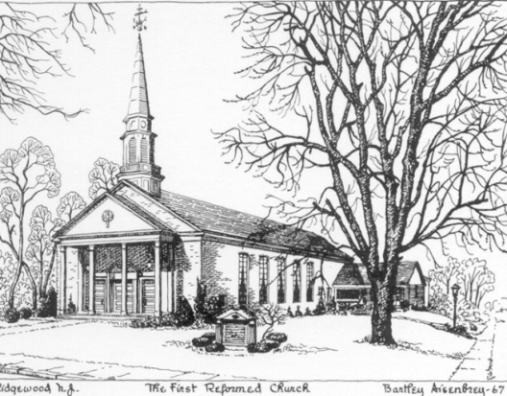

**Friends to Friends Community Church**

*Formally known as the First Reformed Church of Ridgewood,*

*a member of the Reformed Church in America*

*est. in 1875*

303 Prospect Street

Ridgewood, New Jersey 07450

201 652-3952 pastorjudyb@optimum.net

**FRIENDS TO FRIENDS Community Church MISSION STATEMENT**

**Friends to Friends Community Church** is a community of Christians with a focus on the inclusivity of people, primarily people with developmental and physical disabilities. From its inception, September 11, 1994, Friends to Friends has been rooted in the *empowerment* of its congregation and has been guided by the Holy Spirit for its direction. Participation in Friends to Friends offers opportunities for Christian growth and adapts its methods to the needs of its members. Using a casual style of worship, along with various and innovative avenues scripture and prayer are brought into the lives of its members in ways that with God’s help, will *empower* each member to grow more closely to that God in whose image they were created and to Jesus Christ the one who redeemed them. Directed by the words of scripture, guided by the life of our Lord Jesus Christ, and lead by the Holy Spirit, the members of Friends to Friends Community Church and their guest continue to grow as a dynamic, holistic, and a truly inclusive people of God.

**Current Church Functions:**

**Worship** – Contemporary style, Sundays at 7:00 PM: average attendance 75 – actual church membership 7

* Composition of congregation – 20% group home staff (African American, Caucasian, Hispanic)

80% group home residents primarily folks with developmental disabilities

* 3 volunteers from neighboring churches help with worship, as well as, congregation involvement

**Bible Study –** Tuesday nights at 7:00 PM with average attendance 25 – 35 (meeting September through May)

* Two groups based on cognitive ability and currently run by 3 volunteers

**Choir** – performs 3 times a year: 2nd Sunday in Advent, Palm Sunday, and Memorial Day weekend

* has 22 members and rehearses on Monday nights between September and into June

**Birthday Parties –** take place the 1st Sunday of each month after worship (no other gatherings follow worship)

**Monthly Fellowship** – takes place at least once a month. Most fellowships are hosted by various churches in the area. Participating are: Old Paramus Reformed Church, Harrington Park Community Church, Upper Ridgewood Community Church, Ramapo Reformed Church, Trinity Reformed Church, and Wyckoff Reformed Church.

**Church building** – has no debt and is supported primarily by the rental income from a pre-school with a 15 year lease and a Korean congregation. Church parsonage is located on the far side of the church parking lot.

**Searching for a loving full-time RCA Pastor with vision**

* Candidate must be self-motivated, a good administrator, be outgoing and have good energy with a passion to motivate others, be a good communicator and organizer, and be able to think outside the box. AV skills and some previous interaction with people with developmental disabilities would be helpful.
* Salary is based on the Classis of the Greater Palisades compensation package
* New pastor will begin his or her ministry as co-pastor with the current installed pastor for a few months