A Litany Lamenting the Abuse of Power within Faith Communities with Psalm 22
by Sharon R. Fennema, Ph.D.

Symbolic action: As the “We came…” statements are read, members of the community, especially survivors and others acting in solidarity with survivors they know, could be invited to come to the center/front and place stones around a candle on a table.

WORDS of INTRODUCTION -not on slide
Leader 3: In the Old Testament stones were used by Jacob, Joshua, and Samuel
to serve as witnesses and a physical testimony to both what has happened in the
past but also to reaffirm their reliance and faith in the sovereign Lord.

So today as we offer our laments and share our stories we will be laying stones,
stones to serve not only as witnesses to the truth of what has happened,
but also as a testimony that our hope is in
“the living Stone—rejected by humans but chosen by God and precious to him—
[and that] ⁵ we also, like living stones, are being built into a spiritual house^{[a]} to be
a holy priesthood...a chosen people, a royal priesthood, a holy nation, God’s special possession, that you may declare the praises of him who called you out of darkness into his wonderful light.” (1 Peter 2:5,9)

So we come to not only bear witness but also to ask God in his mercy to work in and through us to conform more fully to whom God has called us to be.
-----

LITANY -On Slides

Leader 1: We came with our stories, and no one heard,
Leader 2: because you did not know how to listen.
Sung Refrain:
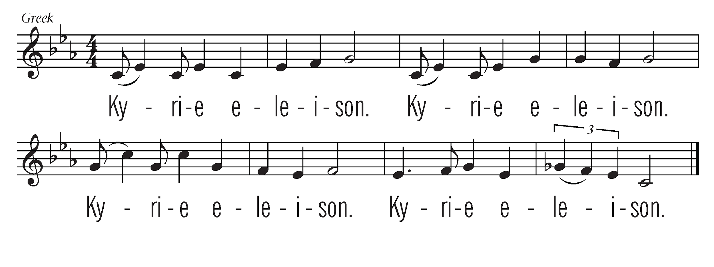
Leader 1: We came with our wounds, and no one noticed,
Leader 2: because you could not see past your loyalty.
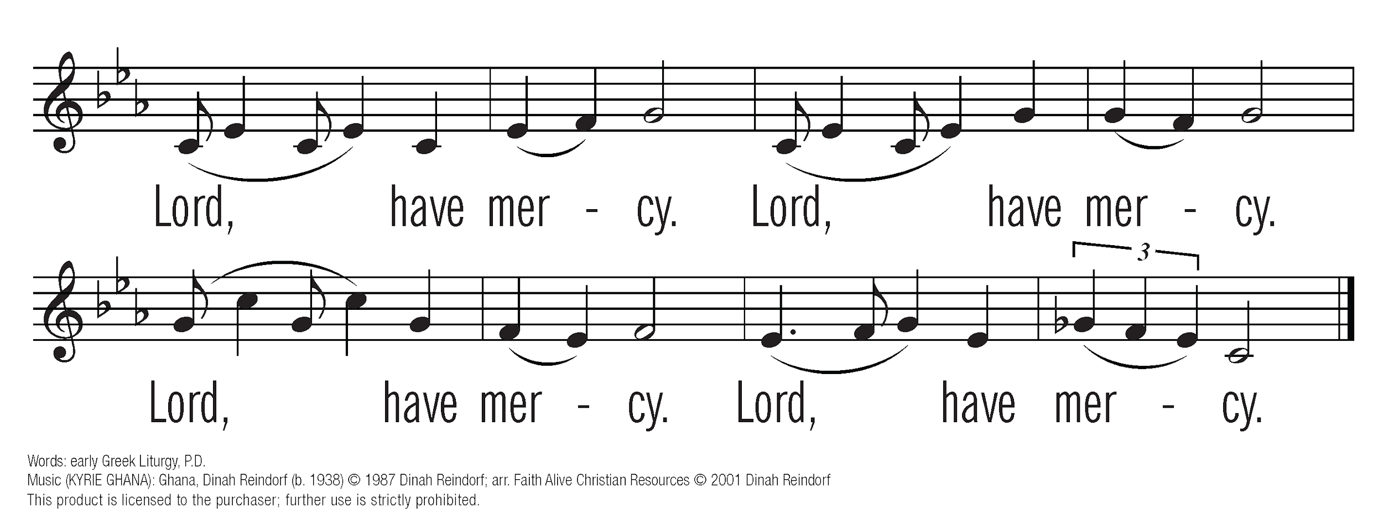

Leader 1: We came with our courage, and no one recognized it,
Leader 2: because you were not ready to receive our truths.

Leader 1: We came with our witness, and no one opened their hearts to us,
Leader 2: because you could not believe it would happen here.

Leader 1: We came with our stories, and the silence was deafening,
Leader 2: because there was no way for us to be restored.

You are invited to bring forward your own stone as a witness to your story or the story of someone you know.

Leader 1: We join with the Psalmist in crying out:
“I am poured out like water
and all my bones are out of joint.” (Psalm 22:14a)
Leader 2: Those who were supposed to care for me used their power to hurt me.
Assembly: For the breaching of relationships and the abuse of sacred trust, we cry out.

Leader 1: “My heart is like wax; it is melted within my breast;” (Psalm 22:14b)
Leader 2: I no longer felt safe in the place where I was supposed to experience God’s love.
Assembly: For the loss of spiritual home, church family, and holy ground, we lament.

Leader 1: “My mouth is dried up like a potsherd, and my tongue sticks to my jaws;
you lay me in the dust of death.” (Psalm 22:15)
Leader 2: Every step of the way I had to fight to be heard and understood.
Assembly: For systems and structures that retraumatize survivors, we wail.
Leader 1: “My hands and feet have shriveled;
I can count all my bones.” (Psalm 22:16b, 17a)
Leader 2: The abuse of power I experienced impacts my life, my work, & my relationships.
Assembly: For the trauma that lives in flesh and bones,
for the wounds that surface and resurface, we grieve.

Leader 1: “I am a worm, and not human;
scorned by others, and despised by the people.” (Psalm 22:6)
Leader 2: When I told my story, the community turned its back on me.
Assembly: For the failure to hear, believe, and take action in response
to reports of abuse, we weep.

Leader 1: “O my God, I cry by day, but you do not answer;
and by night, but find no rest.” (Psalm 22:2)
Leader 2: Because of what happened to me, I have struggled to hold on to my faith.
Assembly: For the effects of abuse that go beyond the capacity of words to capture,
for all that is lost, we mourn.

Leader 3: Yet you, O God, are holy, enthroned on the praises of your people.
In you our ancestors trusted; they trusted, and you delivered them. (Psalm 22:3-4)
So “I will tell of your name to my brothers and sisters;
in the midst of the congregation I will praise you:” (Psalm 22:22)
“For you did not despise or abhor the affliction of the afflicted;
you did not hide your face from me, but heard when I cried out.” (Psalm 22:24)

Leader 1: We came with our stories, and they were honored,
Leader 2: because you heard in them a prophetic voice speaking the truth in love.
Assembly: As disciples of Christ,
we commit to following his way of listening to the outcast and the voiceless.

Leader 1: We came with our wounds, and they were healed,
Leader 2: because you reached out with compassion.
Assembly: As followers of Jesus,
we commit to continuing his ministries of healing and restoration.

Leader 1: We came with our courage, and it was celebrated,
Leader 2: because you saw in each one the radiant image of God.
Assembly: As people of God,
we commit to holding those in power accountable to use it wisely and well.

Leader 1: We came with our witness, and hearts were opened to us,
Leader 2: because you honored your responsibility to one another.
Assembly: As the Body of Christ,
we commit to standing together in solidarity with those who suffer,
as members of one body committed to God’s love and justice.

Leader 1: We came with our stories, and they were heard,
Leader 2: because we learned to listen to what the stones are crying out.
Assembly: Thanks be to God, who showed us in Christ Jesus a new kind of power,
the power to serve, to love, to listen, to heal, and to transform the world.
To this right use of power,
to this way of being in just and loving relationship,
to this manifestation of grace,
to this vision of shalom,
we commit our hearts, our hands, and our Church.
Amen.

Song of Response: We Are Called (LUYH 296)

