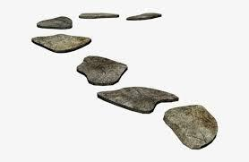
Lent
Lent begins on Wednesday, February 17, 2021 and ends on Easter, April 3. In this bag are two books:
- The pastor read The Biggest Story to children in morning worship last fall.
- Backyard Pilgrim, an adult devotional.

We have also included an activity to help your family focus on the 40 days of Lent. The materials includes:
- Purple fabric
- A cloth bag with 47 stones
- A white paint pen

On Ash Wednesday, place the purple fabric on your table or the floor. Lay out the 40 stones on the fabric, making a path. Begin with a white stone to represent Ash Wednesday, then three black stones, and then another white stone for every Sunday then on out including Easter, which will be your last stone. The paths can be made in a variety of ways; a zig-zag pattern, curves, a labyrinth, etc, as long as they make a path.

Together read the verse for the day from Backyard Pilgrim. Choose a word from that verse that stands out for your kids and write it with the white paint pen on one of the black stones. Place the stone back into the path. Feel free to pack up the stones each day.

Each day, when you lay the stones out you might try a different path. Continue to write on one stone every day until Easter. (You might want to use a black pen for the white stones.)

