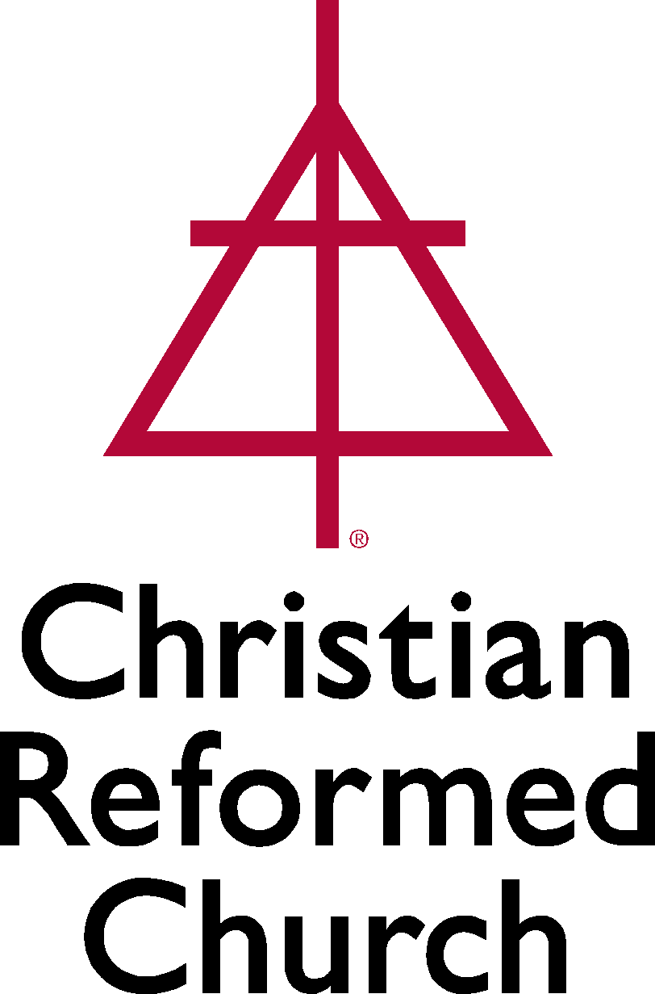

Mentoring Program
For Newly Ordained Ministers

Ministry Description:
- GETTING STARTED: Each newly ordained minister or minister who enters the Christian Reformed Church from another denomination is to select a ministry mentor, typically a pastor or chaplain from within the classis in which he/she will be serving. The mentor should have experience in the type of ministry in which the newly ordained minister is engaged or, at least, be willing to familiarize him/herself with that ministry.
- Each classis has a regional pastor who can help the newly ordained minister make a selection-- particularly when the newly ordained minister is unfamiliar with the classis.
- When mentor and mentee have agreed to the relationship the regional pastor should be informed if he isn’t already aware. The mentoring program for the newly ordained minister can begin!
- If there is no suitable person within the classis the newly ordained minister may find a mentor from another classis or from a closely related denomination who is available, experienced in ministry, and willing to invest in the newly ordained minister (the “mentee”).
- The regional pastor is to communicate with Pastor Church Resources regarding the name of the mentor (see contact information below).

- REGULAR CONVERSATION: The mentor is a conversation partner and coach for the mentee through the first five years of ministry.
- Once the mentor-mentee relationship is established the mentor begins to encourage and advise the mentee by means of regular conversations with the mentee.
- The ideal situation is one in which those conversations should take place in person and on a monthly basis.
- The mentor brings his/her ministry experience, ministry successes, and ministry failures into the conversations so that the mentee can hear about them and learn from it all.
- See the resource list below for more material for those conversations.

- ONGOING CONNECTION: As the mentor engages the mentee in conversation he/she is asked to let Pastor Church Resources (PCR) know, once per year, how the relationship is going and what topics are being covered.
- PCR will send a reminder notice every year along with a few simple questions for mentors to respond to.
- Mentor reports will help PCR to collect good ideas and practices to share with other mentors.

- WHAT IF…
  - If the mentor or the mentee moves to a new ministry setting before the five-year time window is complete then the mentee could do one of two things:
- Find a new mentor, someone who is more local to him/her.
- Continue meeting with his/her mentor across distances via video or telephone link.
This decision should be arrived at in conversation between the mentor and the mentee.
  - If the relationship between the mentor and the mentee is not a good fit then the mentee is always free to seek a different mentor, in consultation with the regional pastor.

- MISSION ACCOMPLISHED? When the mentor and mentee arrive at the end of the five year time span they should be ready to release one another from the mentor-mentee relationship. However, they might consider continuing to bless one another through regular conversation and encouragement. There is no reason to end the relationship simply because five years have gone by.

Resources:
- “Toward Effective Pastoral Mentoring, third edition”. This is our primary resource for mentors. It was designed for mentoring ministers who work in congregational settings in a North American context. However, since it covers topics such as the spiritual disciplines and reading one’s culture it can be of great value for mentoring ministers in other settings as well. The resource is free and can be ordered by calling Faith Alive Christian Resources at 1-800-333-8300. You can also download it from PCR’s website. Paste the following address into your web browser’s address bar:

https://www.crcna.org/sites/default/files/Pastoral_Mentoring_3rd_Ed.pdf

- Pastors’ Spiritual Vitality Toolkit: Developed by Faith Formation Ministries and Pastor Church Resources this toolkit encourages and equips pastors for the life-long journey toward greater spiritual vitality. After all, pastors can’t lead people and congregations to places where they themselves have not been. Access this free toolkit online at www.crcna.org/spe/pastors-spiritual-vitality-toolkit.

- Other books worth reading and discussing together, listed alphabetically by title:

  - Becoming a Pastor: Forming Self and Soul for Ministry by Jaco Hamman (The Pilgrim Press, 2007).
  - The Emotionally Healthy Leader by Peter Scazzero (Zondervan, 2015).
  - The Leader’s Journey: Accepting the Call to Personal and Congregational Transformation by Jim Herrington, R. Robert Creech, and Trish Taylor (Jossey-Bass, 2003).
  - Pastor: The Theology and Practice of Ordained Ministry by William H. Willimon (Abingdon Press, 2002).
  - Persevering in Ministry: Pastors Tell Their Stories, edited by Joel Kok (Faith Alive Christian Resources, 2004).
  - Speaking of Pastors: Parishioners Tell Their Stories, edited by James Schaap (Faith Alive Christian Resources, 2006).
  - This Odd and Wondrous Calling: The Public and Private Lives of Two Ministers by Lillian Daniel and Martin B. Copenhaver (Eerdmans, 2009).
  - Working the Angles: The Shape of Pastoral Integrity by Eugene H. Peterson (Eerdmans, 1987).

- You are always free to contact me or my colleague, Rev. Cecil Van Niejenhuis. If you have questions related to your mentee or if your mentee is raising questions that lead you to want an additional conversation partner please connect with us at:

Dave Den Haan
1-877-279-9994 (ext. 2712)
1-616-224-0712
ddenhaan@crcna.org

Cecil Van Niejenhuis
1-800-730-3490 (ext. 2746)
1-616-224-0746
cvanniejenhuis@crcna.org

