Resources on Adversity/Trauma

Books for Parents
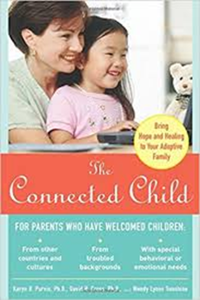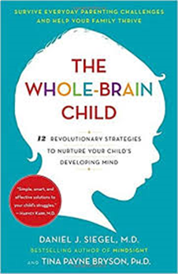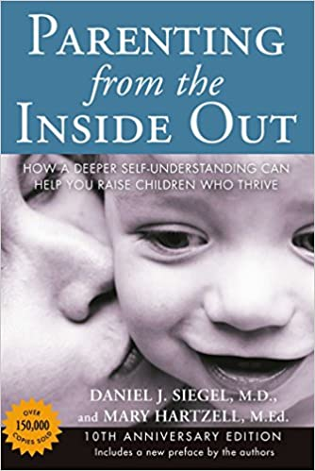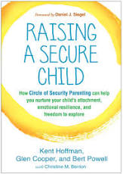

Books for Adults and Counselors
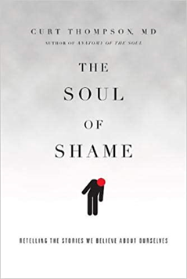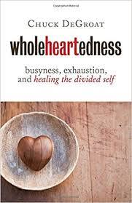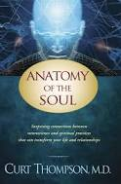

Trauma Informed Care Resources
Trauma Informed Care Project: http://www.traumainformedcareproject.org/resources/SAMHSA%20TIC.pdf

Child Traumatic Stress Indicators: https://www.samhsa.gov/sites/default/files/programs_campaigns/childrens_mental_health/what-is-child-traumatic-stress.pdf

Additional Websites/Resources
Texas Christian University: Karent Purvis Institute of Child Development https://child.tcu.edu/#sthash.BYrCJLpA.dpbs

ACE Study Findings: https://www.cdc.gov/violenceprevention/acestudy/index.html

Iowa ACE 360’s Implications for Faith Communities: https://www.iowaaces360.org/uploads/1/0/9/2/10925571/white_paper_faith_1.pdf

The National Child Traumatic Stress Network https://www.nctsn.org/

