Welcoming the Stranger Webinar
Extra info for participants

Thank you so much for taking the time to listen and ask questions. Following the webinar some of you may want to explore more. So, here are you go…

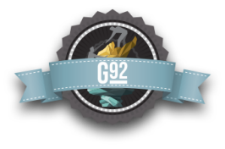
Answers to Common Questions:
- Why don’t immigrants just come the legal way?
- What part of “Illegal” don’t you understand?”
- Aren’t undocumented immigrants a drain on the economy?
- Why don’t immigrants learn English?
Outstanding answers to these 4 common questions can be found at g92.org. The site is maintained by World Relief and the authors of the book Welcoming the Stranger. Go to the sight, click a question, read the one pager, and learn more.

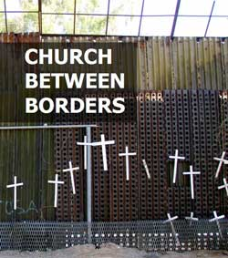
Church Between Borders:
This workshop starts with scripture and gets groups interacting. Since there is already plenty to read online, CBB’s focus is to bring the discussion to life and help groups make decisions to act. It also comes with trained facilitators and a nice book of background articles-- so you can focus on gathering a group and learning. Find out more at http://www2.crcna.org/pages/osj_churchbetweenborders.cfm

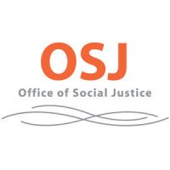
Do More, Learn More:
A copy of the 2010 Report to Synod on Migration, opportunities to join the I Was a Stranger Challenge movement, information about Breaking Bread and Building Bridges and much more can be found at http://www2.crcna.org/pages/osj_immigrationreform.cfm

Other questions:
Contact kvanengen@crcna.org

