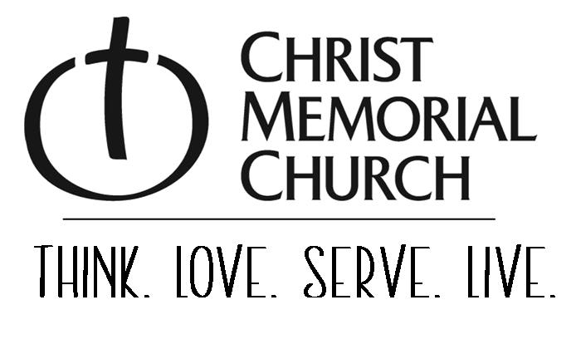
595 Graafschap Rd., Holland, MI 49423, 616-796-3370, www.christmemorial.org
"… to equip God's people for works of service, so that the body of Christ may be built up.” (Ephesians 4:12)
Mission of Staff
The staff at CM Church will shepherd and develop reproducing volunteer ministry teams.
Vision of Staff
CM Church will develop and maintain a spiritually and emotionally mature staff of professionals who will build effective volunteer ministry teams that accomplish the mission of CM Church and mentor interns who will go on to do the same in other churches and ministries.
Position Title: Child Care Attendant
Position Status: As Needed
Reports to: Children’s Ministries Director
Position focus: Provide care for children in the care center
Works cooperatively with: Care Center volunteers and families
Primary Strengths Required: Reliable, Trustworthy, Good communication skills
Responsibilities
- Care for children in care centers while ensuring a safe and nurturing environment
- Communicate with CM Director as needed, and issues arise.
- Support all posted procedures.
- Be in the Care Center before the service or event (15-20 minutes please).
- Greet each family as they arrive and ensure that children have been checked in.
- Take diaper bags from parents, label them, and put them in the cubby area.
- Keep track of time and ensure the flow of the morning is maintained.
- Complete all diaper changes and assist with bathroom usage or designate another adult to assist children.
- Clean up the Care Center after use; keep the area orderly, ensuring that all toys used in the Care Center have been collected and put back in place.
- Ensure all surfaces that children have come in contact with and toys too large to be washed have been sprayed with Lysol spray or wiped down with Clorox wipes.
- Oversee dismissal, verifying children are going to an approved adult. Share a special observation with their parent, if applicable.

Essential Skills and Training – CPR certification (provided by CMC)
If interested in this position, please send a resume to: jobs@christmemorial.org
Resumes should be received by: May 20, 2025
Position Description current as of: April 2, 2025

