Church Profile/Pastor Position
Leota Community Church
Leota, Minnesota

Welcome

Leota Community Church is glad you are taking the time to read our profile, and considering applying to become our next pastor.

After looking over our church profile, if you are interested in this ministry position the search team invites you to contact us. We would welcome an opportunity to get better acquainted with you.
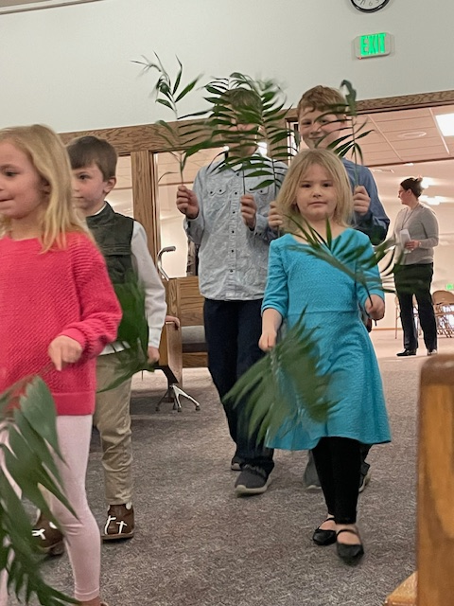
The search team looks forward to hearing from you.

Contact Information

Mike Scott (interim pastor)
leotapastorsearch@gmail.com
phone: 559-706-7180

Church Website: leotacommunitychurch.org

Position Overview

The two churches in Leota, Minnesota – Bethel Reformed Church (Reformed Church in America) and Ebenezer Christian Reformed Church (Christian Reformed Church in North America) are in the process of uniting together as a newly formed organized church - Leota Community Church. This new congregation will be joining a neutral denomination – the Evangelical Presbyterian Church denomination. An interim pastor has been assisting the two churches in this process and will be responsible for making sure it is complete. The next pastor will not be expected to be involved in the process but immediately concentrate instead upon the ministry.

The pastoral search team is looking for the person to carry out Leota Community Church’s mission statement: “Uniting Together in Christ’s Love to Glorify God.” The congregation believes that a continued emphasis on unifying the two congregations today will lead to an effective community outreach and church growth for the future years.

Leota Community Church’s Ministry Plan

Mission Statement – In order for Bethel Reformed Church & Ebenezer Christian Reformed Church to become one congregation, the concentration will be…

Uniting Together in Christ’s Love to Glorify God

Vision Statement - What does this Mission Statement look like for the community of faith for the coming years?

* We will do ministry as one congregation.
* We will exalt God in all that we say, teach and do in ministry.
* We will have Jesus as the focus of our ministry.
* We will be an outward-focused ministry showing Christ to the world.
* We will establish a loving church family that edifies and equips
believers to enjoy worshiping and serving the Lord Jesus Christ.

Ministry Plan - How will this be done? Individual members of the community of faith will be expected to…

* Participate in the life of the church: worship, fellowship, service, etc.
* Serve in some aspect of ministry.
* Possess a J.O.Y. attitude (approach) to ministry. (J-Jesus, O-others,
Y-yourself)
* Grow in one’s relationship with Jesus Christ.
* Connect with unchurched, unsaved people to present Jesus to them
and invite them to church.
* Give financially to the mission and ministry of the church.

Explanation Regarding the Ministry Plan/Mission Statement

Leota Community Church consists of Bethel Reformed Church (from the Reformed Church in America) and Ebenezer Christian Reformed Church (from the Christian Reformed Church in North America). Both churches are in Leota, Minnesota. The churches are located across the street from each other. For the past seven years the congregations have been worshiping and doing ministry together. Lately, an interim pastor has been hired to unite the two churches into one organized church and also to find a neutral denomination for the church to join. The mission statement reveals a firm commitment on the part of the people to unite the churches as one. The hope is that by the time a pastor is called to Leota, the churches will be one organized church belonging to a neutral denomination.

Because both churches have each ministered in Leota, MN for over 100 years, the leadership and people are aware that unity must be intentional in order for there to be oneness among the people. Although the process of uniting the churches and the selection of the denomination is forthcoming, it will take time for the hearts of the members to fully accept what has happened. The strong leadership of the church will make sure the ministry focuses on the mission statement.

For the coming years, the mission statement is relevant for the situation at Leota Community Church. With God’s grace, fulfilling Christ’s Great Commission will take center-stage in our ministry very soon.

Core Beliefs – The most important Christian beliefs of our ministry we want the community to know what we stand for are…


Bible We believe the Bible is the Word of God,
without error, and the only authority for
life and the Christian faith.
2 Timothy 3:16; 2 Peter 1:20-21; Psalm 119

God We believe the One, true God who exists
eternally and equally in three persons:
Father, Son and the Holy Spirit.
Genesis 1:1; John 1:1; 1 John 4:8, 16

Mankind We believe all people were created to have fellowship with God but our
sin separates us from God, subjecting us to His holy judgment.
Genesis 1:26; Romans 3:10, 23; Ephesians 4:18-19

Jesus We believe Jesus, God’s Son, came to earth, lived a perfect life, died and was
raised, providing the only way to a right and eternal relationship with God.
1 John 3:23; 1 Corinthians 1:9; 1 John 5:20

Holy Spirit We believe the Holy Spirit is God living in
Christ-followers, empowering
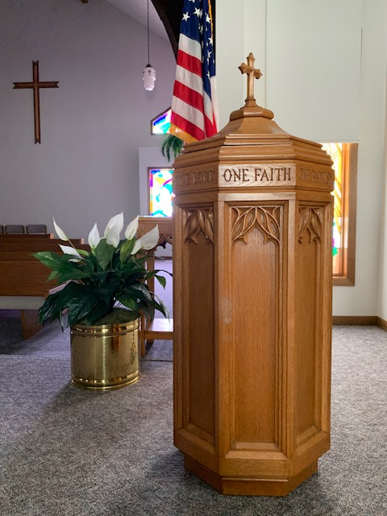
them to live a life that pleases God.
John 16:7-9; John 14:26; Acts 2
Church We believe the church is a community of
Christ-followers existing to glorify God,
and preparing Christians to love and reach
a lost world.
Matthew 16:1; Hebrews 10:25

Worship We believe worship is a daily, active
response of gratitude, praise and
service, declaring God’s worth in every
aspect of life.
John 4:23-24; Psalm 100:2; Luke 4:8; Ephesians
5:19; Hebrews 12:28

Prayer We believe prayer is communicating with
God, expressing our praise, confessing our
sins, making requests of Him and
submitting to His will.
Matthew 6:6-15; James 5:13-16; Philippians 4:6
Core Values – What values do we want to stand out for our community to notice about our ministry?

Bible Believing Church
You will hear the Bible preached in our sermons, taught in our education classes, and lived out by the members of the congregation.

Christ Centered Church
You will see us following the example and teachings of Christ in our prayers, in our education, and in our dealings with others.

Praying Church
You will hear prayer in our service, within our groups, and at our events. We will pray for God’s blessing, intercession, guidance and His will be done. We will pray for each other and lift each other up in prayer.

Christian Church
You will hear us recite the Apostle’s Creed as the summary of the basic doctrines of our Christian Faith. The center of which is the gospel message of Jesus Christ, the Son of God, who died on the cross for our sins and rose from the dead to give us eternal life if we believe.

Community Church
You will see us work for the good of our community and care for the members of our community.

Family Church
Your family will feel welcomed as a part of God’s family.

Positive Church
You will notice the positive attitude and energy of our church as we live and work in the fellowship of the Spirit.

People Church
You will notice we care about individuals, their situation, and their salvation.

Expectations for Our Next Pastor (Job Description)

The job description reflects the expectations and responsibilities required on the part of the pastor to ensure a dynamic ministry for Leota Community Church.

Primary Responsibilities

1. Leadership
* Keep the ministry focused upon the Mission Statement.
* Support and participate in activities that promote the well-being and unity
of the church body.
* Serve as president of the church board in planning, organizing, directing,
coordinating and evaluating the total church ministry.

2. Worship/Preaching
* Prepare and deliver biblically-based sermons that inspire, challenge, and
encourage the congregation to grow in their faith and relationship with
God.
* Plan and lead the morning worship services, in conjunction with the
worship team, musicians and others involved in service planning (note:
Sunday evening worship services are also offered but the pastor is not
expected to do them).
* With the worship team, schedule and organize holiday and special services.
* Administer the Sacraments of the Lord’s Supper & baptism.

3. Pastoral Care
* Build relationships and foster a healthy community within the church.
* Coordinate with the elders to provide shepherding and pastoral care of the
congregation. This will include contact and visitation for shut-ins and the
sick, individual and family counseling and guidance as able and needed,
and monitoring the spiritual health of the congregation.
* Officiate at weddings, funerals, and other church-related services.

4. Discipleship/Spiritual Development
* Provide spiritual guidance and encouragement along with the elders to the
people of all ages for Christian maturity and equipping.
* Offer New Members classes for adults and youth.

5. Outreach to the Community
* Engage with the local community, building relationships, serving others
and sharing the love of Christ through acts of compassion and outreach
initiatives.
* Participate in the life and events of the Leota and surrounding community.

Professional Qualifications

1. A seminary graduate (M-Div.) or the equivalent theological education.
2. Ordained and a participating member in good standing in the Christian
Reformed Church, Reformed Church, Evangelical Presbyterian Church or
another historic Reformed denomination.
3. Hold a Master of Divinity degree from an accredited seminary.
4. Commits to Reformed theology.

Compensation (based upon a full-time position)
1. Compensation includes salary, medical benefits, travel, paid vacation, and
retirement compensation. (details to be shared later)
2. A parsonage is provided for the pastor and family.

Our Congregation

Many of the 189 confessing members from both churches have strong family ties to the Reformed Faith, having been raised in the local community and now raising their families in this church. Descendants of the early 1890’s Charter Members have worshiped in Leota faithfully for more than a century. Seven generations have been traced to attend Leota Community Church!

Age of All Active Members

The Occupations of the Church
Members:

* Many farmers, business people &
retired

* Few teachers, industrial workers,
office and retail workers

(baptized and confessing)
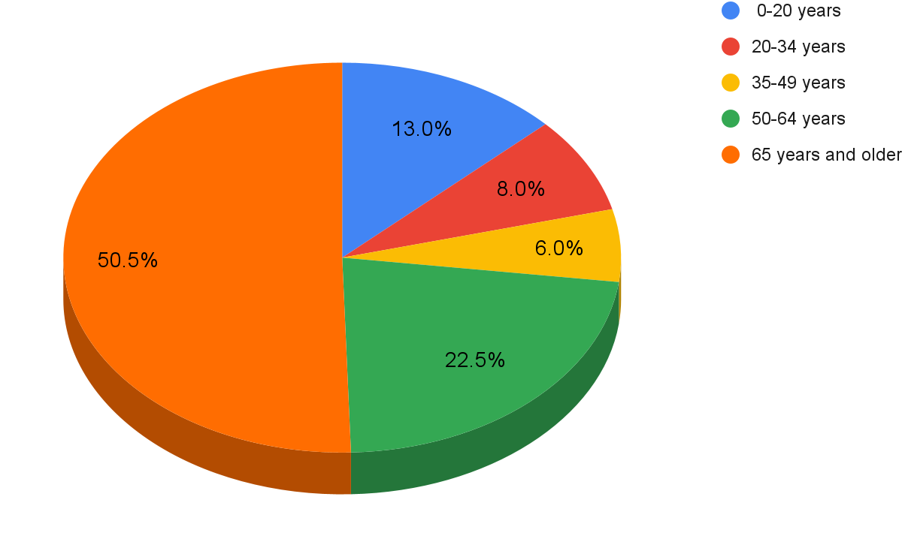

Church Board

At the present moment the church board consists of four elders and four deacons from each church. This board covers the people and ministry concerns of the entire congregation. Each church has its own church board (consistory/council) that will continue to function until both churches become one organized church. The separate boards deal with their own church’s finances and maintenance of property/grounds.

During the process of uniting the two churches, a new governing board structure will be established.

Worship

Our worship style is traditional with contemporary undertones. A typical worship service begins with a prelude, greeting, call to worship and prayer, praise songs/hymns, children’s message, congregational prayer led by an elder, Scripture and the message, and closing prayer. We are eager to hear God’s Word preached. We are open to new ideas in worship, yet appreciate the traditions in the church.
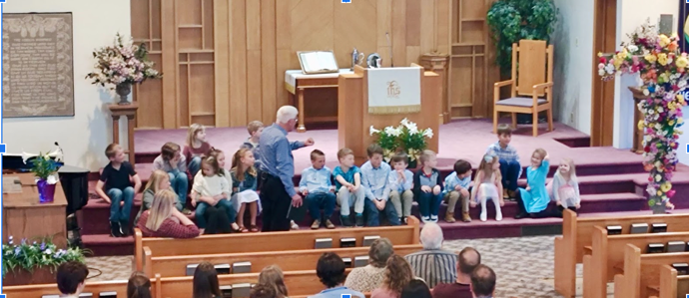
The morning worship services are held at Bethel’s sanctuary the 1st, 2nd, and 4th Sundays of the month. The 3rd and 5th Sundays of the month the services are held at Ebenezer’s sanctuary. The services begin at 10:00 a.m.

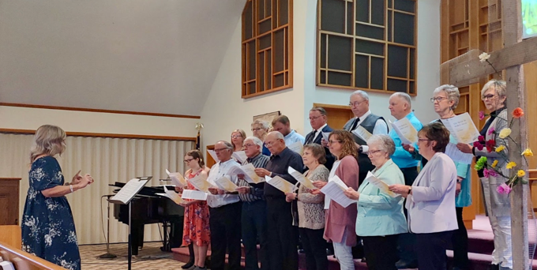
Evening worship services are held every Sunday at Ebenezer’s sanctuary. These services follow a more traditional worship style. The services begin at 6:30 p.m. Note: the pastor will not be responsible for the evening services so that he can spend more time in other areas of ministry.

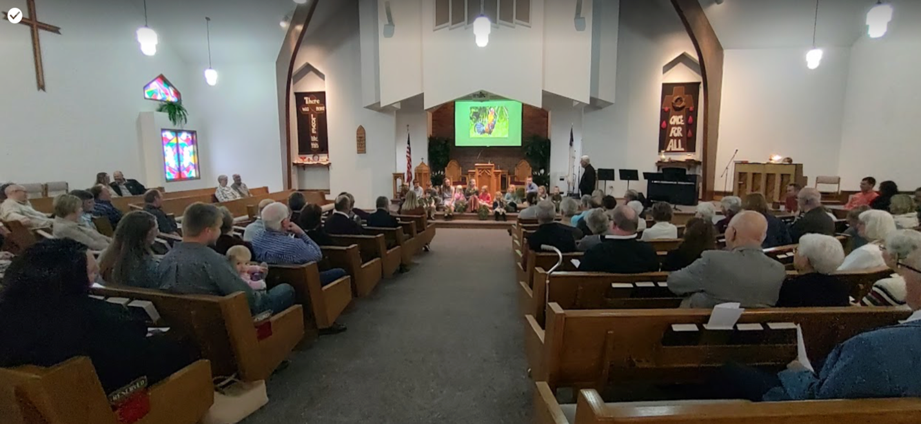
Educational Programs
Family Night Ministries: We are guided by what we read in God’s Word, and our core values motivate us to proclaim the Gospel of Jesus in our community. The Leota area youth program reaches 35 children from our congregation and community. We offer children Christian fellowship & learning for K-3rd grade, a 4th-5th grade class, and a 6-8th grade class tackles the issues facing preteens. An adult Bible study also takes place during class time for the parents of children attending and any others present. A meal is provided before the youth break into their groups.
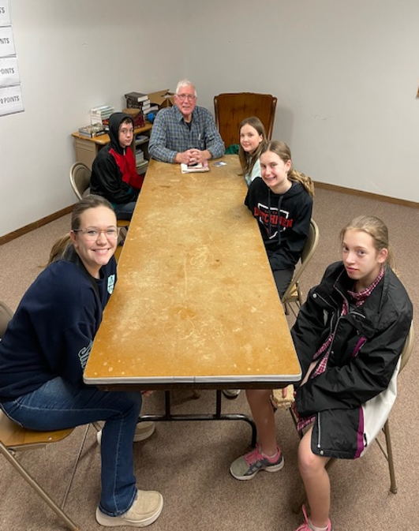
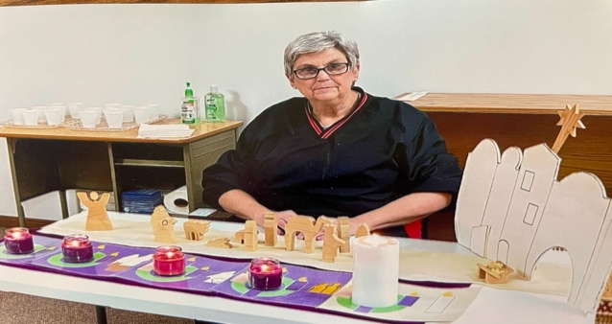

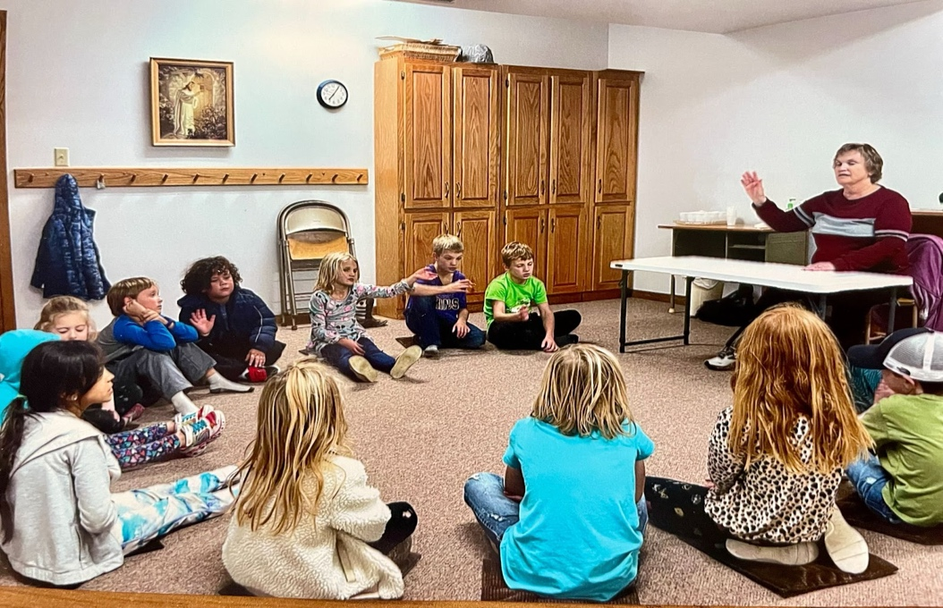

.
GEMS (Girls Everywhere Meeting the Savior) is an active group of 20 from our congregation and community. Each girl has an adult prayer partner supporting her in the mission, ministry and Bible study program. The girls meet every other Wednesday evenings.

.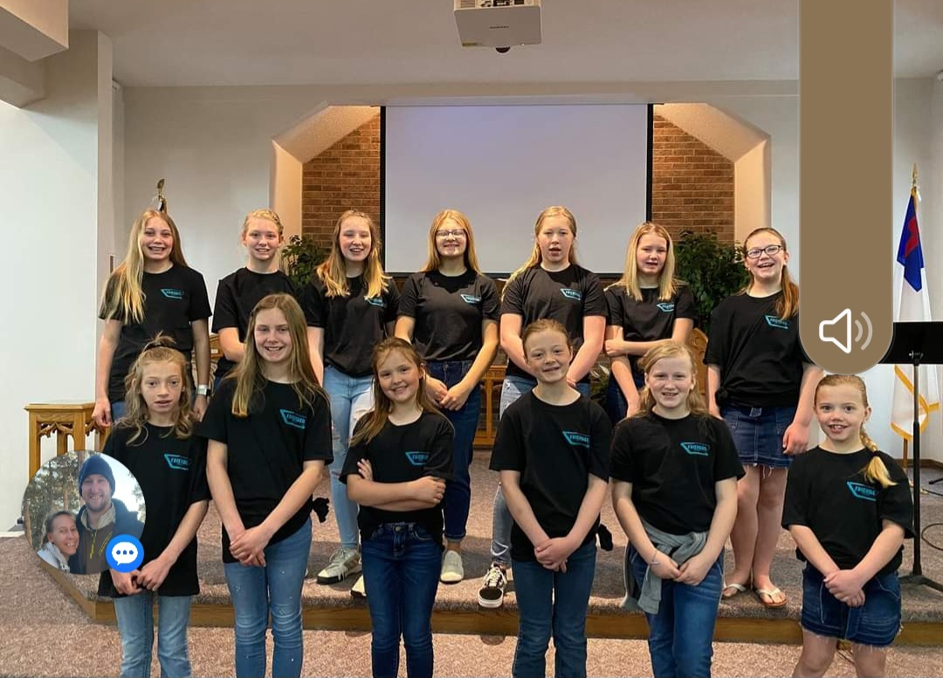
Service Opportunities, Cooperative Ministries,
Community Involvement and Outreach

With hearts filled with gratitude for the unfathomable grace shown to us by God, our members seek out and create opportunities to express the love He has shown to them to others. We regularly organize around opportunities to give back to God by serving our community. We come together in times of need, for example, helping people in our community providing rides to cancer treatments, funds for relatives’ funerals, clothing and furniture for a family who experienced a house fire, fundraising help for medical treatments and meals for families that are hurting. Our congregation provides an outreach program to reach the children of our community as well as their family members. A community meal is served each week, followed by Bible studies and activities.

Serving those outside the community, some church members make homemade pies at Thanksgiving for the Union Gospel Mission in Sioux Falls, collect food and nonperishables for the local food shelf, prepare and serve a meal at the Banquet in Sioux Falls. Christ’s love is also shown by gathering winter clothing and school supplies for children in need at area schools, or preparing Christmas shoe boxes for Samaritan’s Purse.

Some church members travel to and financially support the Justice for All ministry in Juarez, Mexico. Volunteers also work at the Bible League International Thrift Store in Worthington, MN. Some give to VIM (Volunteers in Mercy), a regional diaconal group, or to ATLAS, another ministry whose goals are to mento and serve the needy in our communities. Others serve the Gideon, raising money for Bibles, along with supporting several missionaries and missions.

Some members serve inside the church by staffing the nursery, serving and providing refreshments after church or meals at church events. Some provide musical leadership at worship and others teach children.

Leota Community Church also financially and prayerfully supports the local schools: Southwest Christian School (pre-K thru 12) and the Public Schools. Our students participate in our services with reports on service trips and providing special musical number.

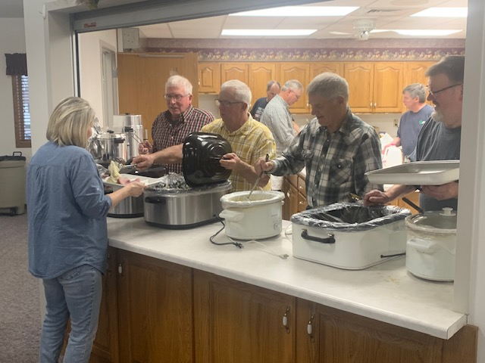
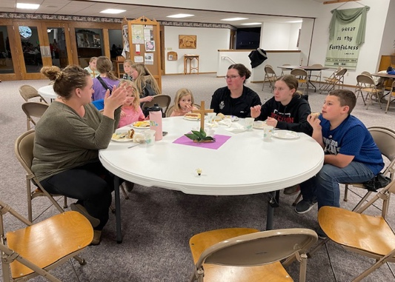
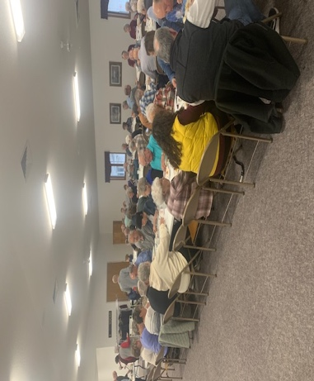
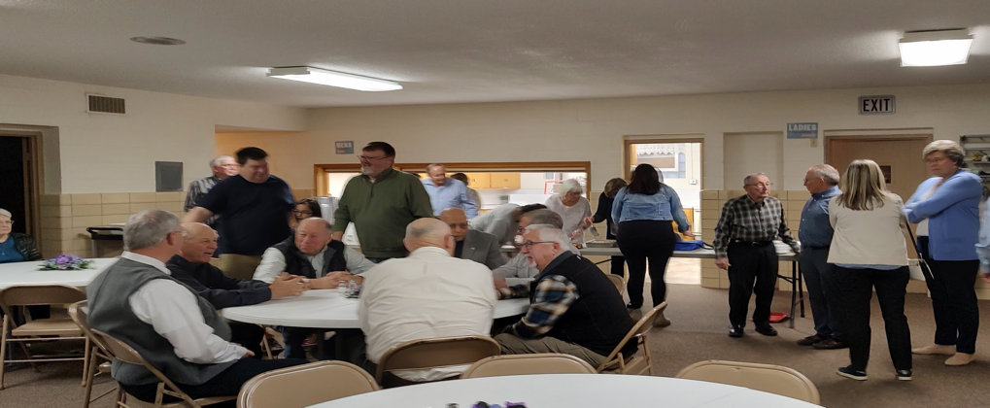
Each member is encouraged to follow Jesus’ example of serving others, to find opportunities to serve inside and outside the church, locally and globally.

Ministry Facilities

Leota Community Church uses the facilities of both churches:

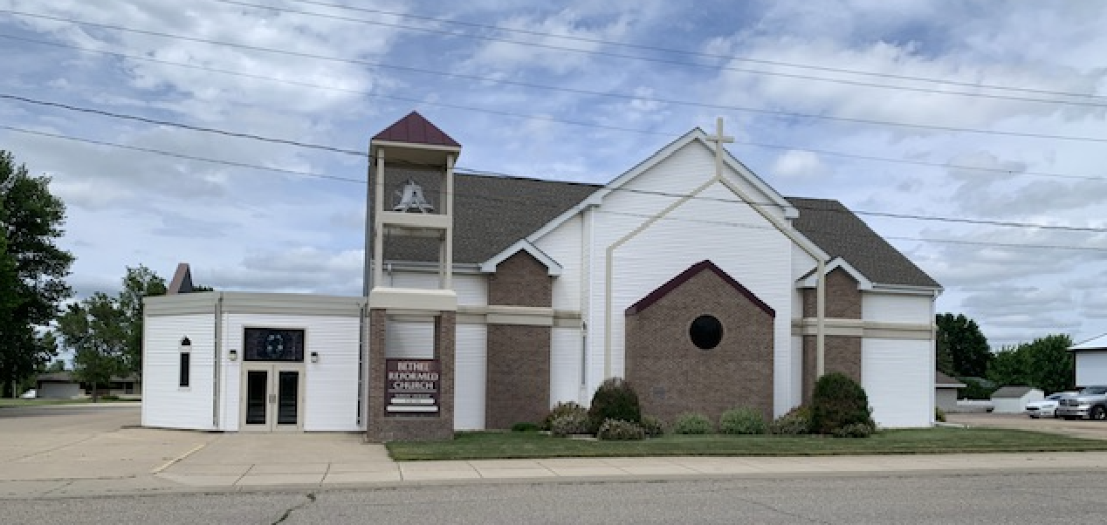
Bethel Reformed Church: The church itself is made up of a beautiful new sanctuary (1997) with pews in a semicircle around a raised pulpit area. Many have commented on the warmth and coziness this arrangement provides. Our sanctuary is carpeted, the pews padded, and includes a pipe organ, a digital piano, an acoustic piano, a choir area to the side of the front, and an excellent sound board complete with a computer and an HD projector.

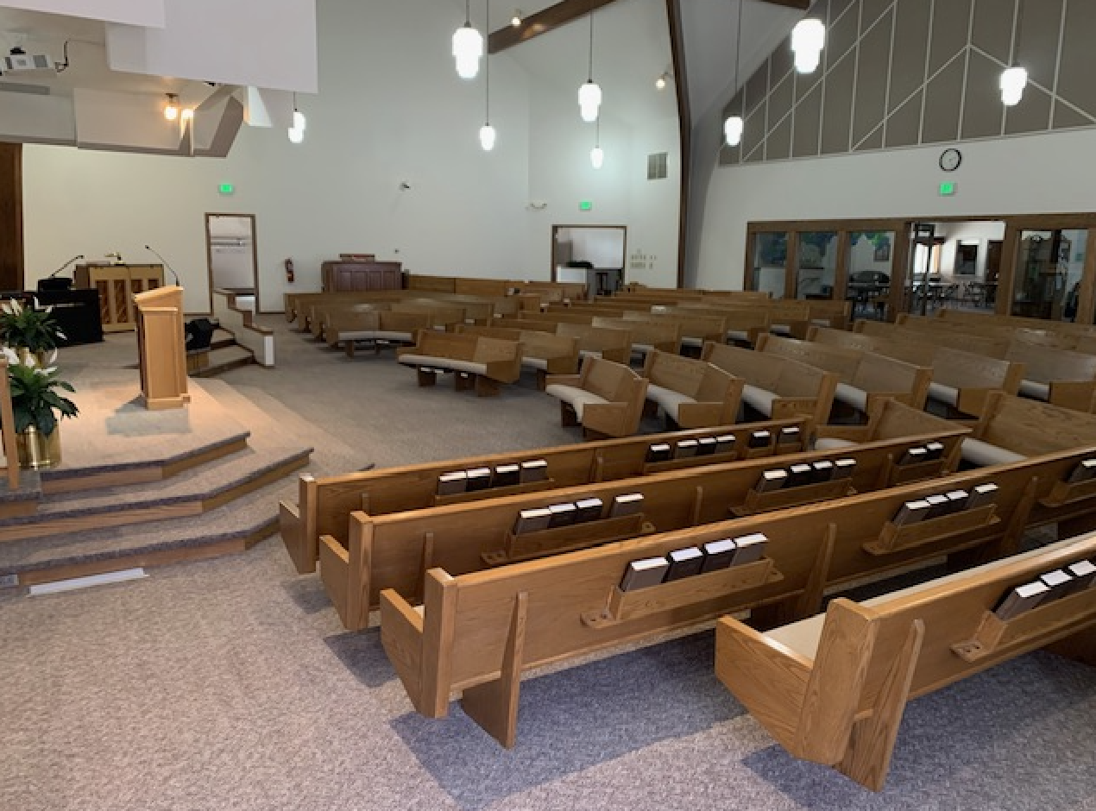
The sanctuary is attached to the fellowship hall where we enjoy fellowship on Sundays, conduct family services before funerals, serve lunch after funerals, entertain baby and bridal showers, set up for the donation auction, and celebrate weddings. The fellowship hall is complete with a fully-supplied kitchen and restrooms.

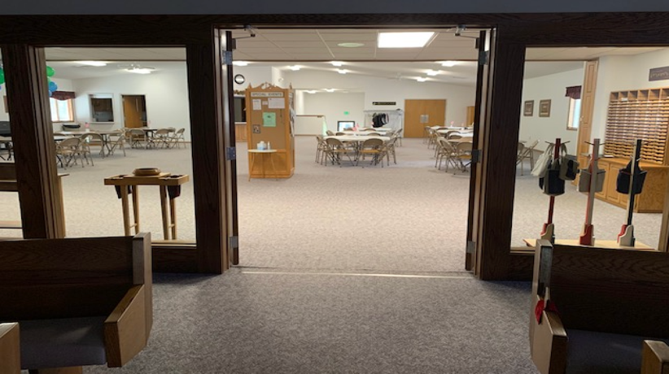
The basement of the church and fellowship hall contains seven Sunday school rooms, a two-room nursery, an office, restrooms and a consistory meeting room.

Ebenezer Christian Reformed Church:
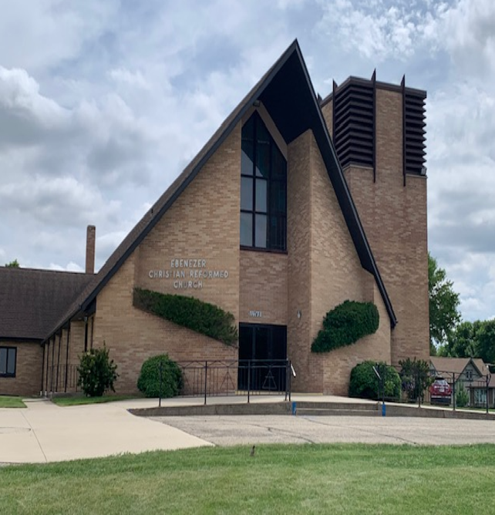
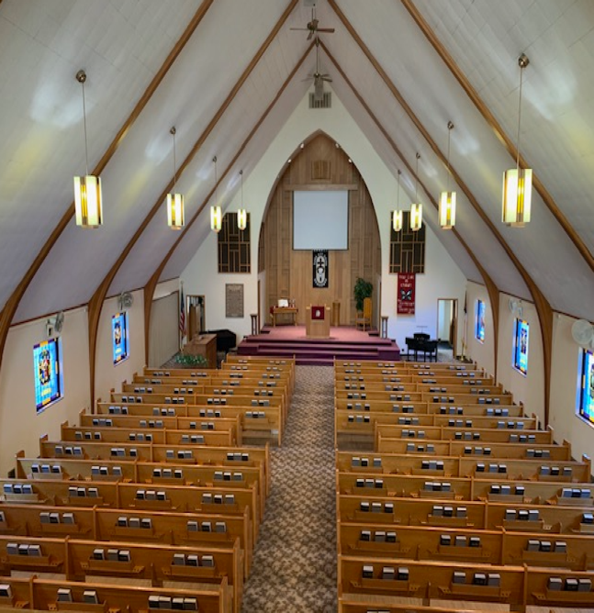

The church is made up of a spacious sanctuary with pews in traditional rows and a raised pulpit area at the front of the sanctuary with side access from the council meeting room and to the basement stairs. The sanctuary also includes a balcony for addition seating. The sanctuary has tiled floor with carpet up the aisles and on the entire pulpit areas, padded pews, and includes an electric organ, a baby grand piano, a digital piano. A sound booth area and computer that operates the projector are located at the back of the sanctuary.

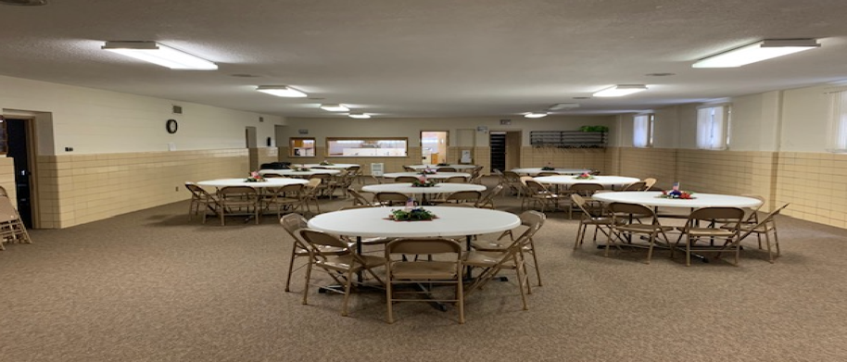
The basement is equipped with a fellowship hall connected to a fully-supplied kitchen at the one end and a raised stage area at the other. The fellowship hall is used for many purposes and can be accessed by elevator for those unable to use the stairs. The nursery and a large classroom that can be divided into two rooms are also just off the fellowship area, which is carpeted. Another classroom is located further down the hall and restrooms are at the bottom of the stairs. The council room is on the main floor. This room also functions as an office for copying, etc.

Parsonage: The pastor and family will be using Ebenezer’s parsonage to live in. It is a ranch-style house conveniently located near the church, sharing the church’s parking lot to access its double attached garage. The main floor consists of the pastor’s study, a large formal dining room, kitchen, three bedrooms, two and a half bathrooms. The basement consists of two large multi-purpose rooms, a bathroom, a workshop and a kitchenette area. Appliances are included. The parsonage was renovated in 2023.

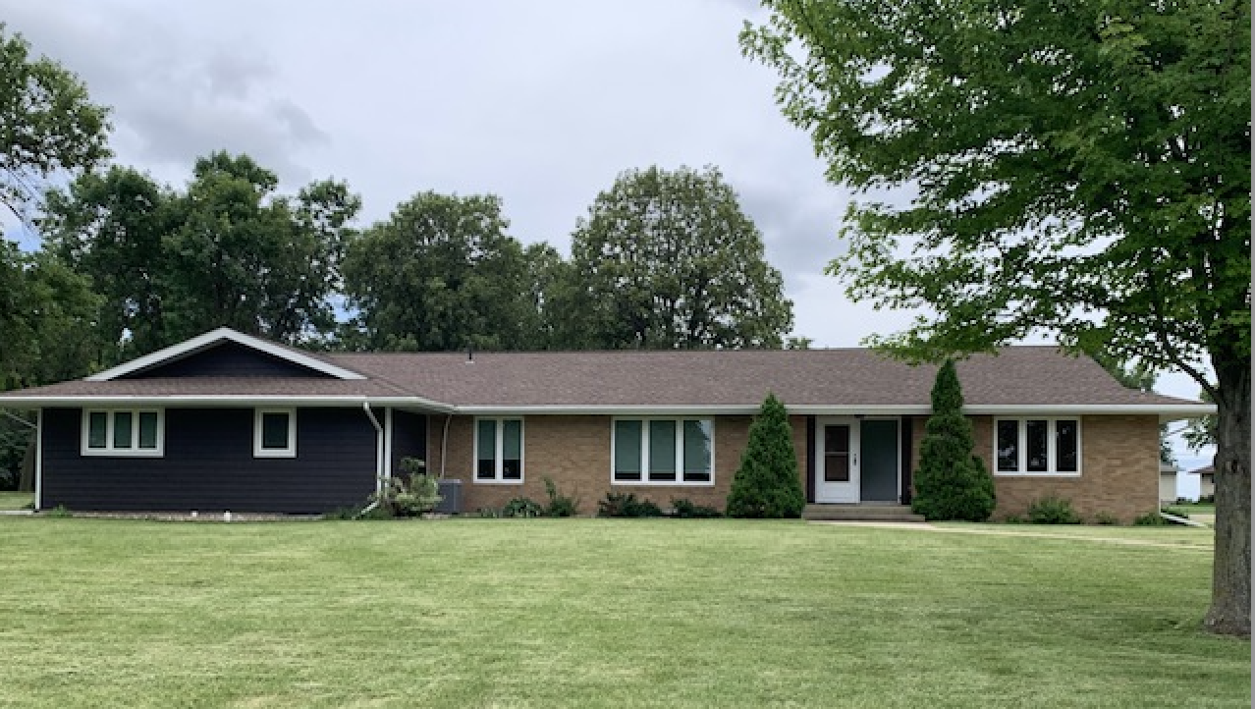

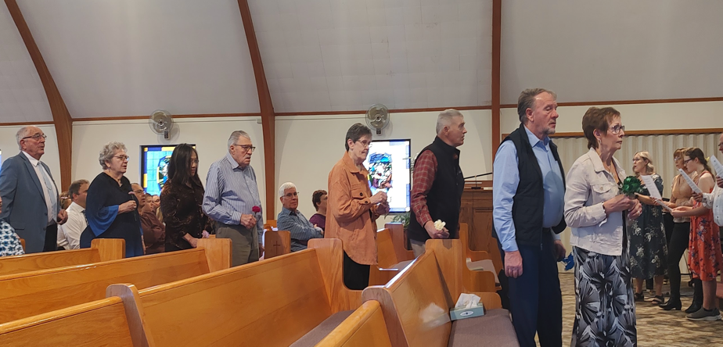
Easter Service (placing flowers on the cross)
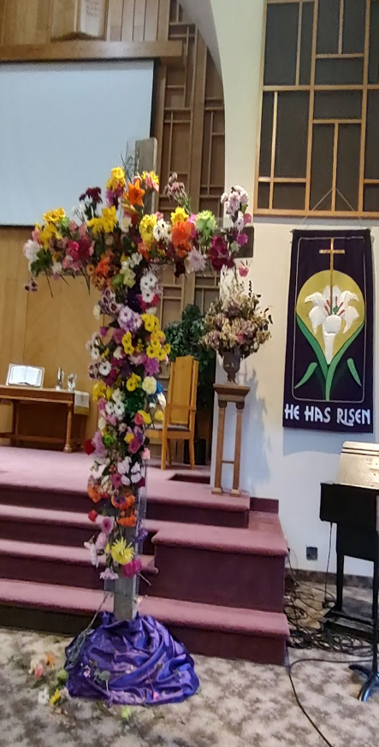

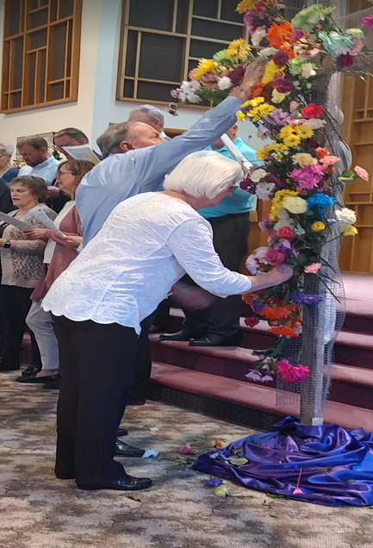

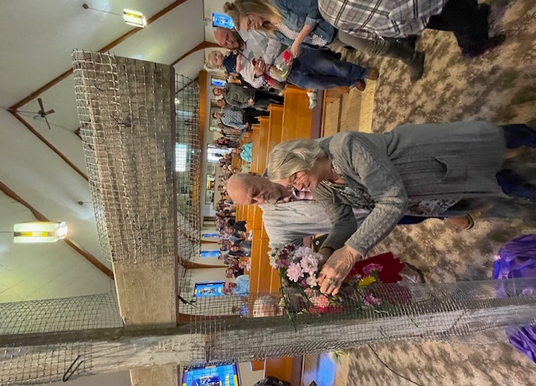

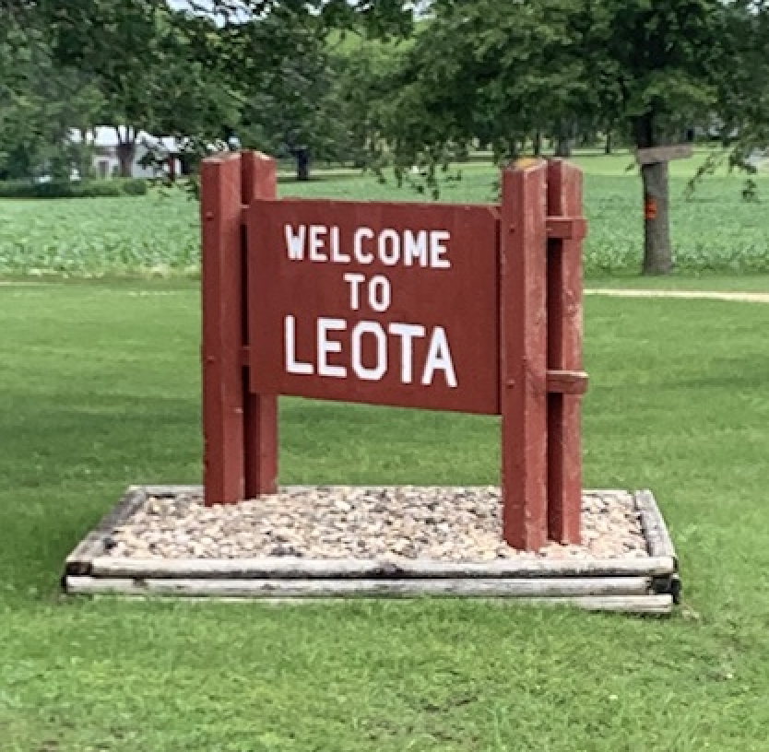
Community

Leota is a diverse community with people from various backgrounds.
Leota Community Church is located in a rural community with 230 residents in close proximity to the vibrant business community of Edgerton where both the public and private Christian school systems are located.
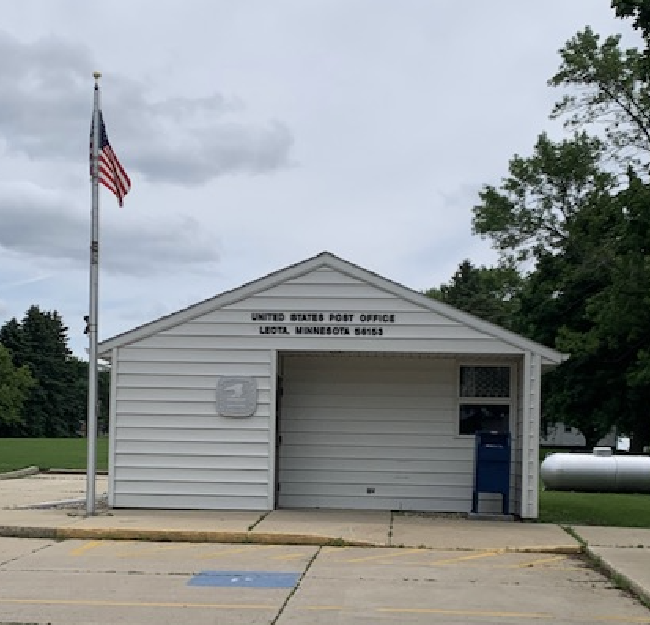
Today Leota boasts a busy grocery store, locker, bank, post office along with agricultural based businesses. A well-kept park and campground, maintained by staff and volunteers from the community, is enjoyed by many.
