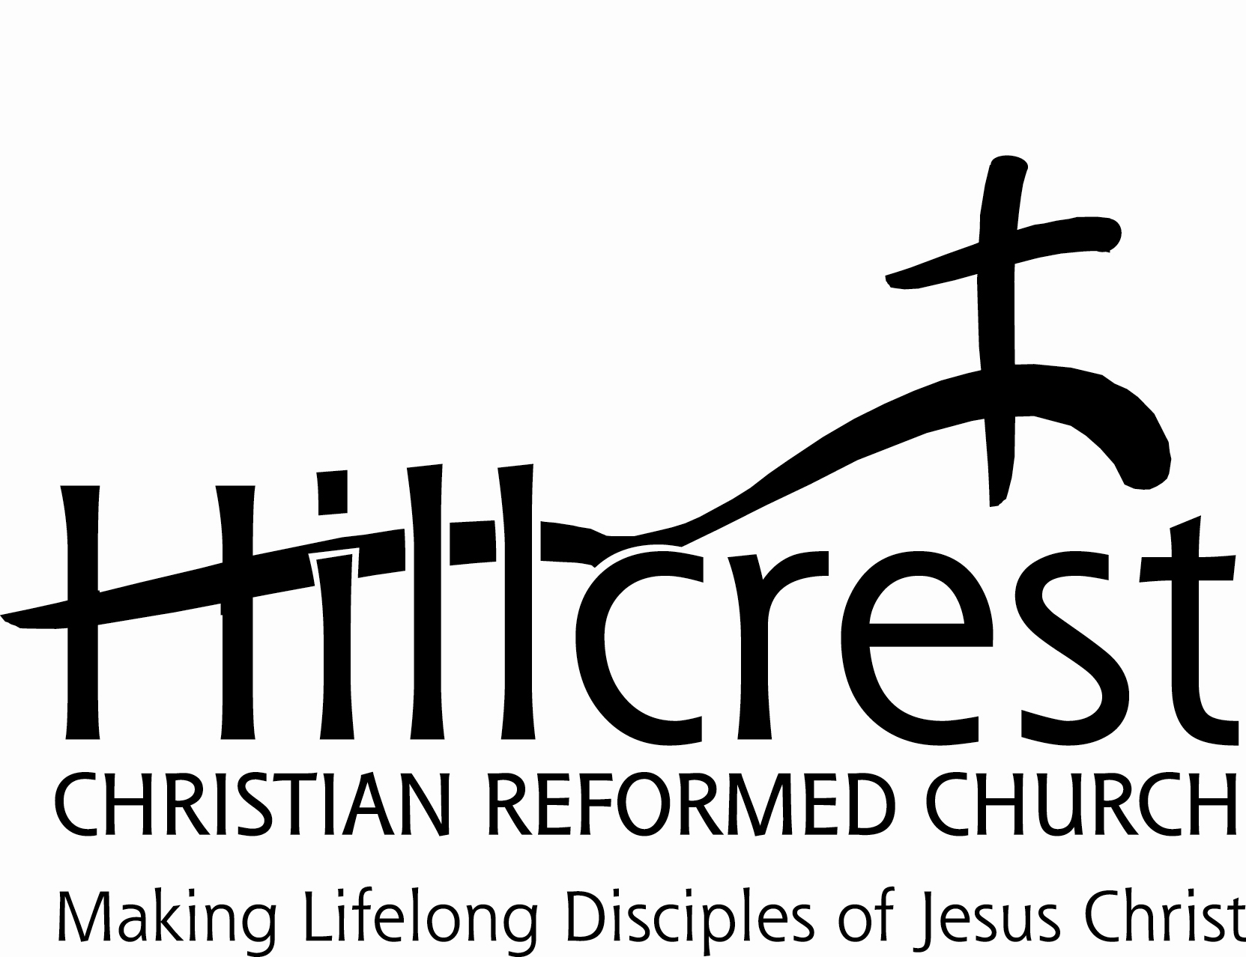
Position Description: Director of Worship and Music

June 2022

Description
The Director of Worship and Music is responsible under the direction of the Lead Pastor for planning and helping to lead the worship services of Hillcrest CRC with a particular focus on the musical aspects of worship.

Qualifications

- Gives evidence of a sincere commitment to Christ and a dedication to the advancement of the Kingdom of God.
- Is committed to the Reformed faith.
- Is committed to the Mission, Vision and Values of Hillcrest CRC.
- Is a skilled musician and is able to organize and coordinate the participation of other musicians and participants for the worship services of Hillcrest CRC.
- Strong oral and written communication skills.
- Demonstrated ability to recruit, build, train, collaborate with, and lead strong worship teams.
- Must be able to work in a "team" atmosphere.
- Is or will become a member of Hillcrest CRC.
- A Bachelor’s Degree (or higher) in an applicable area of study is preferred.

Responsibilities

1. Leads planning for all aspects of Sunday and special worship services in association with the pastors and the Worship Planning Team; and oversees the master worship planning schedule.
2. Serves as primary accompanist for worship services; and is responsible to secure accompanists when not personally scheduled.
3. Creates and prepares vibrant worship services that glorify God; and promotes a blended and intergenerational style of worship that will regularly include organ, piano, other appropriate instruments, worship singers and other participants.
4. Coordinates the weekly details of Sunday and special worship services.
5. Encourage church members' use of their gifts in every aspect of the worship service.
6. Uses rehearsal time to effectively prepare for worship services.
7. Assists with the preparation, oversight, training and schedule of the technological needs for worship services.
8. Responsible for organizing and directing any seasonal choirs and/or instrument ensembles, as needed.
9. Serves as the chairperson of the Worship Planning Team, and facilitates the planning meetings.
10. Responsible to secure guest pastors/pulpit supply when needed.
11. Works with the office staff to prepare the weekly worship folders.
12. Ensures all musicians and other participants are adequately prepared each week for their part in the worship services.
13. Works with the Director of Children’s Ministries to ensure that children are a part of the worship experience.
14. Arranges for maintenance and care of the musical instruments.
15. Performs any other duties as assigned by supervisor.

Reporting

The Director of Worship and Music reports to the Lead Pastor.

This position will be filled via recommendation from the Lead Pastor, Staff Administrator, and Human Resources Team, with an endorsement by the Elders, and final approval from the Ministry Council.

Compensation

Compensation will be hourly, with additional allowances for certain approved expenses and professional development. This position is 20-25 hours per week. The position does not include benefits such as vacation pay, holiday pay, sick pay, pension or health insurance, except disability and life insurance which is provided by Hillcrest CRC.

Job Description Review
This job description is current as of , and I commit to performing all tasks listed to the best of my ability. I understand that if I fail to meet the expectations of the Hillcrest CRC leadership, my supervisor or HR may bring it to my attention for improvement.

Signature: Date:

