CHURCH PROFILE

Church Information:
Name: First Christian Reformed Church of Montreal
Location of church (City, State/Province): Dollard-des-Ormeaux, QC
Classical Committee Contact: Piet Heerema

Search Committee Contact:
Name: Michelle De Pooter Francis
Home/Cell/Work: 514-839-8253
Email: michilie@hotmail.com

Community Setting:
Location: Metropolitan, Suburban
Function: Bedroom Community
Growth: Growing & Declining

Approximate population of community: 1,000,000

Church Profile

We are open to: Male & Female pastors
List all staff positions: none
Position available: Pastor
Date of vacancy: current

General Position description: Preach the word Sunday mornings based on sound Biblical and Reformed doctrine. Provide worship leadership to the worship committee. Attend council meetings (as required). Provide premarital counseling and officiate at weddings, funerals, etc. of church members. Train leaders (evangelistic ethical, discipleship) and encourage leaders of church programs (youth, adult education, community supper, GEMs, Cadets, etc.) Work alongside the deacons to provide/enable congregational care (ex. home and hospital visits, training and encouraging members to care for each other. Be aware/involved in other community agencies and programs as appropriate and in keeping with the congregation's vision and mission. Participate in, and cooperate with associations, regional and nation programs, events and activities (classis, synod, etc.)

Position: Full-time
Bi-vocational: No
Number of years preferred of ministry experience of potential candidate: minimum 3 years
Required languages: English. Knowledge of French is an important asset.

Church Demographics:

Average Sunday attendance: 40 incl. children
Active adult professing members: 43 (31 active non-professing members)

Profile of church members:

Age: | % | Count (# of persons)
0-11 | 13.5 | 10
12-18 | 13.5 | 10
19-24 | 4 | 3
25-34 | 0 | 0
35-49 | 15 | 11
50-64 | 23 | 17
65+ | 31 | 23
Total | 100 | 74

Occupation: | % | Count (# of persons)
Business | 7 | 5
Professional | 23 | 17
Trades | 1 | 1
Agricultural | 1 | 1
Retired | 35 | 26
Student | 29 | 21
Stay-at-home parent | 0 | 0
Other | 4 | 3
Total | 100 | 74

Percentage of members belonging to the congregation: | % | Count  (# of persons)
Less than 5 years | 11 | 8
5-10 years | 15 | 11
10 or more years | 74 | 55
Total | 100 | 74

Racial/Ethnic composition of congregation and surrounding community:
- Congregation (Multi-cultural): French-Cdn, English-Cdn, European, visible minorities
- Community: South Asian, black, Arab, French-Cdn. and English-Cdn.

Composition of congregation: multi-cultural

List the last 3 persons in this position:
- Jacob Boer
- Frank Guter
- Bill Kuurstra

Worship:

How are members involved in planning and participation in the liturgy/worship?
A 6-member Worship Committee plans the year's liturgy (Lent, Easter, Advent, etc.) and committee members alternately prepare the weekly order of worship. We try to encourage our youth and others of our church body to be involved in music, readings, giving updates on church ministries, etc.

Describe the worship services in your church:
The service's structure involves liturgy, prayer, congregational singing (a mixture of traditional and contemporary music) as well as the sermon, and a time for the children's message and singing. The praise team joins the pianist once a month, and their participation is well-appreciated. Some of our youth are involved as well in the praise team. A deacon presents the weekly distribution of the offering and describes the various CRC ministries that benefit. Nursery attendants care for the children under the age of 3. We are blessed by classis pulpit supply and Michelle De Pooter Francis, chaplain at the Mtl. Seafarer's Centre preaches on a frequent basis.

Describe the discipleship practices in your church for all ages of members and attendants:
- Children and youth: Cadets, GEMs, Sunday school, Catechism
- Adults: Sporadic Bible and book study groups, a Discipleship class was given a few years ago, regular Sunday morning sermons, Adult education time (pre-service)

Building/Financial:

- Present annual budget: $126,367
- Last year’s annual budget: $139,504
- Percentage of financial obligations met (last complete year reported)
- Budget: (2016) 74% total income vs budget (99% of total income vs actual)
- Denominational Ministry Shares: 75%
- Classical Ministry Shares: 95%
- Amount contributed above budget and ministry shares: $13,299

Facilities:

Describe facilities:
- Are your buildings adequate for your ministries? Yes
- Is a building program projected? No
- Does the church own a parsonage? Yes
- Location of office or study: Historically in the parsonage, previously in the church

Compensation:

- The salary range we are prepared to offer our new pastor is based on the CRC Minister Compensation Survey for our area: Yes
- The average annual increase for this position over the past 3 years is: 2.4%
- Housing: Parsonage only

Benefits and expenses:
- Pension
- Medical Insurance
- Life insurance
- Social Security or Canada Pension
- Travel/Mileage
- Continuing Education funds
- Continuing Education time allotted
- Sabbatical policy in place
- Annual vacation (4 weeks)

Church Characteristics

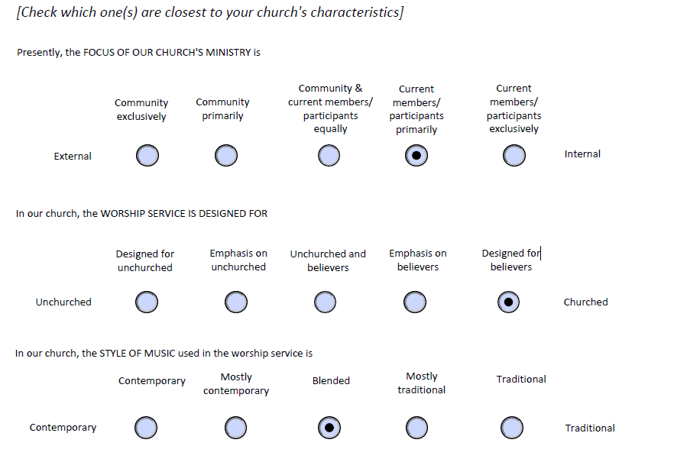
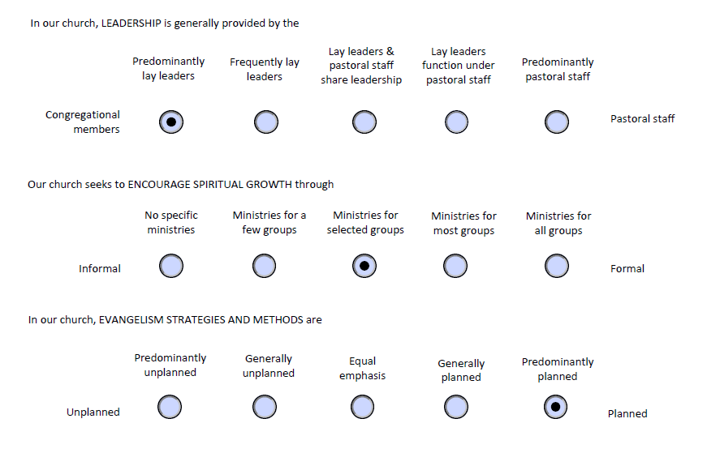

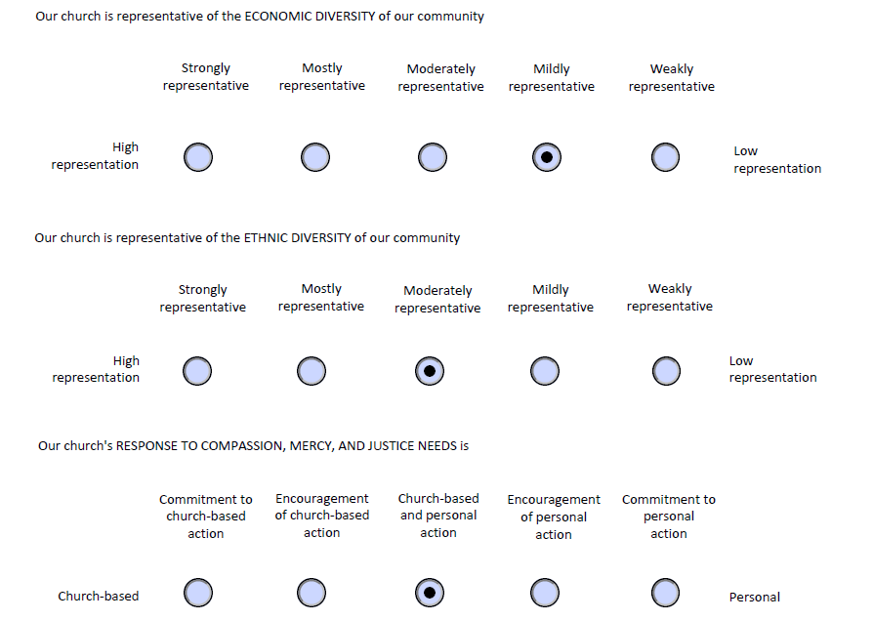

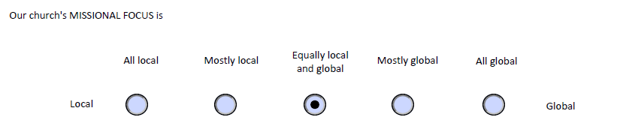
Narrative

Do you have a recently articulated mission/vision for ministry? No

In what ways does your church participate in ecumenical activities?
- West Island Mission: Aid with providing and distributing food and clothing locally
- Mission Montreal: Financial and prayer support for this organization as well as volunteering
- Ecumenical Unity services with local churches, Good Friday prayer walk
- Involvement with the Ministry to Seafarers
- Financial support to Emmanuel Christian School as well as a church trust fund to aid church members with tuition costs
- Monthly Community Supper - provides a home-cooked meal and hospitality, devotional, to the community

Reflect on your strengths/gifts as a church:
The church has a good connection with its youth by offering GEMs, Cadets, Sunday school, and a youth group with dynamic leadership. The adults show interest in and try to include the youth and children. People are willing to step up to help when help is needed. The people in the church notice newcomers and make them feel welcome.

Reflect on your passions as a church:
- To continue our calling in being a Reformed Christian influence in all areas of our lives.
- To faithfully teach and be Godly examples to our children, and to lead and guide them along the right paths to ensure that they are equipped to continue on this path into future generations.
- To be welcoming to newcomers and attentive to include and involve them in the body of Christ.
- A passion for music and singing.

List specific problems with which your congregation struggles:
- Service: Those who are involved in active service - i.e. Elders, Deacons, Cadet and GEM leadership, Sunday School teachers, committee members - often service in two or three of these roles simultaneously and the church is aware of the fatigue of multi-tasking.
- Being geographically distanced from other CRC churches, and the resulting limited - if any - contact with them for fellowship and support. Fellowship among members is reduced because the congregation is very geographically dispersed.

What has been the most interesting and challenging event in the life of your church in the last 3 years?
Maintaining and sustaining the congregation for the past 2 years in the absence of a pastor.

List the major goals that this congregation has set for itself or opportunities the congregation anticipates:
- Become an active component of the community in which we find ourselves.
- Become effective Disciples of Christ.
- Build future leaders.

Describe what being Christians of Reformed accent mean to you:
It's being a Christian with a stronger assurance for the future. The knowledge that God will never let me go. The strength of knowing that God's in charge, sovereign, but that I have a role to play in this plan, or predestination even though with or without us, God will work things through. We belong to God.

Describe your understanding of the relationship between the local church and the Christian Reformed denomination:
First CRC Montreal - we are the denomination's presence and representation in Québec. There is a relationship of giving and receiving. We are given the support of a church visitor and a church counselor, also people like Sheila Murphy.

Identify some of the cultural challenges facing Christians and Christian churches today:
- Demonstrating the need for God in a society where the individual has become the centre of everything
- Reinforcing the seriousness of sin and the need for salvation in a society where truth is based on feelings (i.e. do what feels good for you as long as is doesn’t stop me from doing what feels good for me)

What have been the 3 most important events in the history of your church?
- A historical visit from Queen Julianna of Holland.
- 50th anniversary celebration.
- Implementing a Community Supper program

Leadership:

How many council members does your church have? 8
What is the length of term for council members? 3 years
How often does the full council meet? Once a quarter
What subgroups of council exist, how do they function and how often do they meet?
- Pastoral elders: meet 6 times a year
- Administrative elders: meet 6 times a year
- Executive committee: monthly
- Deacons: once a quarter

