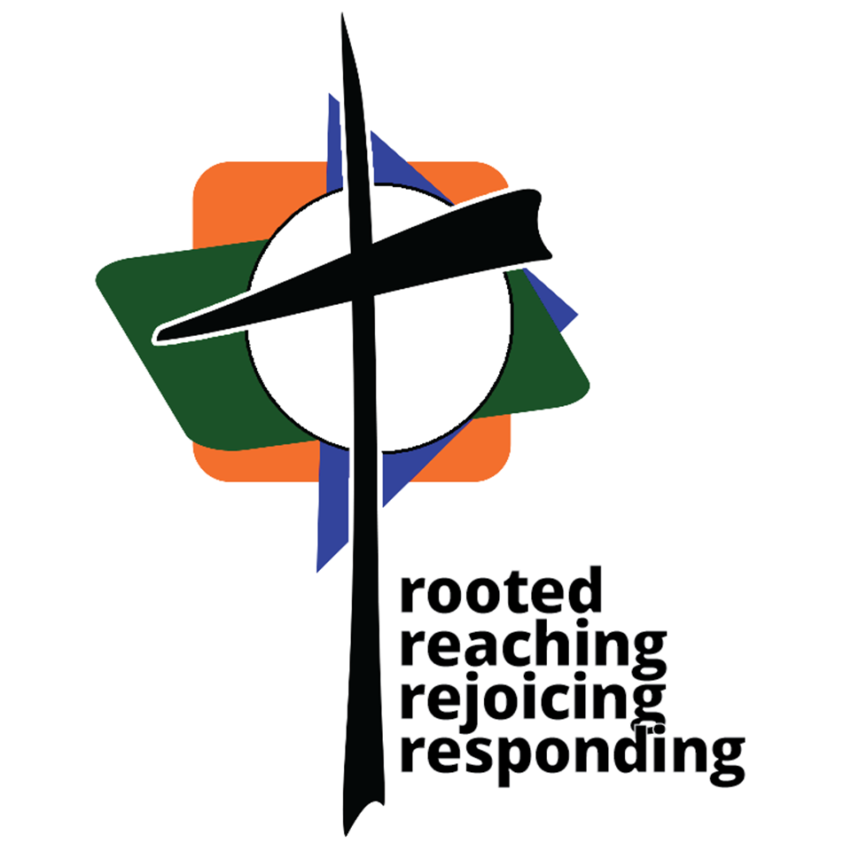
Friendship Christian Reformed Church (FCRC)

Position Description

PASTOR OF CONGREGATIONAL CARE AND OUTREACH

Oversight and direction:
- Reports to the Ministry Council Pastor Development Team.
- Is accountable to Ministry Council in doctrine, life and duties.
- Council supervision will include love, counsel, encouragement and assistance in the work of the Lord.

Works closely and in mutual accountability with:
- The Lead Pastor of Worship and Discipleship, Youth Pastor, and Director of Administration.

Provides Supervision, Development and Evaluation for:
- Pastoral Care (crisis and visitation), Mission/Outreach, and Fellowship Ministries.
- Kids Hope Coordinator.

Classification:
- Ordained, Full Time, Salaried, Exempt.

Hours of Work:
- Scheduled work hours as needed to fulfill needs of the ministry.
- Hours worked should average about 45 hours per week over a calendar year.

General Responsibilities:
- Utilize gifts of pastoral care, relationships and teaching to provide congregational care and outreach, develop the congregation as a healing community and facilitate missional opportunities.
- Promote a vision for both personal and church evangelism, growth and development.
- Serve as a role model in witnessing to Jesus Christ, leading the congregation in global (local, regional and international) outreach.
- Share secondary responsibility for preaching and planning/coordinating worship services under the leadership of the Pastor of Worship and Discipleship.
- Preach the Word, administer sacraments, and faithfully shepherd the congregation in love.
- Pray regularly for Friendship Christian Reformed Church, its leaders, staff, congregation members and community.
- Ensure teaching and ministries are implemented consistent with the Reformed Faith of the Christian Reformed Church.

Specific Responsibilities:

- Primary Responsibility: Pastoral/Congregational Care
- Minister to pastoral needs that require home, hospital, hospice or other care facility visitation.
- Provide spiritual care counseling as the need arises, referring to professionals as appropriate.
- Minister to grief situations, including leading funeral services.
- Inform, train and assist pastoral elders and deacons in evaluating and responding to congregational and community care needs.
- Provide opportunities and train lay-members in support care ministries such as leading or co-facilitating care and support groups related to grief, addictions, financial, relationships, etc.
- Contact and counsel those planning to be married, recently married or experiencing marital challenges.
- Provide leadership in development of vibrant Church Small Group, People Care and Fellowship Ministries, promoting and equipping use of spiritual gifts by church leaders and members.

- Primary Responsibility: Evangelism/Outreach Leadership
- Work in cooperation with other Pastors to challenge the congregation in evangelism and outreach through visionary teaching, training and equipping members for ministry involvement.
- Pray for, meet regularly with, and guide the various care and outreach ministries of the church.
- With other Pastors, provide classes and meet individually to prepare youth and adult believers for Profession of Faith, teach Catechism and offer other faith education opportunities.
- Lead the assimilation and enfolding of new believers into congregational life.
- Support the Youth Pastor in periodically sharing the Word of God at scheduled FYSH and 1-Way Youth meetings and integrating youth in pastoral care and outreach opportunities.

- Secondary Responsibility: Worship Leadership Support
In conjunction with the Pastor of Worship and Discipleship:
- Apply strong biblical principles through preaching the Word to life in today’s realities (scheduled for 20-25% of FCRC services per year).
- Administer sacraments in coordination with the Pastor of Worship and Discipleship as needed.
- Encourage and challenge the congregation regarding stewardship of time, talent and treasure.

- Shared Responsibilities with Church Pastors and Staff
- Schedule and lead the Mission and Faith Nurture Ministries, communicating and implementing impactful church outreach and fellowship programs.
- Provide a written ministry update and actively participate in monthly Ministry Council and Elders meetings.
- Actively participate in regular scheduled meetings of the Church Leadership Team, giving oversight and direction for church vision, ministry and financial planning, evaluating trends in congregational and community life, and discerning needs and opportunities for greater impact.
- Provide support in assuring annual evaluations of FCRC church staff, programs and ministries.
- Support preparation and editing of church publications.
- Represent Friendship CRC to the wider church and community, including Classis and Denominational meetings.

Qualifications and Requirements

- Personal Qualifications:
- A committed Christian with a close personal relationship with Jesus Christ, being in the Word
and praying daily.
- Displays love, faith, humility, and obedience in Christian discipleship.
- Committed to continuous learning, as well as personal and professional growth and development.
- Self-directed, detail oriented, well organized and able to multi-task.
- Agrees with and upholds doctrines of the Reformed faith, exhibiting qualities of an
Elder as stated in 1 Timothy 3, Titus 1 and the Form for the Ordination of Ministers in the Christian Reformed Church.
- Gifted in building relationships and fostering healthy relationships among a diversity of people.
- Demonstrates a personal lifestyle which serves as a model for the congregation, balancing commitments to church, self and family.
- Acknowledges with love the Body of Christ and submits to its authority.
- Becomes a professing member of FCRC within six (6) months of hire, if not already a member.

B. Professional Qualifications:
- Passion for communicating God’s Word through preaching and teaching.
- Excellent verbal and written communication and interpersonal relationship skills.
- Strong Pastoral Care skills, especially in the art of listening and providing spiritual counsel.
- Able to work effectively and cooperatively in a staff and leadership team environment.
- Ordained Pastor of the Word in accord with requirements of the Christian Reformed denomination. An MDIV degree is preferred.
- Prior proven experience within a congregation or setting similar to that of FCRC.
- Expressed agreement and support for FCRC’s stated vision, mission and goals.
- Uncompromising confidentiality to protect member and church information.
- Proficient with administrative computer software, including MS Office: Word, Publisher and Excel.

Responsibilities and qualifications delineated in this position description will be reviewed and modified annually, or more often at the discretion of the Ministry Council, to assure it is both an accurate reflection of the staff member and best meets the changing goals, plans and needs of the church.

Modifications in this position description are subject to approval by the FCRC Ministry Council.

