Getting to
Know You…
English Language Materials for Building Relationships

Paid for by an Ignite Grant
through Trinity Christian Reformed Church
Materials created by Laura Koning and Marcie Pyper
© 2018
For questions or suggestions about these materials,
please contact Laura Koning laurakoning4@gmail.com

Unit themes
Unit 1 Who lives with you? 7
Unit 2 Where is your home? 15
Unit 3 What do you do every day? 25
Unit 4 What food do you eat? 40
Unit 5 What do you wear? 52
Unit 6 How do you thrive at work or school? 62
Unit 7 What do you do for fun? 74
Unit 8 What makes your house a home? 83

Introduction to Getting to Know You
Each Getting to Know You unit is broad enough to extend about four to six weeks. Lesson activities do not have to be used in the order given, but they generally progress from less difficult to more difficult. Some lesson suggestions may require bringing some pictures along with you to class or perhaps making copies of a worksheet, so it will be helpful to read the lesson before you arrive to teach.

Importance of building relationships

Remember that at that time you were separate from Christ, excluded from citizenship in Israel and foreigners to the covenants of the promise, without hope and without God in the world. But now in Christ Jesus you who once were far away have been brought near by the blood of Christ. For he himself is our peace, who has made the two groups one and has destroyed the barrier, the dividing wall of hostility, by setting aside in his flesh the law with its commands and regulations. His purpose was to create in himself one new humanity out of the two, thus making peace, and in one body to reconcile both of them to God through the cross, by which he put to death their hostility.
Ephesians 2:12-16 (NIV)
These English language materials are intended to foster friendships between the language helper and English learners (ELs) in outreach contexts.
Each of the units begins with a quote from David I. Smith’s book Learning from the Stranger to encourage reflection on the Biblical mandate to be a neighbor to those we live among and those who come to live among us from other countries. The book is published by Eerdmans © 2009 (www.eerdmans.com). The quotes are used with permission of the publisher.
It can work well to begin each session with a whole group (mixed levels) “icebreaker” game, such as Uno, Sorry, Candyland, Skip-Bo, Ping Pong, Twister, Fruit Basket Upset, Simon Says, Memory (Concentration), before breaking up into smaller mentor groups.

Tips for teaching vocabulary
You will find the basic vocabulary for each unit in the vocabulary box on the first page of the unit. Introduce vocabulary one word at a time. As you move to the second word, go back and review the first one before adding a third. Keep re-cycling the vocabulary as you move on to another word. Unless your students are very eager and capable, only teach about 6 words per session and then practice them in a variety of ways so your students can master them before adding new ones. Note: Not all of the vocabulary for the intermediate activities are included in the vocabulary box.
Have your English Learners repeat the words/phrases as you introduce them and then ask your ELs questions at increasing levels of difficulty (as they are able) to practice the words many times. For example, ask yes/no questions about the vocabulary to building listening skills, e.g. Is this ___? Yes, it is./No, it isn’t. Make sure that some of the questions you ask are negative instead of having all answers affirmative so students need to listen carefully. When ELs cannot yet produce the vocabulary on their own, include choice questions like, “Is this a ____ or a ____?” Work up to the ELs answering, “What is this? It’s ___.”
At the end of each unit you will find several pictures to support the vocabulary learning. These images are a sample of what can be used or downloaded from the internet or found in magazines/printed materials for each unit. Use the pictures in a variety of ways when introducing and practicing vocabulary. Due to the size of the pictures provided, they will best be used in smaller groups of four ELs or less.

How important is pronunciation?
It is not necessary to pressure beginning ELs to pronounce all words correctly. Some sounds that we use in English do not exist in other languages, so it can be difficult for ELs from other language backgrounds to hear particular sounds and to produce them. Help your ELs see how you are forming sounds in your mouth if a word is causing difficulty. A general rule for new language learners is, if you can understand what they mean, the pronunciation is close enough. However, as students progress you will want to encourage to keep building pronunciation skills.

What about grammar?
Each unit includes some grammar, or focus phrases, found in the box on the first page of the unit. Generally, you will not need to explain the grammar in detail. If the phrases are taught and used in a meaningful and comprehensible context, your ELs will catch on to the meaning over time. Your ELs will not likely use the grammar correctly; it takes a lot of listening and speaking practice in order to master these aspects of language.

Can-Do Statements for novice and intermediate
Mentors and students can use these assessment statements to determine progress in English learning. Mentors should refer to Novice statements for new/early English learners; Intermediate statements for developing English learners/speakers. Be sure to complete all of the statements over the course of the four to six weeks of study, choosing one or two statements as the focus for each lesson.

Going further
Simple children’s books, EasyReaders, content books, books on hobbies/recreation, or picture books can be a great resource for teaching vocabulary, listening skills, and beginning reading skills. Follow these steps as you introduce and read books with your ELs. This pattern can be used with any of the eight Getting to Know You units.
- Begin by looking at the pictures and talking about what they see. What do the ELs think this book will be about?
- Using the pictures, introduce any key vocabulary that the ELs will need to know in order to comprehend the story.
- Read the story with your ELs (track with your finger to show which direction English text is read), showing them the pictures as you go.
- Ask questions with each page to check comprehension and practice new vocabulary. Include both positive and negative response questions.
- Have the ELs read the book with you as much as they are able. Talk about any words that are difficult to pronounce or any that are not understood.
- Have ELs retell you the story using the pictures as a guide.
- Have ELs write a few sentences to summarize the story and/or write as many details from the story as they can remember. You could use the six-frame story chart for this type of activity.

Terminology used in unit activities
Terminology | Meaning
EL | English Learner
recycle | to incorporate target vocabulary and target grammar from previous lessons into the current unit of material being studied. The idea is repetition of words and phrases in a variety of contexts.
yes/no questions | a language learning tool that develops listening and speaking skills in the learner. Mentor will ask questions that will require a “yes” answer, and a “no” answer. Example: (Q) “Is your birthday in May?” (A) “Yes, my birthday is in May?” (Q) “Is your birthday in June?” (A) “No, my birthday is not in June.” Use this method frequently and in each unit as appropriate.
comparison chart | a tool that helps the mentor and EL get to know each other better and to focus attention on specific vocabulary and phrases. One comparison chart can be used repeatedly over the month of activities by concentrating on a limited amount of the vocabulary/phrases for each lesson; repeat activity next lesson adding more vocabulary/phrases. See chart in unit materials.
six-frame  story chart | a tool for drawing and writing simple stories based on unit vocabulary/phrases. Mentor and EL will draw simple stick figures and objects. Mentor will assist EL in writing 1 or 2 sentences per frame relating to the pictures. Use this activity in a variety of units and/or conversations. See chart in unit materials.
pantomime | an activity that dramatizes some elements of the unit vocabulary. Dramatization or gesturing is an effective language learning tool.

Tool kit
Each mentor should carry a “tool kit” to be used as needed in lesson activities. Your tool kit should include some pencils, pens, colored markers, blank paper, drawing tablet, scissors, old magazines, easy reader book, photos of family, and cell phone for internet images. We are sure you will think of other essentials as you teach each lesson.

Unit 1 Who lives with you?

FOOD FOR THOUGHT
[We have a tendency toward] a common subconscious assumption. It goes like this: God is with me, God works and speaks in my culture (despite its defects), and if I take the risk of venturing into other cultures I bring God with me; I have little expectation that God is saying things to members of the other culture that I need to hear, or that they will teach me obedience or challenge my sin. God speaks my language and likes my ways, and must surely share my discomfort at the strange ways of others. If we assume that there is none of this attitude in us, it may be because we have never ventured far enough from home to be put to the test.
Learning from the Stranger, p.21

TARGET VOCABULARY
husband  wife  mother  father  child/children  son/daughter  sister/brother | uncle  aunt  cousin  nephew  niece  friend  Numbers 0-20 | grandparents  grandfather (grandpa)  grandmother (grandma)  grandchildren  granddaughter  grandson | brother-in-law  sister-in-law  mother-in-law  father-in-law  son-in-law  daughter-in-law

TARGET GRAMMAR
He is my ___.  She is my ___.  Who is ___?  How many ___ do you have? I have ___.  Hello, my name is ___.  What’s your name? | I want to introduce you to my ___.  Nice to meet you. Pleased to meet you. What is your ____’s name?  This is my ___. Is this your___?  Goodbye. See you later/soon.

CAN-DO STATEMENTS FOR NOVICE & INTERMEDIATE
Novice
- I can greet and leave people in a polite way.
- I can introduce myself and my family.
- I can say and write something about the members of my family.
- I can ask about someone’s family.
- I can count from 0-20.
Intermediate
- I can talk and write about family members and their characteristics.
- I can ask questions about someone’s family members and their characteristics.
- I can ask and answer questions about the ages of my family members.
- I can ask questions about someone’s family history.
- I can talk and write about my family history.

LESSON ACTIVITIES: NOVICE

Activity 1
- Draw your family tree to use with your learners. Add members with names one at a time to allow for sufficient practice. Use sticky notes to identify relationships of people in the family tree. Begin slowly with two words (husband/wife or mother/father). Take the sticky notes off and switch them around so they are incorrect. Practice negative sentences, too, for example, “____ is not my father. ____ is not my mother.” Take the sticky notes off and see if the ELs can place them correctly.
- Form oral sentences with the new words, e.g., This is my father. This is my mother. He is my father. She is my mother. Ask the ELs, Is ____ my _____? Make sure some answers are affirmative (Yes, he/she is. or Yes, that’s your ____.) and some are negative (No, he/she’s not. or No, that’s not your ____.). [Use my and your as appropriate to your ELs even though they will not master possessive adjectives at this point.] When the ELs can use the initial words correctly, write a sentence using each of the words and practice reading them. As appropriate, add more target vocabulary and build as you did with the first two words.

Activity 2
- Have your ELs draw their family trees and explain the relationships to you. Ask your ELs lots of questions to practice vocabulary and build listening skills. Add any new vocabulary necessary. Help the ELs write some basic sentences about the relationships.
- Have your ELs ask another EL about their family members using sticky notes and diagrams as appropriate.
- Introduce numbers 0-20. Start with 0-5, then add 6-10; keep reviewing the numbers already introduced as you add more. Write out the numbers for your ELs to see and practice them in order. To connect numbers to family members, ask how many [cousins] your ELs have. If students catch on easily to the numbers, you can also challenge their thinking by asking them to say the numbers backwards or showing a numeral out of order and asking what number it is. You could also try some simple addition to work with 0-20.

Activity 3
- Show a photo of your family and have the ELs ask you questions about the relationships. Who do they think the people are in the photo? Have the ELs describe the relationships. Write some simple sentences about the picture and read them together.
- After practicing the sentences several times, write one of the sentences on a large strip of paper and cut it apart by phrases or words. See if the ELs can put the sentence back together. You may need to model this with one sentence first and then use another for the ELs to try.

Activity 4
Designate someone to be the father, mother, sister, brother in a family using name tags. You may need to model this first with the language helpers. Introduce one member of your “family” to each individual in the group (“Hello, ___. This is my ___.”) and have the individual respond politely with “Nice to meet you” or “Pleased to meet you.” Change roles and do another round to give all ELs practice. If possible, use the phrase, “I’d like you to meet ____” or “I want to introduce you to my ___.”

Activity 5
Make copies of the six-frame story chart at the end of this unit. Have your ELs draw a picture of each of their family members and write a sentence about him/her. You could use several ¼ pages stapled together for your Els to create a story in “book” form.

LESSON ACTIVITIES: INTERMEDIATE

Activity 1
Tell the ELs some details about your family history—where your parents lived as children; when they moved; why they moved; where they lived as adults. Use a map as appropriate to aide in comprehension. As it seems appropriate, ask questions to gently allow opportunities to talk about the ELs’ family history, being mindful that it could be difficult, painful and/or considered private.

Activity 2
If your ELs already know all of the target vocabulary, move on to diagramming and explaining relationships such as mother-in-law, father-in-law, sister-in-law, brother-in-law, daughter-in-law, son-in-law, step-mother, step-father, step-brother, etc.; divorce, marriage, ex-husband (being sensitive to the cultural norms of your ELs).

Activity 3
Talk about physical characteristics of family members including tall, short, fat, thin, old(er), young(er), hair color, eye color, glasses. Teach numbers 20-100 and talk about ages of family members. Write the names of people in your family on the board or on a paper. Have the learners copy the names. Then, in random order, tell the ages or other characteristics of each of the members of the family in complete sentences and have the learners listen and write the information as they hear it. Follow up with questions or have one or more students report on the information.

Activity 4
Write a paragraph for your ELs about your family members, their characteristics, and your family history on the white board. Practice reading the paragraph together. Answer questions about words or phrases that your ELs do not understand. Ask your ELs about the content of your paragraph to check for comprehension.
Have the ELs write several sentences or a paragraph about their family (including characteristics and family history). Have each EL read their paragraph to the group. Ask each other questions about family members and their characteristics.

Going further
Simple children’s books, EasyReaders, content books, books on hobbies/recreation, or picture books can be a great resource for teaching vocabulary, listening skills, and beginning reading skills. Follow these steps as you introduce and read books with your ELs. This pattern can be used with any of the eight Getting to Know You units.
- Begin by looking at the pictures and talking about what they see. What do the ELs think this book will be about?
- Using the pictures, introduce any key vocabulary that the ELs will need to know in order to comprehend the story.
- Read the story with your ELs (track with your finger to show which direction English text is read), showing them the pictures as you go.
- Ask questions with each page to check comprehension and practice new vocabulary. Include both positive and negative response questions.
- Have the ELs read the book with you as much as they are able. Talk about any words that are difficult to pronounce or any that are not understood.
- Have ELs retell you the story using the pictures as a guide.
- Have ELs write a few sentences to summarize the story and/or write as many details from the story as they can remember. You could use the six-frame story chart for this type of activity.

SIX FRAME: Who lives with me?
1  _____________________________________  _____________________________________  _____________________________________ | 2  _____________________________________  _____________________________________  _____________________________________
3  _____________________________________  _____________________________________  _____________________________________ | 4  _____________________________________  _____________________________________  _____________________________________
5  _____________________________________  _____________________________________  _____________________________________ | 6  _____________________________________  _____________________________________  _____________________________________

Unit 1 vocabulary visuals
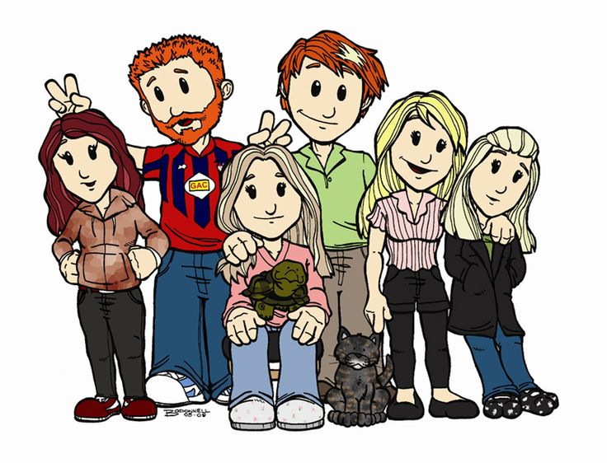
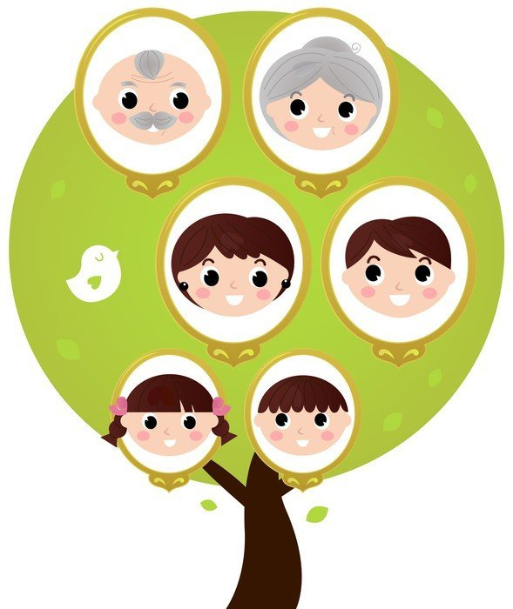

Unit 2 Where is your home?

FOOD FOR THOUGHT
We use cultural differences as weapons to secure our own superiority at the expense of others, and culture thus becomes a hook on which to hang our own pride, arrogance, insecurity, and anger. Messages of cultural inferiority are, moreover, often internalized by those on the receiving end, breeding feelings of hopelessness and lack of worth.
Learning from the Stranger, p. 50

TARGET VOCABULARY
country name(s)  city  country  house/home  apartment  farm  refugee camp  village | United States of America (USA)  name of state/province  other state/province names  north  south  east  west | far away (from)  nearby  close to  small  large | desert  mountain  river  lake  stream  ocean/sea Numbers 20-100

TARGET GRAMMAR
Where are you from?  I am from ____.  He/She is from ____.  You are from ____.  Where do you live?  I live at ____. | My country is ____.  My home is ____.  I live(d) in ____.  I moved to ____.  How long have you lived in ____?  How long did you live in ____?

CAN-DO STATEMENTS FOR NOVICE & INTERMEDIATE
Novice
- I can tell where I am from and where I live.
- I can ask where someone is from.
- I can tell some information about where I live now and where I used to live.
- I can find my country on a map/globe.
- I can say how long (how many years/months/days) I lived in….
Intermediate
- I can tell someone what my country is like.
- I can tell where my family is from and where they live now.
- I can draw a picture of my country (village, home) and describe it.
- I can write about where I live.
- I can write about where I used to live.

LESSON ACTIVITIES: NOVICE

Activity 1
- Use a globe/map to locate country of origin for the EL (or if you have a computer and internet access, use Google Maps to find the location). Using the vocabulary and grammar targets above, practice the question and response for saying where you and the EL are from. Repeat phrases and helpful words.
- Show U.S.A. on a map or globe. As you work with identifying important locations (state/province, city, etc.), use the direction points (north, south, east, west) as appropriate. Help students practice directions pointing out locations on the map with which they are most familiar.
- Show pictures of various geographical land forms/features and ask questions about the EL’s country. Describe the geographical features and have EL choose what picture describes EL’s home country. Practice the features that are most relevant to the EL’s home country and the current home. Use phrases such as, “Are there ___ in [home country]? No, there aren’t./Yes, there are.”

Activity 2
Use pictures or drawings to describe large and small city, town, camp, home. Introduce one vocabulary word at a time making sure to connect it to a visual representation. Have ELs repeat each word/phrase. Ask your ELs questions about where they live now and, if able, where they used to live. As noted in the introduction, start with easier questions (yes-no), move to choice questions (Is this a __ or __?), then to questions that require a one word or short phrase answer. Work up eventually to question that require a complete sentence answer.
Use pictures of various geographical features and ask simple questions about where family members live using Unit 1 vocabulary.

Activity 3
- Draw a sketch of the area in which you live. Point out whether you live in the city or country, a house or apartment. Draw your street (and several cross streets) and write the names on it. Also write your house number on the house on your drawing. Talk about how to say your address. Write your address on the board.
- Ask your ELs to draw a picture of their home/apartment and street. Ask questions that will provide more details to the drawing and engage in conversation using target vocabulary. Assist the ELs in writing several sentences about their home in the native country and/or in their current neighborhood.

Activity 4
Talk with your ELs about where you have lived in your life and for how long (or at what ages). (Practice this before the lesson so you can keep it very simple, at the level of your ELs.). Include phrases like, “When I was a child, I lived in…” “I lived in ___ for __ years.” Ask them questions after your introduction to check their comprehension. Then, talk with your ELs about where they live now (country, state, city) and where they are from. Also ask, “Where did you live (when you were young/age__)?” Practice both of the following questions using the map/globe to contrast and refine understanding: Where are you from? (I am from…) Where do you live now? (I live at/on/in…)

Activity 5
In order to review family member vocabulary, talk about your family members and where they live. Show the places on a map or globe as appropriate to aid in comprehension. Include how long they have lived in each place. Ask your ELs questions to check comprehension about your family members. Ask your ELs about their family members and where they live now or where they have lived. Model several sample sentences on the board to talk about family members and where they live. Ask your ELs to write several sentences about one or more family members. Have the ELs read one or more sentences to the other ELs. Correct any errors that impede comprehension.

Activity 6
Practice numbers 20-100, starting first by 10s (10, 20, 30, 40…), then work with 21, 22, 23, etc. Introduce the concept of day, week, month, year using a calendar. If your ELs do not know the names for days of the week or months of the year (and are eager learners), you can introduce and practice those.

LESSON ACTIVITIES: INTERMEDIATE

Activity 1
Using pictures or drawings, describe geographical features of the city/state where you live. Be sure to include some features that are not present in the local area (e.g., mountains, rivers, desert, etc.) so that you can elicit negative responses as well. Ask the ELs questions about the information you share to check for comprehension. Ask questions to find out about the geographical features where the ELs live/lived.

Activity 2
Ask the ELs to draw a picture of the area/country they came from. As they draw, ask questions about what they are drawing and what features it represents. Have them practice describing the picture to each other. Ask one or more ELs to share in front of the class. Have the other learners ask questions.

Activity 3
Provide a Six Frame for your learners (see sample next page). Model how to draw a picture and write a sentence in each frame to create a “story” about “Where I live.” Ask questions as students work on their stories and help with necessary vocabulary. Have the ELs read their stories to each other. Have one or more present to the class. You could use several ¼ pages stapled together for your Els to create a story in “book” form.

Activity 4
Using the Six Frame again, have your learners create pictures and sentences for “Where I used to live.” Assist learners with necessary vocabulary and spelling as they work. Have ELs practice reading their story to each other. Have the listeners ask questions of the presenters. Practice listening and speaking skills by having one or more students summarize the information presented by another student. You may need to model this first.

Going further
Simple children’s books, EasyReaders, content books, books on hobbies/recreation, or picture books can be a great resource for teaching vocabulary, listening skills, and beginning reading skills. Follow these steps as you introduce and read books with your ELs. This pattern can be used with any of the eight Getting to Know You units.
- Begin by looking at the pictures and talking about what they see. What do the ELs think this book will be about?
- Using the pictures, introduce any key vocabulary that the ELs will need to know in order to comprehend the story.
- Read the story with your ELs (track with your finger to show which direction English text is read), showing them the pictures as you go.
- Ask questions with each page to check comprehension and practice new vocabulary. Include both positive and negative response questions.
- Have the ELs read the book with you as much as they are able. Talk about any words that are difficult to pronounce or any that are not understood.
- Have ELs retell you the story using the pictures as a guide.
- Have ELs write a few sentences to summarize the story and/or write as many details from the story as they can remember. You could use the six-frame story chart for this type of activity.

SIX FRAME: Where I Live | Where I Used to Live
1  _____________________________________  _____________________________________  _____________________________________ | 2  _____________________________________  _____________________________________  _____________________________________
3  _____________________________________  _____________________________________  _____________________________________ | 4  _____________________________________  _____________________________________  _____________________________________
5  _____________________________________  _____________________________________  _____________________________________ | 6  _____________________________________  _____________________________________  _____________________________________

Unit 2 vocabulary visuals
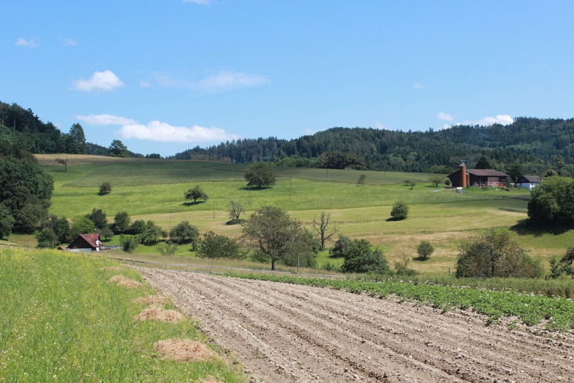

Unit 2 vocabulary visuals
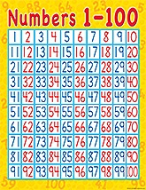 | 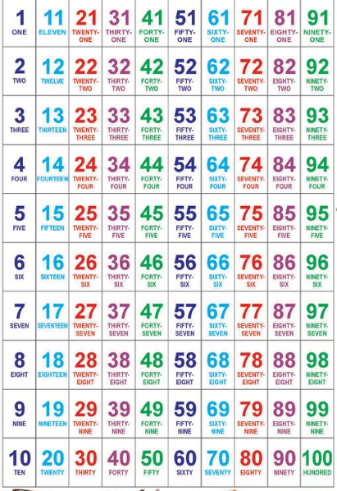
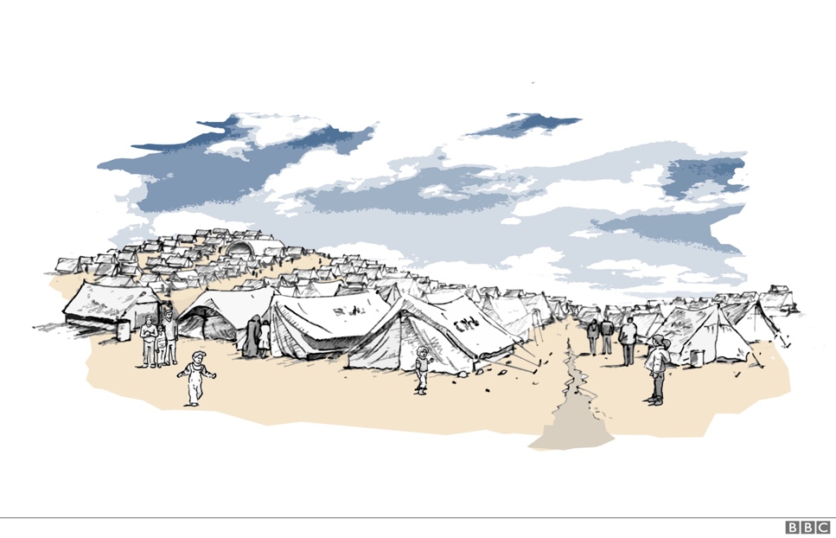

Unit 3 What do you do every day?

FOOD FOR THOUGHT
The most interesting [cultural] differences are invisible until we begin to interact…. Culture is a little like bad breath—you tend to notice it in other people sooner than you detect it in yourself.
Learning from the Stranger, p. 25

TARGET VOCABULARY
alarm clock  wake up  get up  shave  take a shower  eat breakfast  brush my teeth  eat lunch | go to school  work/play/study  eat supper  relax  watch TV  read a book  go to bed | early  late  in the morning  in the afternoon  in the evening  at night  days of the week  on the weekend | body  head/face  hands  arms  legs  feet  eye, ears, nose, mouth, hair

TARGET GRAMMAR
What do you (does he/she) do every day?  Yes, I do. No, I don’t.  Every day I ____.  What day is it? It’s Monday, Tuesday... | When do you ____?  What time do you (does he/she) ____?  I ___ at ___ o’clock.  First, second, next, then, later  On Monday (Tuesday,…)…

CAN-DO STATEMENTS FOR NOVICE & INTERMEDIATE
Novice
- I can say the days of the week.
- I can tell time.
- I can tell what I do every day and ask what others do.
- I can tell what my family members do every day.
- I can write something about daily routines.
- I can tell what time I do daily activities.
- I can name basic body parts.
Intermediate
- I can say and write the days of the week.
- I can talk and write about daily routines in the present
- I can talk and write about daily routines in the past.
- I can ask questions about someone’s daily routines, past or present.
- I can say what time I did daily routines in the past.

LESSON ACTIVITIES: NOVICE

Activity 1
- Introduce basic body parts by touching and naming. Remember to review the previous words (out of order) after each new word is introduced.
- Describe a “monster” and have your ELs listen and draw what they hear. Have ELs show their pictures and tell one thing about the monster they drew.
- Have ELs create a “monster” using basic body parts. Have them write several sentences describing the creature to share with the class.
- Play Simon Says to review body parts.
- Teach the Hokey-Pokey for a fun review.

Activity 2
- Find some pictures of people doing morning routines or think of ways to act out daily routines (use props). Ask yes/no questions about the pictures/actions to building listening skills. Use the format: “What does s/he do every day? S/He ___.” (Stay away from “Is she ___ing?” because it introduces the gerund -ing form.) Have your ELs repeat the phrases after the second time through. At this point don’t worry about sequencing the routines/activities. Add the phrase “in the morning” or “every day” to your sentences. Make sure that some of the questions you ask are negative instead of doing all of them affirmative.
- Very simply tell about your morning routines using pictures or movement/gestures with props. Repeat your routines and have your ELs repeat each phrase. Practice with several ELs asking you the question, “What do you (usually) do in the morning?”
- Ask your ELs yes/no questions about their morning routines. Have them practice asking each other the questions and responding appropriately.
- Introduce before and after to talk about your morning routines. Ask questions to reinforce the meaning of before/after: Do I ___ before or after I*__? Insert other adverbs such as then, later, afterwards, usually as able with your group of ELs.
(*Notice that this question could use the gerund –ing forms, as in “Do I eat breakfast before or after brushing my teeth.” Since this introduces a new form, keep the sentence as written earlier, using “I” and a verb, e.g. “before or after I eat breakfast.”)
- Write out some of the sentences (or have them written out ahead of time) either using “I” or “He” or “She.” Practice reading each of the sentences together. Cut the list of sentences into strips (one set for each person or pair, if able). Ask your ELs to mix up the sentences and put them back in logical order. Compare with another pair to see if the order is the same. Talk about why there may be some differences (e.g. Does everyone take a shower before eating breakfast?).

Activity 3
- Introduce other daily routines (afternoon and evening) following the pattern in Activity 1. Work on building listening comprehension and speaking skills as you move through the steps.
- Pantomime one of the daily routines and have your ELs guess what you are doing. Practice with several actions and then let one of your ELs mime and the other students guess.

Activity 4
- Review numbers 1-30. Use visuals or write the numbers 1-10 on a piece of paper (or whiteboard) in order. Practice saying the numbers in order several times (depending on learner mastery) and then point to a number at random and have the students say the number. Ask the students to count backwards, count by 2’s, by 3’s, by 5’s, if possible. Use the same process to teach or review numbers 10-20 and 20-30.
- Introduce clock time with the use of visuals (analog and digital clocks). Draw or show some clock faces with various hour times. Practice with the students, “What time is it?” “It’s ___ o’clock.” Ask the question, “What time do you ___?” inserting daily routine vocab into the blank. Students respond with “I ___ at ___ o’clock.” You can also add the phrases usually or every day in these questions and responses.
- Introduce half hour and quarter hour times, “It’s 3:30” and “It’s quarter after/quarter to 4.” Use also phrasing like 3:15 and 3:45.
- Talk about your daily routines adding the time of day you typically do those things. Ask the students to write down the times they hear. Check their answers.
Activity 5
Strip Story: Design your own story (or photocopy the one below) being careful of the sequence of events and the adverbs/times used to denote sequence. Cut up the story so each sentence is on a separate slip of paper. Pass out the slips so each student has one and all slips are distributed. Tell students they cannot show their slip to anyone—it’s a secret!! But they can tell others what it says (the purpose is to practice speaking, not reading!). Tell them that the sentences make a story and they need to put the story back in order. Ask the students to stand (reminding them not to show their slip to anyone), repeat their sentence to their peers, listen to others and put themselves in the correct order. Students might need help with ordering vocabulary such as first, last, next, after, before. Write these words on the board and review the meaning so students have the linguistic tools they need for this activity.

Activity 6
- Comparisons: Ask your students to compare their daily routine with another person in the class. Use a chart to organize information such as the sample chart at the end of this unit. Help students understand how to fill out the chart by drawing one on the board and filling it out for you and a student or class helper. Begin by filling out your own daily routines and information. Then use questions to gather information from a helper or another student.
- Composition: Use this charted information to write a paragraph comparing your daily routines. Encourage students to look at the sequence of daily routines as well as time frames. You may want to introduce an opening line, such as: My daily routine is very similar to/different than Abdoul’s. Students may also need a phrase like “He gets up at 6:00, but I get up at 7:00” in order to contrast.

LESSON ACTIVITIES: INTERMEDIATE

Activity 1
If your ELs already know all of the target vocabulary, move into talking about the past. First model with your own story and then build into questions and answers such as:
- When you were ____ years old, what did you do every day?
- What did you (or your family members) do in the morning/in the afternoon/in the evening? What did you usually do…? What did you used to do…?
- Yes, I did. No, I didn’t. (In response to yes/no questions about routines in the home country using the vocabulary.)
- What time did you (did he/she)…? I used to…at…o’clock.
- I used to…every day/ in the morning, in the afternoon, in the evening.
- Where did you…? When did you…?

Activity 2
Ask questions to gently get at the family story of daily routines in their home country or, perhaps, refugee camp. Be charitable in your listening. Be sure that you don’t pry into aspects of life that are too difficult to talk about. It might be best before you start to inquire if you may ask questions about daily routines in ___.
If students are able to talk about the past, use the Six Frame (see Units 1 or 2 for sample) to have them draw and write a story to share.
Activity 3. (same as novice level)
- Comparisons: Ask your students to compare their daily routine with another person in the class. Use a chart to organize information such as the one that follows at the end of this unit. Help students understand how to fill out the chart by drawing one on the board and filling it out for you and a student or class helper. Begin by filling out your own daily routines and information. Then use questions to gather information from a helper or another student.
- Composition: Use this charted information to write a paragraph comparing your daily routines. Encourage students to look at the sequence of daily routines as well as time frames. You may want to introduce an opening line, such as: My daily routine is very similar to/different than Abdoul’s. Students may also need a phrase like “He gets up at 6:00, but I get up at 7:00” in order to contrast.

Going further
Simple children’s books, EasyReaders, content books, books on hobbies/recreation, or picture books can be a great resource for teaching vocabulary, listening skills, and beginning reading skills. Follow these steps as you introduce and read books with your ELs. This pattern can be used with any of the eight Getting to Know You units.
- Begin by looking at the pictures and talking about what they see. What do the ELs think this book will be about?
- Using the pictures, introduce any key vocabulary that the ELs will need to know in order to comprehend the story.
- Read the story with your ELs (track with your finger to show which direction English text is read), showing them the pictures as you go.
- Ask questions with each page to check comprehension and practice new vocabulary. Include both positive and negative response questions.
- Have the ELs read the book with you as much as they are able. Talk about any words that are difficult to pronounce or any that are not understood.
- Have ELs retell you the story using the pictures as a guide.
- Have ELs write a few sentences to summarize the story and/or write as many details from the story as they can remember. You could use the six-frame story chart for this type of activity.

STRIP STORY EXAMPLE (8 sentences for up to 8 students)
[** sentence could be removed for fewer students and the story will still make sense]
Mark wakes up every morning at 6:30.
Then he gets up at 6:45.
Next, he takes a shower and sings.
After his shower he eats breakfast.
Before he leaves for school, he brushes his teeth.
He leaves for the bus at 7:20. **
At 7:50 he gets (arrives) to school.
He goes to class at 8:00 am.

COMPARISONS CHART
Compare your daily routine with another student. Is it the same? Different? Why?

DAILY ROUTINES | ME _______________ | MY FRIEND  ________________
example: wake(s) up | 6:30 a.m. | 7:00 a.m.

Unit 3 vocabulary visuals
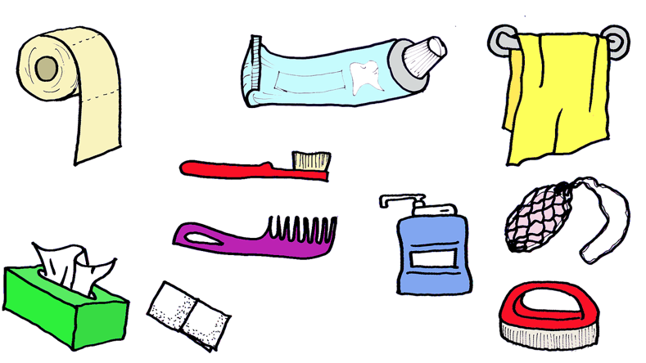
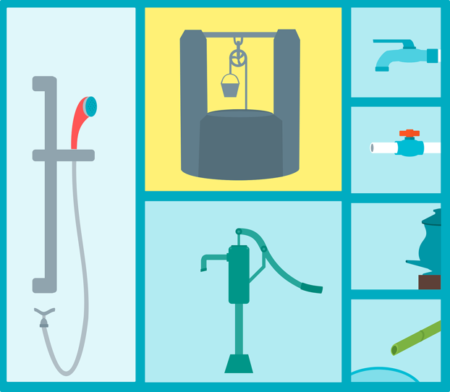 | 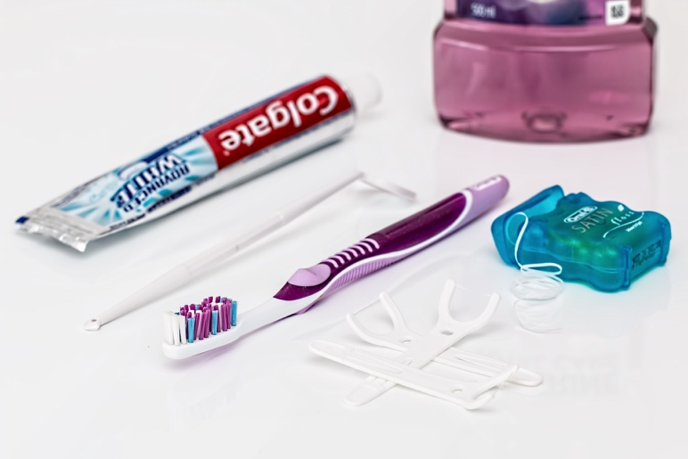

Unit 3 vocabulary visuals
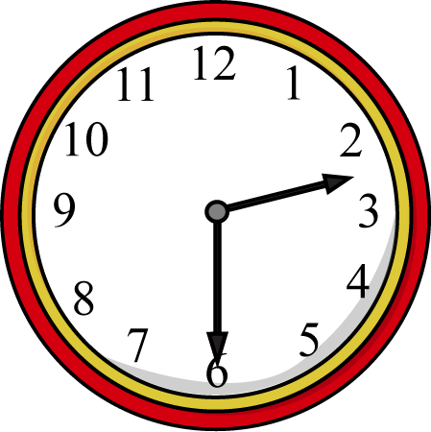 | 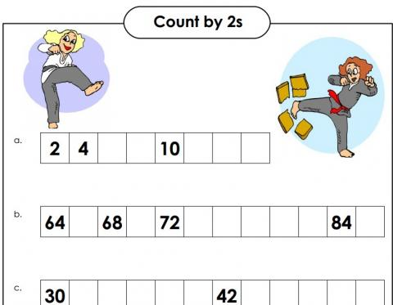
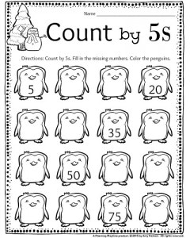

Unit 3 vocabulary visuals
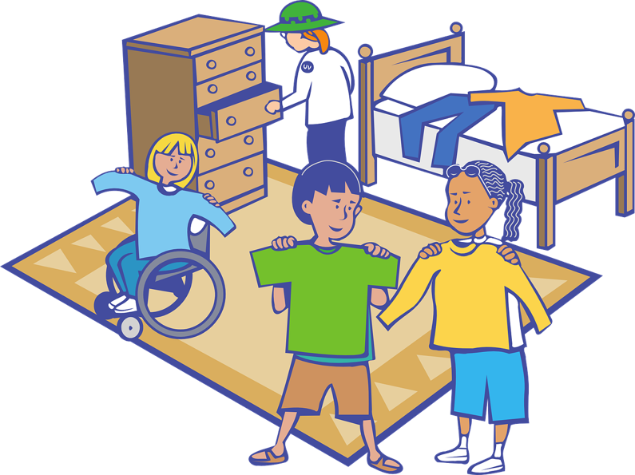 | 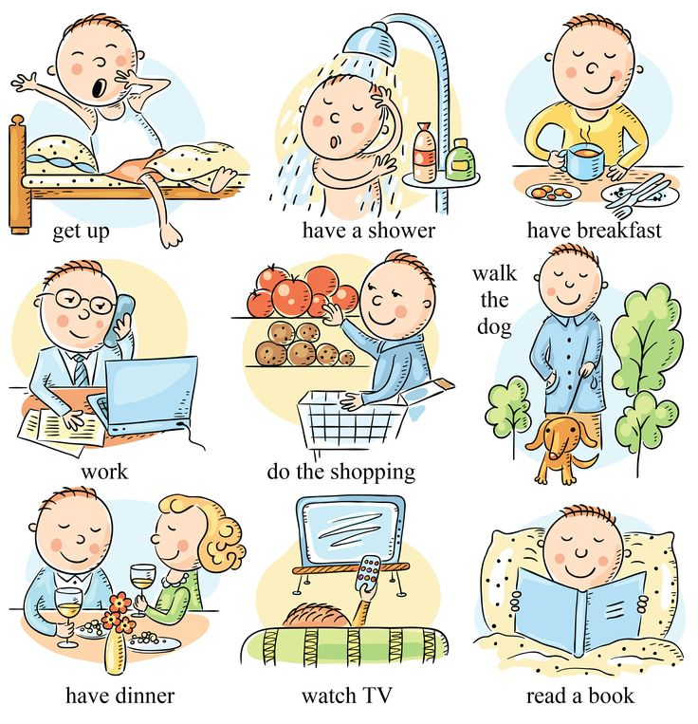
 | 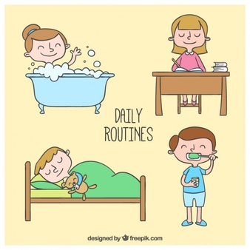

Unit 3 vocabulary visuals

Unit 4 What food do you eat?

FOOD FOR THOUGHT
Willingness to share table fellowship with another person was (and still often is) an important marker of inclusion or exclusion.
Learning from the Stranger, p. 139

TARGET VOCABULARY
water  milk  juice  bread  rice  meat  beans | vegetables  fruit  eggs  grocery store  supermarket  open-air market  produce stand | meals  breakfast  lunch  dinner  supper  snack  holidays | plate  cup  bowl  fork  knife  spoon  napkin | sometimes  usually  never money/cash  debit/credit card  dollar bill/coins

TARGET GRAMMAR
What do you eat every day?  When do you eat?  I eat (at/with) ___.  Where do you buy your food?  I buy food at ___.  Do you eat (at/with) ___?  Yes, I do. No, I don’t. | What is your favorite food?  My favorite food is ___.  What do you like/not like?  I like ___.  I don’t like ___.

CAN-DO STATEMENTS FOR NOVICE & INTERMEDIATE
Novice
- I can tell what I eat every day.
- I can tell what my family members eat every day.
- I can write something about the food I like to eat.
- I can tell what time I eat meals.
- I can tell something about special foods for special days.
- I can tell where I buy the food I need and how I pay.
Intermediate
- I can talk and write about eating habits in the present.
- I can talk and write about eating habits in the past.
- I can ask questions about someone’s eating habits, past or present.
- I can talk and write about what I like to eat on special occasions.
- I can talk and write about what I ate and did on a special day in the past.

LESSON ACTIVITIES: NOVICE

Activity 1
- Find some pictures or bring in typical food items that fit into your daily eating routine. Introduce only one item at a time. Once you move to the second item, go back and review the first. Keep re-cycling the vocabulary as you move on to another word. Unless your students are very eager and capable, only teach about 6 words per lesson so your students can master them. Have your ELs repeat the words/phrases. As you recycle the new words, ask yes/no questions about the items to building listening skills, e.g. Is this a ___? Yes, it is./No, it isn’t. Make sure that some of the questions you ask are negative instead of doing all of them affirmative. Move to choice questions: “Is this a ___ or a ___?” Work up to: “What is this? It’s (a) ___.”
- Very simply tell about your breakfast routine using pictures or items. Keep it to four or five sentences. Include what you eat, what time you eat and with whom you eat. Use food items or draw a picture as you tell the story. Repeat your “story” and have your ELs repeat each phrase. Practice with several ELs asking you the question, “What do you (usually) eat for breakfast?” (If you customarily pray before meals, you can share that along with your eating routines if you like. Do not ask your ELs to repeat that line though, in order to be sensitive to their own religious beliefs.)
- Ask your ELs yes/no questions about their breakfast routines using the food items: Do you eat ___? Be aware that they may have very different foods and eating routines than you. Have them practice asking each other the question prompt and answering. Build up to the question “What do you eat for breakfast?”
- Using a similar process as 1.1-1.3, work on vocabulary for lunch.
- Use a similar process to talk about supper/dinner.

Activity 2
Ask your ELs to draw the items they eat for breakfast. Have each EL say one sentence about his/her breakfast. Include what time he/she eats. Compare breakfasts and create more sentences if more than one student eats the same thing or at the same time.

Activity 3
- Write out some sentences about meals and foods ahead of time (in large letters on large paper for easy viewing) either using “I” or “he” or “she” or write some on the board and have each student copy one. Be sure to have enough for one sentence per EL. Practice reading each of the sentences together. Cut one of the sentences into words. Model how to mix up the order of the words and put the sentence back together. Read the sentence with your ELs again.
- Have the learners cut each of the other sentences into word strips so that you have one set for each person or pair. Ask your ELs to mix up their sentences and trade with another student. Have each student read the sentence to the class to check for accuracy.
Activity 4
- Ask your students to bring in food items that are common to them for the next class. Ask them to tell you what they eat for breakfast, lunch, and supper. Ask questions of the other students about what one of the students eats. Bring in some of the vocabulary from your eating routine into the questions to practice those words again.
- Have students follow up by writing 3-5 sentences about what they eat every day. Have several ELs read their sentences to the class or have several ELs write a sentence on the board (if available). Read the sentences together.
Activity 5
- Introduce the terms usually, sometimes, and never by talking about what you eat and don’t eat. Ask your learners questions about what they usually, sometimes or never eat. Have ELs fill out a 3-column chart about what they eat. Label the columns: Usually, Sometimes, Never. Model how to fill in the chart by putting food items in correct columns.
- Introduce the question “How often do you eat ___?” Practice with your ELs by asking them about various foods. Compare how often you eat ___ with your ELs. Write several comparison sentences on the board like, I often eat ____, but Omar never eats ___.
- Have ELs ask each other questions about how often they eat certain foods. Have them write several sentences comparing their habits with other students.

Activity 6
- Bring in some play money and pictures of food to purchase. Label the food with prices. Decide whether to give all students the same amount of money or to vary the amount among the students. Have your ELs practice deciding what food to purchase with the money they have.
- Show a debit/credit card or a picture of one. Ask if ELs know what they are. Ask about how to use a debit/credit card. Compare the risks of using a credit card vs. debit card.
Activity 7
- Comparisons: Ask your students to compare their eating habits with another person in the class. Use a chart to organize information (see sample at end of unit). Help students understand how to fill out the chart by drawing one on the board and filling it out for you and a student or class helper. Begin by filling out your own daily routines and information. Then use questions to gather information from a helper or another student.
- Composition: Use this charted information to write a paragraph comparing the eating habits of your students. You may want to introduce an opening line, such as: My eating habits are very similar to/different than Abdoul’s. Students may also need a phrase like “He eats (at/with), but I eat (at/with)” in order to contrast.

LESSON ACTIVITIES: INTERMEDIATE

Activity 1
If your ELs already know all of the target vocabulary, move into talking about the past. First model with your own story and then build into questions and answers such as:
- When you were ____ years old, what did you eat every day?
- What did you (or your family members) eat in the morning/in the afternoon/in the evening? Who bought the food? Who prepared the food?
- What special days did you celebrate with special food? What did you eat? When? Why?

Activity 2
Ask questions to gently get at the family story of eating habits in their home country or perhaps refugee camp. Be charitable in your listening. Be sure that you don’t pry into aspects of life that are too difficult to talk about. Perhaps you need to request permission before you start by asking if your ELs are willing to talk about eating habits in ___.

Activity 3
- Use the Six-Frame (see end of unit) to have ELs tell a story about eating on a special day. Note that they could use several possible story starters (depending on whether they still do this or whether it was customary in the past or a one-time event) : Every year my family…; or, My family used to…; or, One time my family… . Have ELs tell their stories and show their pictures to the small group.
- Have ELs follow up by writing a paragraph about eating on a special day. Have ELs read a sentence or the whole paragraph to each other. As you watch ELs work on their writing, jot down some sample sentences to write on the board to address errors or talk with ELs individually to help with accuracy.

Going further
Simple children’s books, EasyReaders, content books, books on hobbies/recreation, or picture books can be a great resource for teaching vocabulary, listening skills, and beginning reading skills. Follow these steps as you introduce and read books with your ELs. This pattern can be used with any of the eight Getting to Know You units.
- Begin by looking at the pictures and talking about what they see. What do the ELs think this book will be about?
- Using the pictures, introduce any key vocabulary that the ELs will need to know in order to comprehend the story.
- Read the story with your ELs (track with your finger to show which direction English text is read), showing them the pictures as you go.
- Ask questions with each page to check comprehension and practice new vocabulary. Include both positive and negative response questions.
- Have the ELs read the book with you as much as they are able. Talk about any words that are difficult to pronounce or any that are not understood.
- Have ELs retell you the story using the pictures as a guide.
- Have ELs write a few sentences to summarize the story and/or write as many details from the story as they can remember. You could use the six-frame story chart for this type of activity.

COMPARISONS CHART
Compare your eating routine with another student. Is it the same or different? Why?

 | ME _______________ | MY FRIEND  ________________
WHAT DO YOU EAT…?
- for breakfast?
- for lunch?
- for supper?
- for snacks?
WHAT TIME DO YOU EAT…?
- breakfast?
- lunch?
- supper?
- snacks?
WITH WHOM DO YOU EAT…?
- breakfast?
- lunch?
- supper?
- snacks?

SIX FRAME:
1  _____________________________________  _____________________________________  _____________________________________ | 2  _____________________________________  _____________________________________  _____________________________________
3  _____________________________________  _____________________________________  _____________________________________ | 4  _____________________________________  _____________________________________  _____________________________________
5  _____________________________________  _____________________________________  _____________________________________ | 6  _____________________________________  _____________________________________  _____________________________________

Unit 4 vocabulary visuals
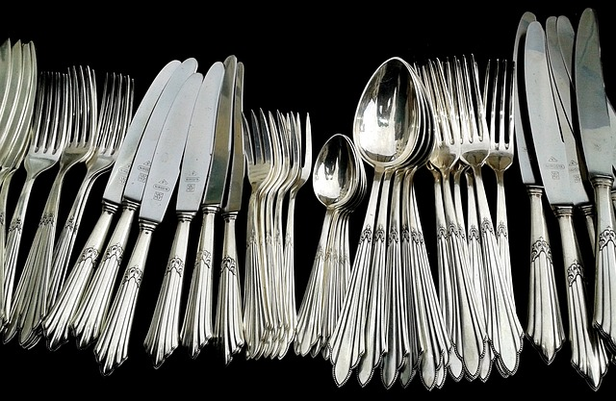
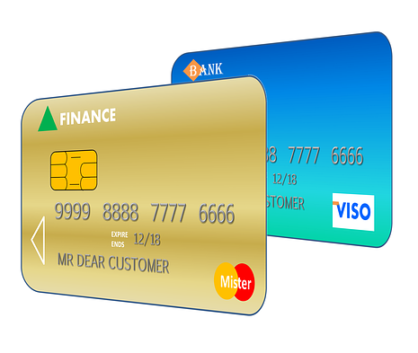

Unit 4 vocabulary visuals
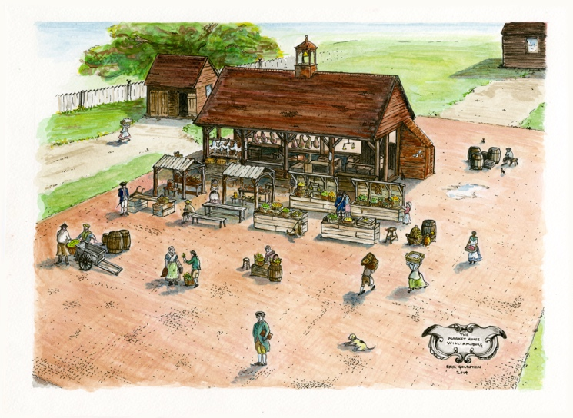
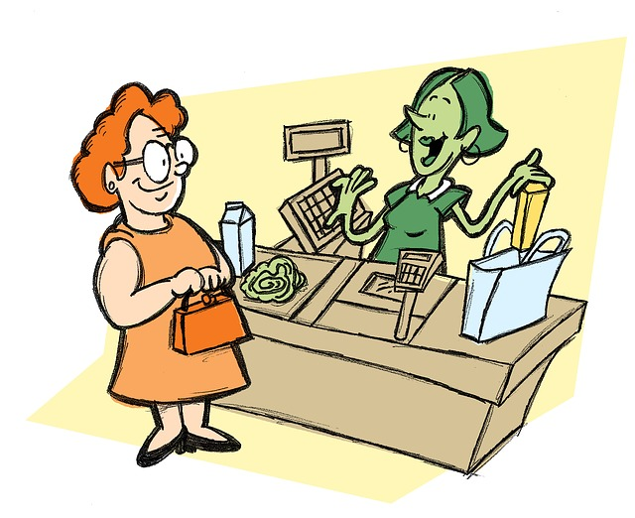

Unit 4 vocabulary visuals
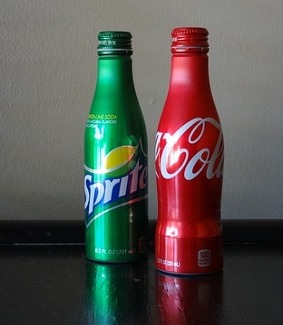
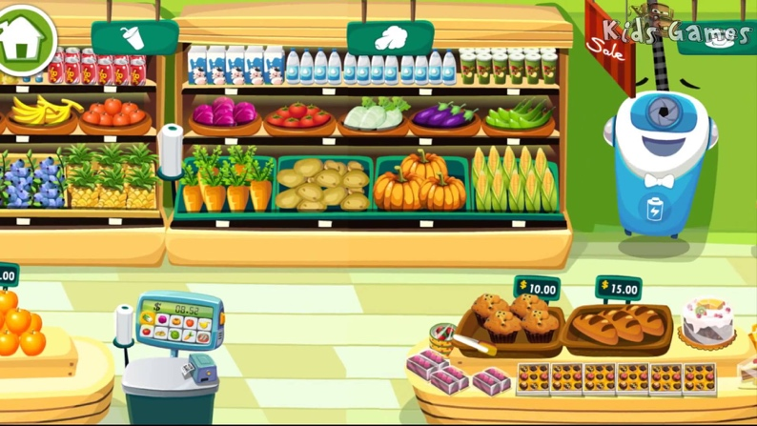

Unit 5 What do you wear?

FOOD FOR THOUGHT
I may legitimately love my native culture, but I must do so without being blind to its faults, and without assuming that the call to image God is somehow uniquely reflected in my own cultural heritage.
Learning from the Stranger, p. 55

TARGET VOCABULARY
dress  skirt  blouse  sweater  pantyhose  underwear  umbrella  coat  raincoat  belt | pants  jacket  shirt  tie  shorts  tennis shoes  boots  sandals  shoes  socks | red  orange  yellow  green  brown  purple  blue  black | seasons  winter  summer  spring  fall  It’s cold.  It’s hot.  It’s cool.  It’s windy.  It’s raining.  It’s snowing.

TARGET GRAMMAR
What do you wear?  Why do you wear what you do?  I wear ___. I am wearing ___.  Where do you buy your clothes?  I buy clothes at ___. | What is your favorite color?  My favorite color is ___.  When do you wear ___?  What do you like/not like to wear?  I like to wear ___.  I don’t like to wear ___.

CAN-DO STATEMENTS FOR NOVICE & INTERMEDIATE
Novice
- I can tell what I wear every day.
- I can tell what my family members wear every day.
- I can write something about the clothing I like to wear.
- I can tell what I wear in different seasons.
- I can tell something about special clothing for special days.
Intermediate
- I can talk and write about what I wore in the past.
- I can ask questions about someone’s clothing habits, past or present.
- I can compare seasons where I live now to where I used to live.
- I can talk and write about what I used to wear for special occasions.
- I can talk and write about what I wore on a special day in the past and why.

LESSON ACTIVITIES: NOVICE

Activity 1
- Find some pictures of different seasons. Introduce only one season at a time. Once you move to the second season, go back and review the first. Keep re-cycling the vocabulary as you move on to another word. Unless your students are very eager and capable, only teach about 6 words per lesson so your students can master them. Have your ELs repeat the words/phrases. Ask yes/no questions about the seasons to building listening skills, e.g. Is this ___? Yes, it is./No, it isn’t. Make sure that some of the questions you ask are negative instead of doing all of them affirmative. Use choice questions (“Is this ___ or ___?”) and finally “What season is this? It’s ___.”
- Bring pictures of weather associated with each of the four seasons. Practice the seasons adding phrases about weather: In the [season], it’s _____. Ask questions about each of the seasons and the weather introduced.
- Write out some sentences ahead of time (in large letters on large paper for easy viewing) about weather and seasons and cut them in half with the season on one half and weather on the other, e.g. In the winter, it’s cold. Ask the students to put the sentences back together. Have them read the sentences out loud. If you have multiple sets of the sentences (snack bags are great for keeping these separate), you can have students work together in pairs to piece the sentence back together again.

Activity 2
Ask your ELs about weather and seasons in their home country with questions such as, “Do you have winter (or snow) in ______? Compare to weather/seasons locally. Have ELs write several sentences about weather and seasons in both locations. A chart may be helpful.

Activity 3
Bring in several clothing items for hot weather and for cold weather, e.g., sandals, boots, scarf, mittens, sunglasses, short-sleeved shirt, sweater, raincoat, winter jacket, etc. Make two signs before class: “WINTER—It’s cold!” and “SUMMER—It’s hot!” Put each sign in a different spot in the classroom. Hold up each clothing item, say the name of the item (as simply as possible) and ask one of your ELs to decide if this is for hot weather or cold. Choose a different learner to place each item of clothing by the hot or cold signs. Recycle vocab as you go so you are not introducing or practicing 8-10 new words in a row. After all items are classified, review the vocabulary by stating the item name, having the ELs repeat.
Activity 4
- If the common attire was very different in the home country, ask your ELs to bring in clothing items that are common to them for the next class. Ask them to tell you what they wear every day. Ask questions of the other students about what one of the students wears. Bring in some of the vocabulary from the HOT/COLD activity into your questions to practice those words again.
- Have students follow up by writing 3-5 sentences about what they wear every day. Have them read their sentences for each other. If you notice any common errors, address one or two errors at the end.
Activity 5
- Introduce the other clothing items that were not covered in the HOT/COLD activity. As you work on each of the items, associate it with weather/seasons as appropriate. Be sure to include negative questions as well as affirmative. Only introduce a few items at a time and then begin to recycle to familiarize your ELs enough with the words before moving on. Ask questions to review and practice.
- Introduce colors using colored paper or markers. Describe the clothes you are wearing using colors. Ask ELs to tell what clothing/colors they are wearing. Identify the other clothing items used so far by color.
Activity 6
Fashion show: Ask your ELs to work with a partner to write a description of what the other person is wearing. Try to make the description interesting by adding some details. You may need to provide some adjectives. Have a color chart visible with the English words for each color for reference. Have one student read his/her description while the other person models the clothing. If they want, they can add some clothing items from the HOT/COLD activity earlier in this unit.
Composition: Provide a variety of pictures of people with different clothing. You could choose some that reflect a variety of cultures rather than all U.S. culture. Have each EL choose one picture to write a description. Post the sentences and pictures in the classroom for the other learners to read.

LESSON ACTIVITIES: INTERMEDIATE

Activity 1
If your ELs already know all of the target vocabulary, move into talking about the past. First model with your own responses and then build into questions and answers such as:
- When you were ____ years old, what did you wear every day?
- What did you (or your family members) wear? Where did you buy your clothing? Who made the clothing?
- What special days did you celebrate by wearing special clothing? What did you wear? When?
- How has clothing/fashion changed with time in the ELs home country? Or hasn’t it? Why does it change or why not?
- What factors determine what a person wears in the home country? Social status? Weather? Religion? Wealth?
- Was there a time when it was difficult to have the necessary clothing?
- How does proper clothing differ between males and females?

Activity 2
Ask questions to gently get at the family story of clothing habits in their home country or, perhaps, refugee camp. Be charitable in your listening. Be sure that you don’t pry into aspects of life that are too difficult to talk about. Perhaps you need to request permission before you start by asking if you can talk together about clothing patterns in ___.
Activity 3
Fashion show: Ask your ELs to work with a partner to write a detailed description of what the other person is wearing. You may need to provide some adjectives such as striped, polka-dotted, plaid, plain, long-sleeved, short-sleeved, V-neck, etc.). Have one student read his/her description while the other person models the clothing. If they want, they can wear some items from the HOT/COLD items used earlier in this unit.
Story: Provide a variety of pictures of people with different clothing. You could choose some that reflect a variety of cultures rather than all U.S. culture. Have each learner choose one picture to write a story about the person and what they are wearing. Have the ELs read their stories to a partner to check for understanding.
Activity 4
Return to the questions from Activity 1. Ask the ELs to choose together one of the questions to write about. Help the ELs draft a class composition to answer the question. First, think together about some ideas you could put into the composition. List them on large paper or on the board. Then, writing large enough for the group to see, have the ELs suggest what to write. It will be natural for the ELs to make errors in their speech. As you write the composition, quietly make corrections in the sentence structures. Re-read together what the class has written. Ask individual ELs to read it. Underline any new vocabulary.

Going further
Simple children’s books, EasyReaders, content books, books on hobbies/recreation, or picture books can be a great resource for teaching vocabulary, listening skills, and beginning reading skills. Follow these steps as you introduce and read books with your ELs. This pattern can be used with any of the eight Getting to Know You units.
- Begin by looking at the pictures and talking about what they see. What do the ELs think this book will be about?
- Using the pictures, introduce any key vocabulary that the ELs will need to know in order to comprehend the story.
- Read the story with your ELs (track with your finger to show which direction English text is read), showing them the pictures as you go.
- Ask questions with each page to check comprehension and practice new vocabulary. Include both positive and negative response questions.
- Have the ELs read the book with you as much as they are able. Talk about any words that are difficult to pronounce or any that are not understood.
- Have ELs retell you the story using the pictures as a guide.
- Have ELs write a few sentences to summarize the story and/or write as many details from the story as they can remember. You could use the six-frame story chart for this type of activity.

COMPARISONS CHART
Compare the clothing patterns in your home country to the clothing patterns in the U.S.

 | My home country _______________________ | In the United States
WHO WEARS WHAT?
MEN
WOMEN
CHILDREN
WHAT DO YOU WEAR?
FOR WORK?
FOR PLAY?
FOR HOLIDAYS?

Unit 5 vocabulary visuals
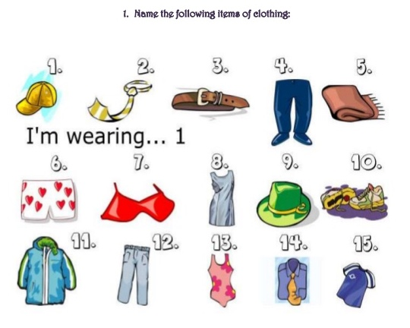 | 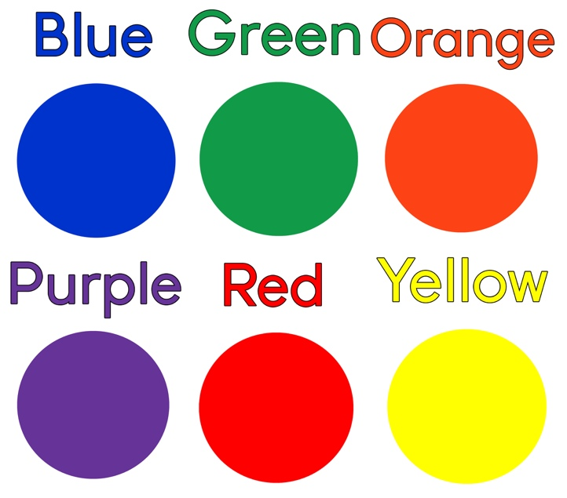
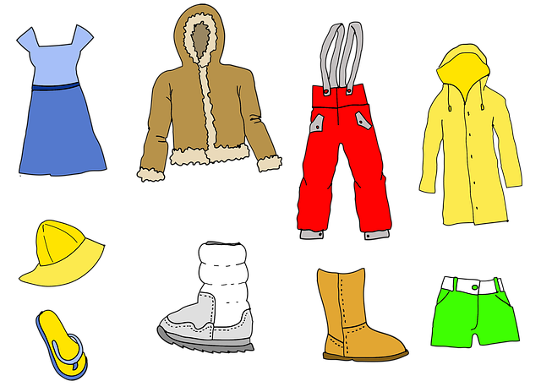 | 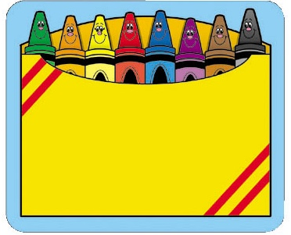

Unit 5 vocabulary visuals

Unit 6 How do you thrive at work or school?

FOOD FOR THOUGHT (quote box)
Sometimes our easy assumption that we understand arises not from interpreting the strange too quickly, but from assuming too quickly that what we are seeing is familiar.
Learning from the Stranger, p. 113

TARGET VOCABULARY
toothpaste  toothbrush  hairbrush  comb  bath soap  shampoo  deodorant  mouthwash | alarm clock  wake up  on time/early/late  school bell  punch in/punch out time clock  schedule | breakroom  cafeteria  classroom  boss/manager  co-worker  desk  chair  locker | transportation  car  bus  bicycle  walk

TARGET GRAMMAR
after/before  It is important that I…  It’s important to…  I need to…/ I have to… | How do you get to work/school?  How long does it take to get to work/school?

CAN-DO STATEMENTS FOR NOVICE & INTERMEDIATE
Novice
- I can describe my daily schedule.
- I can tell someone where I work or go to school.
- I can draw my work station/locker and describe it.
- I can tell how I get to work/school.
Intermediate
- I can describe what I do at school or work.
- I can compare typical travel in my home country and in the U.S.
- I can talk about the American value of time.
- I can describe the value of being clean and neat at work.

LESSON ACTIVITIES: NOVICE

Activity 1
- Using a clock with movable hands or a digital clock, review the o’clock phrases from Unit 3. After sufficient practice, move the hands in random order and have EL say, “It is… o’clock. Repeat the activity to review telling time phrases.
- Using visuals of toiletries, practice saying target vocabulary and describe how each is used. Compare use of these items in home culture and U.S. culture.
- Use pictures of target vocabulary and practice saying each phrase or word to describe a daily schedule. Ask the EL to draw the action and assist EL in labeling the drawing, “I wake up.” “I take a shower/bath.” Practice phrases and sentences with EL.
- Expand 1.2 activity by adding clock times to each activity. Example: “I shower at 7:00 o’clock in the morning.” “I eat breakfast at 7:30 a.m.” etc. Change times for the weekend days and create new sentences. Example: “On Saturday, I wake up at 8:00 o’clock.”
- For each family member use pictures to describe their day. Remind EL of different verb endings for “he/she” as opposed to “I” or “you.” For example: Mom or My mother wakes up at 7:00. Dad or My father works at Meijer, takes a shower, punches in/out.

Activity 2
- Take turns acting out the vocabulary actions and practice using the words. EL will describe what actor is doing.
- Select an action word from a daily schedule and a clock hour. Create practice sentences with each action + hour. Add a family member and lengthen the sentences with more details as EL is able. Write some of the sentences and practice reading them together.
- Cut the practice sentences apart and have EL reconfigure them. Read the sentences together, then change the family member (subject) and restate the sentence.

Activity 3
- Converse with EL about clocks in native country and in their new country. Are clocks important and what place do they have in daily routines? How do you tell time with/without a clock in native country? Who uses a clock/time in your country?
- Talk about the daily routines of ELs in native country. How is the value of a clock/time different in native country from the new country? What does it mean to be late in native country? What happens if EL is late to work/school in the U.S.?

Activity 4
Present visuals of transportation modes. Name the transportation modes and practice how to say each word with the EL. Describe what is needed to travel by car, bus, bicycle (helmet, license, bus ticket, road rules, etc.). Talk about how you get to work/school. Talk about how your EL gets to English class, school, work, store, etc.

LESSON ACTIVITIES: INTERMEDIATE

Activity 1
- How do people travel in EL’s neighborhood? Who drives in home country? Do you know what a license is? Does one need a license to drive in home country? Who usually/sometime/never drives in EL family? How much does it cost to drive/get license? What is important to know about traveling to work in the U.S./home country?
- Talk about riding public transportation. Is it convenient? What is it like to wait in the snow? Do you travel with anyone to work? Who rides the bus from work? What is carpooling?
- Determine which modes of transportation are most applicable for your ELs and do any of the following:
- Obtain a bus map to help with directions to/from a work site in the city.
- Obtain a Driver’s Training manual to talk about American driving classes.
- Compare the U.S. bus system (or other modes of travel) with the bus system in EL’s home country.

Activity 2
Daily or Weekend Routines: A Listening Activity (see chart at end of Unit 6)
- [Prepare this before class.] Choose 5 clock times of your day (decide whether to use a work/school or weekend day) and fill them in on the chart (see sample below). For intermediate ELs, you can make the clock times more complex. Fill in what you do at each time.
- Give a copy of the blank chart page to each of your ELs or have them draw a T-chart on a piece of paper.
- Tell your ELs what you do at each of those times and have them listen and then write the times and the activity.
- Ask your ELs to report back to you what you do during the day and what times.
- You can use this same chart to talk about PAST activities as appropriate for your ELs. What did you do last Saturday at 10:00 am, etc.?
- You can use this same chart to talk about FUTURE activities as appropriate for your ELs. What will you do next Friday at 2:00 pm, etc.?
Sample Listening Activity
Who? [mentor] |  | Day of the week:
hour of the day | activity
6:30 am | I take a shower. OR I am taking a shower.
10:00 am | I take a break at work. OR I am taking a break at work.
4:00 pm | I ride the bus home. OR I am riding the bus home.
7:30 pm | I watch TV. OR I am watching TV.
10:00 pm | I go to bed. OR I am going to bed.

Activity 3
Using the same chart, have each EL select several times of the day. Have them use those times to interview someone else in the group about their daily routines (present, past, future). If necessary, write out a model question for them to follow: What do you do at ______ on ______? (Past: What did you do…?; Future: What will you do…?). Ask your ELs to report back to the class what they learned.

Activity 4
Discuss: What is easy about your day and what is hard? What is the breakroom or classroom like? Are there “rules” while during break time (cell phone, leaving building, smoking, etc.)? What are the rules? What must you wear to work or school (uniform; jeans; skirt/dress pants)?

Activity 5
Use the written information to write a “story” about a typical day for the EL or for mentor. This can be done together as a class or individually. Have ELs read their stories to each other or to the whole group. Determine according to the level of your ELs whether to have the focus of the story be present, past or future:
- What do I do on Saturdays?
- What did I do last Wednesday?
- What will I do next Sunday?

Activity 6
NOTE: Determine, based on the context of your ELs and your relationships with them, how important the topic of cleanliness is for their success in the U.S. context.
The topic of “cleanliness” can be a sensitive subject with ELs. Approach the topic with sensitivity and no judgment as much as possible. However, the American value of cleanliness is important for gainful employment in most of our American neighborhoods. Important cultural information on this topic needs to be exchanged. Mentor can share his/her own morning routine and value of being clean and neat for work/school. Describe employee/employer perspectives on topic of cleanliness.

Going further
Simple children’s books, EasyReaders, content books, books on hobbies/recreation, or picture books can be a great resource for teaching vocabulary, listening skills, and beginning reading skills. Follow these steps as you introduce and read books with your ELs. This pattern can be used with any of the eight Getting to Know You units.
- Begin by looking at the pictures and talking about what they see. What do the ELs think this book will be about?
- Using the pictures, introduce any key vocabulary that the ELs will need to know in order to comprehend the story.
- Read the story with your ELs (track with your finger to show which direction English text is read), showing them the pictures as you go.
- Ask questions with each page to check comprehension and practice new vocabulary. Include both positive and negative response questions.
- Have the ELs read the book with you as much as they are able. Talk about any words that are difficult to pronounce or any that are not understood.
- Have ELs retell you the story using the pictures as a guide.
- Have ELs write a few sentences to summarize the story and/or write as many details from the story as they can remember. You could use the six-frame story chart for this type of activity.

Daily/Weekend Routine: A Listening Activity

Who? |  | Day of the week:
hour of the day | activity

Who? |  | Day of the week:
hour of the day | activity

Who? |  | Day of the week:
hour of the day | activity

Unit 6 vocabulary visuals
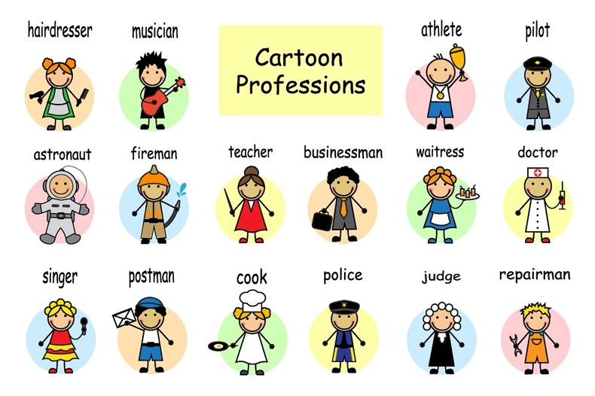

Unit 6 vocabulary visuals

Unit 6 vocabulary visuals

Unit 7 What do you do for fun?

FOOD FOR THOUGHT
If the aim is to love my neighbor as myself, then the most basic question is not what works pragmatically, or what is the least I can get away with, but rather what best honors the others with whom I am engaging. Such honoring does not come for free.
Learning from the Stranger, pp. 96-97

TARGET VOCABULARY
calendar  months (& seasons)  holidays  celebration  birthday  vacation | rainy season  dry season sun  snow  rain  cloudy/clear  cool/warm  temperature | play  television  movie  games  parade | sing  dance  food  sports (soccer, baseball, football)

TARGET GRAMMAR
What’s the date today?  What season is it? It’s ___.  It’s [weather] in [season].  What do you do in your free time? | I like to ___.  I prefer…  My birthday is in ___.  To celebrate, we/I ___.

CAN-DO STATEMENTS FOR NOVICE & INTERMEDIATE
Novice
- I can name the 12 months of the year in order.
- I can describe the weather during each season (in Michigan).
- I can tell someone the day, month and season of the year.
- I can ask questions about day, month and season of the year.
- I can name some American holidays.
- I can name some of my native country holidays.
Intermediate
- I can name holidays and celebrations in my home country and in the U.S.
- I can describe the weather during the holiday times (in U.S. and native country).
- I can describe the significance of some national holidays.
- I can talk about the significance of events (parades, speeches, national monuments).

LESSON ACTIVITIES: NOVICE

Activity 1
- Using a calendar, practice the months of the year and naming the 7 days of the week. Write names of each calendar month/day on 3X2 cards. Play a game putting them in order, mixing them up and reordering them. Say each word and have EL repeat it. Sort the 12 months by season and use the 4 season words to categorize the months.
- Mentor will describe weather in each season using target vocabulary. Draw a picture of each season and label each picture. Have EL share what season s/he likes best in Michigan.

Activity 2
Mentor will name several major holidays (in U.S.) and the season and month they are celebrated. Use visuals of typical decorations and celebration activities (Easter, lily flowers, cross, candy; Christmas, tree, ornaments, turkey, presents; Independence Day, parades, flags, candy, picnics) to practice vocabulary and grammar.

Activity 3
Ask EL about national celebrations in native country. Have him/her draw what a celebration may look like. Talk about when the holiday is celebrated using target vocabulary.

Activity 4
Using visuals or equipment, talk about sports played (in Michigan), and during what seasons. Talk with EL about sports played in home country and what sport is a favorite. Play catch/throw ball/engage in physical activity with EL if appropriate.

Activity 5
Using visuals or equipment, describe who plays each sport (boys, girls, men, women) and listen for cultural clues about EL native country. Have EL draw equipment pieces and talk about each game mentioned. (Prior vocabulary can be incorporated: body parts, clothing, etc.)

LESSON ACTIVITIES: INTERMEDIATE

Activity 1
Play a board game together like Sorry, Uno, Jenga, Parcheesi, Monopoly, etc. Teach vocabulary words relating to parts of game or any equipment used in the game. Teach basic rules, goal and strategy of the game. Play an open hand (if cards are used), or a practice round of the game until the EL understands the game. Talk about how family games are what some people do for fun.

Activity 2
Watch/Play a soccer, baseball or football (other?) together. A television or cell phone can be used for this activity. Write down some important vocabulary words and describe their meaning. Draw the playing field on paper and mark the positions of players. Talk about leisure and recreational time activities and what months and/or seasons they are enjoyed.

Activity 3
Prepare information on some national athletic “stars.” Describe the game the athlete plays and any historic information you may know about the athlete. Recycled vocabulary may include: birthdate (month, day, year) of athlete, what season of year athlete was born, country of origin, name of sport, position of play, etc. Ask EL if s/he knows any famous athletes and discuss the athlete. Make a list of as famous people in sports, government, TV, etc. Discuss the variety of ways people have fun together.

Activity 4
Prepare information on some famous historic people: presidents, activists, heroes. Bring a book or watch a YouTube on a famous person. Provide EL an opportunity to share some information on famous people from his/her country of origin. Compare ways of celebrating with a two-column chart. Write a 6-Frame Story on a famous person.

Activity 5
Watch a parade and describe how parades are used in the U.S. to celebrate a holiday or person/team/event. Draw a diagram of a parade, bystanders, floats, marching band. If possible attend a “live parade” event for an American holiday. Describe what kind of music is played (high school bands, community bands, marching music, etc.). Using photos of instruments, name the instruments used in the parade. Ask yes/no questions to ensure comprehension of vocabulary and parade activities. Perhaps the EL has attended a parade in her/his country of origin. Talk about how parades are used for fun.

Going further
Simple children’s books, EasyReaders, content books, books on hobbies/recreation, or picture books can be a great resource for teaching vocabulary, listening skills, and beginning reading skills. Follow these steps as you introduce and read books with your ELs. This pattern can be used with any of the eight Getting to Know You units.
- Begin by looking at the pictures and talking about what they see. What do the ELs think this book will be about?
- Using the pictures, introduce any key vocabulary that the ELs will need to know in order to comprehend the story.
- Read the story with your ELs (track with your finger to show which direction English text is read), showing them the pictures as you go.
- Ask questions with each page to check comprehension and practice new vocabulary. Include both positive and negative response questions.
- Have the ELs read the book with you as much as they are able. Talk about any words that are difficult to pronounce or any that are not understood.
- Have ELs retell you the story using the pictures as a guide.
- Have ELs write a few sentences to summarize the story and/or write as many details from the story as they can remember. You could use the six-frame story chart for this type of activity.

Unit 7 vocabulary visuals
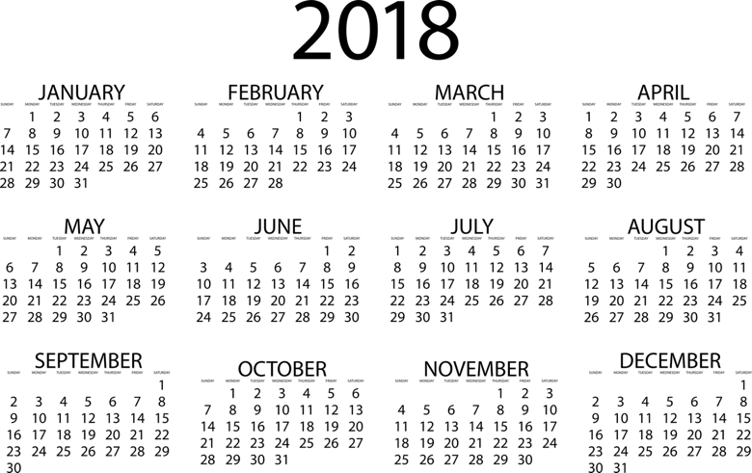
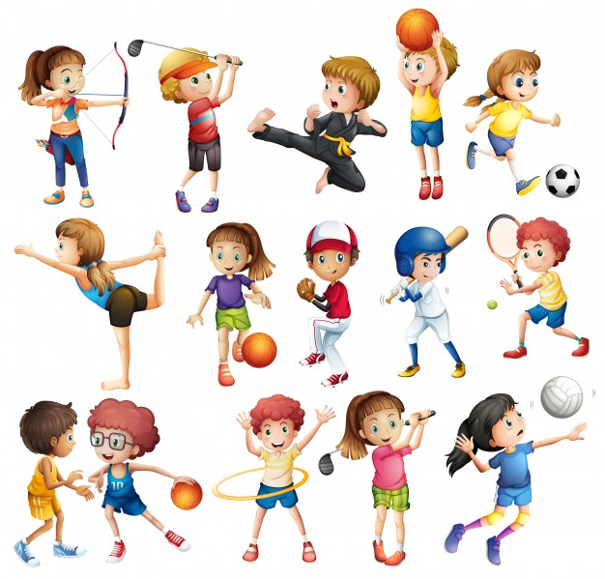 | 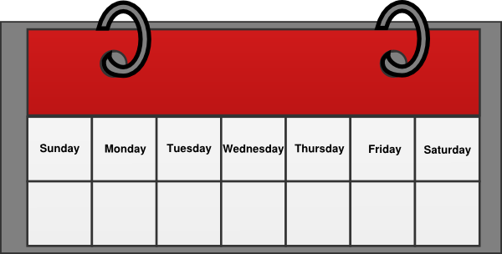

Unit 7 vocabulary visuals
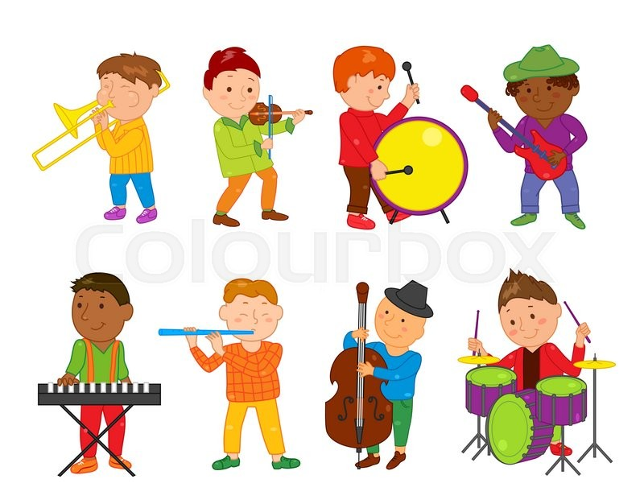 | 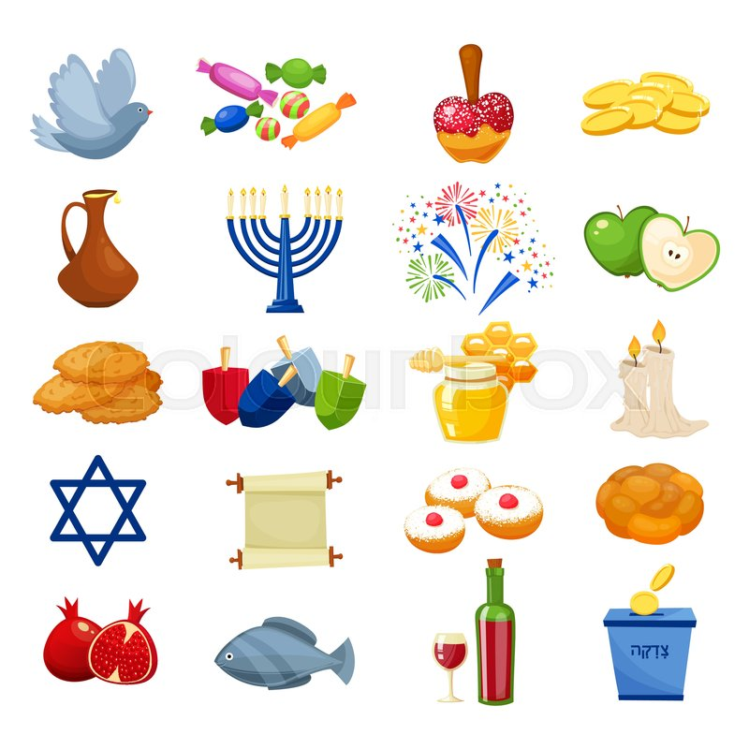

Unit 7 vocabulary visuals

Unit 8 What makes your house a home?

FOOD FOR THOUGHT
Loving the stranger is not about putting up with the inferior ways of others; it involves realizing that I am a stranger too.
Learning from the Stranger, p. 121

TARGET VOCABULARY
kitchen  cook  sink  wash/dry  stove  oven  microwave refrigerator  countertop  cupboards garbage/trash | dining room  table  chairs  tablecloth  chores  clean/dirty  vacuum/dust  sweep  broom  dustpan | bedroom  bed  pillows  sheets  blankets  make bed  closet  hangers | bathroom  toilet  toilet paper  sink/faucet  soap  towels  shower  tub | living room  hallway  sofa  easy chair  lamp  coffee table  television  PlayStation/Xbox

TARGET GRAMMAR
In the _____ there is a [furniture piece].  I need to [clean] the [bathroom]. | Who does the chores?  Who cleans the bathroom?  Who vacuums the living room?  Who makes the bed?
CAN-DO STATEMENTS FOR NOVICE & INTERMEDIATE
Novice
- I can name the rooms in my house.
- I can name the furniture in my house.
- I can say what I do in each room.
- I can ask what others do in each room.
Intermediate
- I can talk and write about what chores need to be done in each room.
- I can tell what chores I did last week.
- I can name furniture for each room and write about what my family does in each room.
- I can ask what someone else’s house looks like.
- I can talk about what happened yesterday in each room.

LESSON ACTIVITIES: NOVICE

Activity 1
- Use pictures of different rooms in a house or draw a house with distinctive features for each room. Review the pictures and practice the names for each room. Put a sticky note label on each room. Remove the labels and have your ELs replace them and read/name the room. Intentionally put the wrong room name on a room and ask, “Is this the bedroom?” EL response is, “No, it is (it’s) not the bedroom. It’s the bathroom.” Practice with other rooms eliciting both positive and negative answers.
- Start with one room, using the pictures, and label the objects in the room. As you add each new item, review (out of order) the previous items. Use sticky notes to label the items. After several, mix them up and see if your ELs can put them back on the correct objects.
- Draw a family member figure in a room and talk about what the family member does in that room. Example: Draw a baby in the bedroom. “What does the baby do in the bedroom?” Draw a father in the kitchen. “What does your father do in the kitchen?” Be conscious of cultural differences in what family member chores may be.
- On slips of paper draw furniture pieces for each room, one room at a time. EL places correct furniture pieces in each room and names it. Have EL describe how it is used (e.g., I sleep in the bed. I brush my teeth in the sink. My mother cooks in the kitchen. I sweep the living room floor.) Ask positive and negative questions (e.g., Do you sleep in the sink? No, we don’t sleep in the sink. We sleep in the bedroom.)

Activity 2
- Write sentences on the white board/paper using the target vocabulary. EL changes the subject and makes verb/subject corrections.
- Talk about what chores need to be done in the U.S. and in his/her home country. Write down differences in two-column chart and compare/contrast similarities in EL and mentor home.
- Write a 2-5 sentence paragraph about other chores your EL does in his/her home.
- Talk with EL about cultural differences in who does what tasks in the family. Be cautious about assigning certain tasks to certain genders.

LESSON ACTIVITIES: INTERMEDIATE

Activity 1
- Bring some cleaning items or pictures of cleaning items. Name the items: vacuum, dust cloth, broom, bucket, cleanser, hanger, iron, etc. Describe how to use them or pantomime how to use each item. Name the room where each item can be used.
- Have EL draw a room in their house with basic furniture. Review names of furniture and clarify any vocabulary. Pantomime a chore done in the room. Ask EL to name the chore and the person(s) who does it at home. Repeat with several rooms and different people. Switch roles: Mentor pantomime and EL name the chore and who does the chore. Ask Yes/No questions: Does your grandfather vacuum? Does your father vacuum and dust? Does your brother cook or do dishes?
- Using the cleaning items or pictures, name the items, talk about what chores we do every day. How often do you sweep the kitchen or mop the kitchen floor? Cook? Clean the bathroom? Clean the living room? Do the dishes? Use phrases such daily, every day; once a week, weekly; often, seldom, frequently, three times a day.

Activity 2
- Find two different pictures each of various rooms in the house (magazine or pictures off the computer). Compare pictures by only asking each other questions (you can’t look at each other’s pictures until the end!) Have EL ask about the furniture in the rooms of your home (picture). “Do you have a lamp in the bathroom?” Do you have a couch or sofa in the living room? Is there a TV in your kitchen? Answer the EL questions positively or negatively according to the items in your picture. Ask the EL questions about his/her house (pictures). Restate the question in your answer to reinforce sentence structures.
- Have various pictures of rooms in the home (magazines work great). Have your ELs work with a partner. Student A sees the picture and Student B does not. Student A describes the picture to Student B. Student B needs to listen and draw without showing the picture to Student A until the description is done. Then they compare the pictures and talk about the differences.

Activity 3
- Talk with your EL about what cleaning you did last week. Have the EL listen and make a list of the things you did. Use the phrase, “Last week, I (cleaned, vacuumed, swept, washed, etc.) in the (name room). Try to include at least 5 activities and 2-3 rooms.
- Ask your EL questions about what family members did yesterday or last week to use the past tense. Write the answers out together. Read the sentences. Ask new questions in the past tense using other room and chore vocabulary. You might want to use the six-frame story sheet to have ELs write a story about who did what chores last week.

Going further
Simple children’s books, EasyReaders, content books, books on hobbies/recreation, or picture books can be a great resource for teaching vocabulary, listening skills, and beginning reading skills. Follow these steps as you introduce and read books with your ELs. This pattern can be used with any of the eight Getting to Know You units.
- Begin by looking at the pictures and talking about what they see. What do the ELs think this book will be about?
- Using the pictures, introduce any key vocabulary that the ELs will need to know in order to comprehend the story.
- Read the story with your ELs (track with your finger to show which direction English text is read), showing them the pictures as you go.
- Ask questions with each page to check comprehension and practice new vocabulary. Include both positive and negative response questions.
- Have the ELs read the book with you as much as they are able. Talk about any words that are difficult to pronounce or any that are not understood.
- Have ELs retell you the story using the pictures as a guide.
- Have ELs write a few sentences to summarize the story and/or write as many details from the story as they can remember. You could use the six-frame story chart for this type of activity.

Unit 8 vocabulary visuals
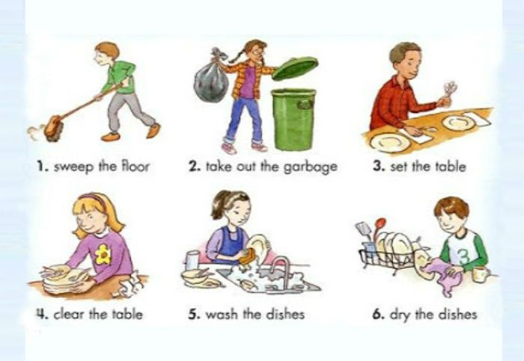
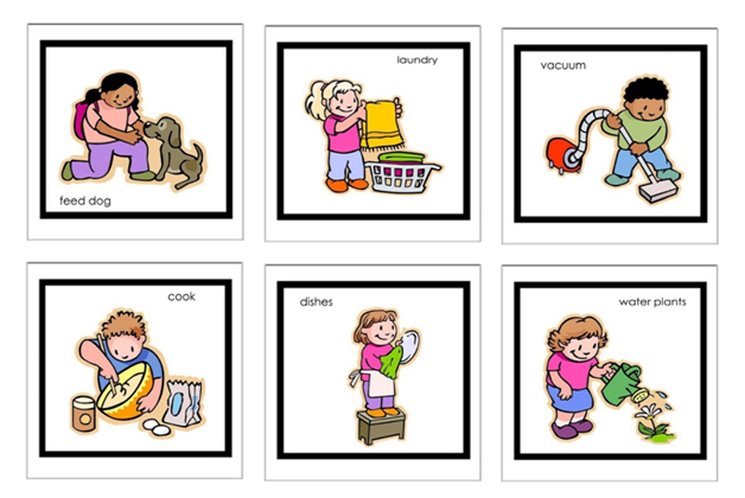

Unit 8 vocabulary visuals
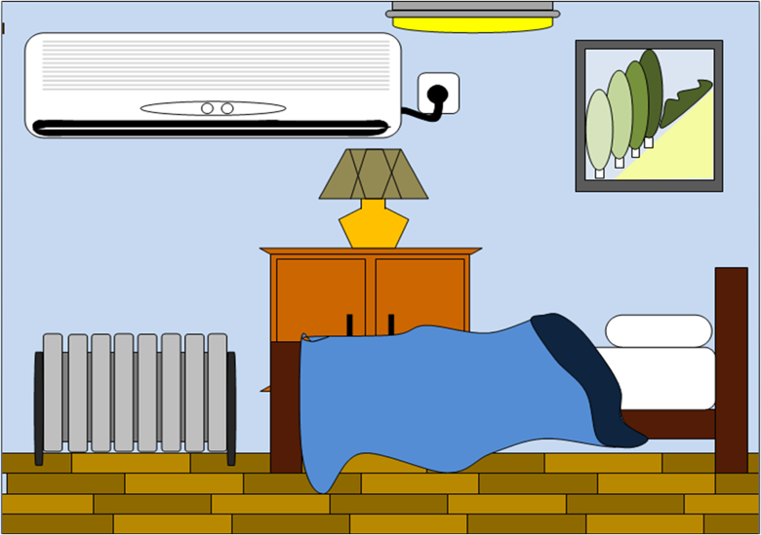

Unit 8 vocabulary visuals
