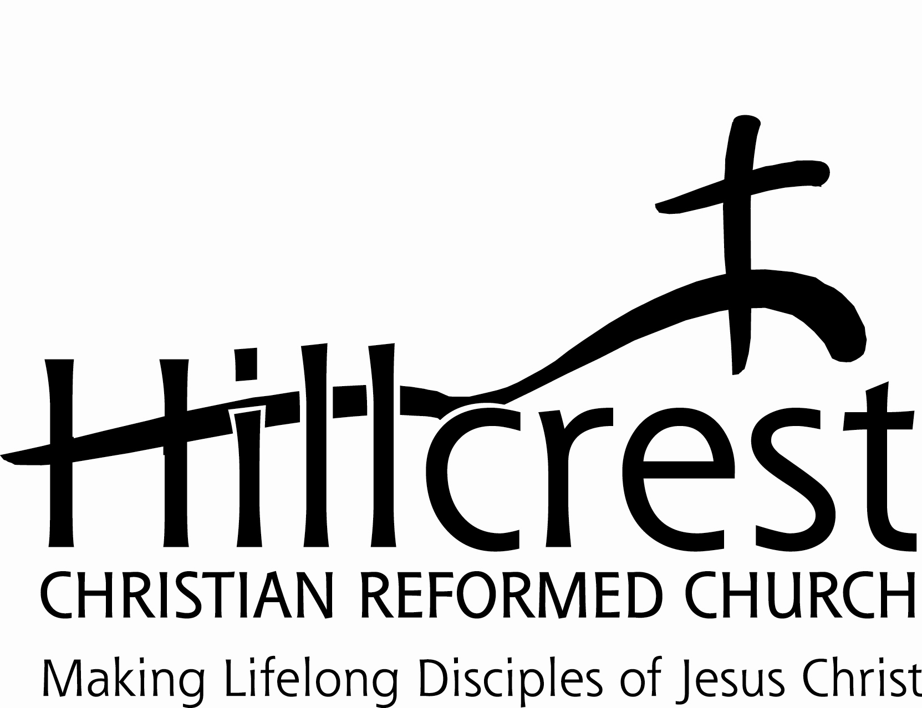
Position Description: Director of Youth and Young Adult Ministries

June, 2020

Description
The Director of Youth and Young Adult Ministries is responsible for 6th through 12th grade youth and young adult ministry programs and activities with the aim of helping them in becoming lifelong disciples of Jesus Christ.
Qualifications
1. Shows evidence of godly character, sincere commitment to Christ, and a dedication to the advancement of the kingdom of God.
2. Is in agreement with and committed to the beliefs and doctrinal statements of the Christian Reformed Church.
3. Is or will consider becoming a member of the Hillcrest Christian Reformed Church.
4. Is committed to the vision of Hillcrest Christian Reformed Church and has a passion and excitement for:
a. Leading and encouraging youth to develop a personal relationship with Jesus Christ.
b. Motivating and encouraging Hillcrest members to use their God given talents and abilities in ministry with the youth.
5. Has educational background and/or work experience specifically in areas of youth ministries. A Bachelor’s degree is preferred.
6. Is a compassionate and caring person that is able to minister to and disciple young people and young adults in their spiritual growth.
7. Has the ability and desire to meet and connect with youth in their world.
8. Is an effective communicator with good organizational and interpersonal skills.
9. Seeks continued education for the development of their skills and for the effectiveness of this ministry.
10. Must be able to work in a “team” atmosphere.

Responsibilities
1. Provides leadership for the middle school and high school youth groups, and builds relationships and programs with students and leaders in order to challenge them to grow in their relationships with the Lord and live their lives in gratitude to God, making life long disciples of Jesus. This includes all aspects of planning, obtaining and training of volunteer leaders, leading meetings, lessons and activities.
2. Helps other staff with church-wide events; such as the Live Nativity, Easter Egg Hunt, Fun Camp, Family/Kid’s Fun Nights, etc.
3. Create a relational (personal) ministry and builds a community where students are free to share their lives with each other.
4. Organizes and implement service projects and social events for youth groups and young adults.
5. Attends student activities including area school events with student participation (i.e. sporting events, concerts, plays, etc.).
6. Organizes and develops youth mission trips; and plans and organizes fundraising events for youth mission trips, along with the Director of Outreach.
7. Uses social media/texting with the youth as a tool for outreach and development of appropriate relationships.
8. Develops and directs Hillcrest’s Church School program for grades 6-12 (Taking Root/Growing Branches). Prepares the schedule, recruits teachers, develops curriculum, and implements.
9. Leads and participates in youth publicly professing their faith in Jesus Christ.
11. Makes connections with area schools, other area youth directors, and other organizations such as Young Life, Youth for Christ, etc.
12. Leads and/or coordinates Young Adult ministries at Hillcrest. “Young Adults” includes college students or those in the workforce in their late teens and twenties (either single, engaged, or married).
13. Responsible for any other duties assigned by their supervisor.

Reporting
This position will be filled via appointment by the Lead Pastor, with assistance from the Staff Administrator, and the approval of the Ministry Council. The Director of Youth and Young Adult Ministries reports to the Lead Pastor, with assistance from the Staff Administrator.

Compensation
Compensation will be determined with consideration of previous experience, training and abilities. The benefits for this position will be negotiated with the candidate and Hillcrest Human Resources.

