Immanuel Christian Reformed Church
61 Mohawk Road West, Hamilton, Ontario L9C 1V9

Immanuel CRC is a vibrant, thriving church in the heart of the Hamilton mountain and is part of Classis Hamilton. The congregation was established in 1959 and is actively involved in the Rolston neighbourhood community, an older suburb surrounding the church. Immanuel is an intergenerational church with a growth mindset, actively seeking to enfold its members and those in the community.

Mission Statement

Our purpose is to grow in loving God by walking in the Spirit, serving each other, and reaching out to our neighbours.

Vision Statement

Empowered by the Spirit, we see all members pursue a deep personal relationship with Jesus, grow in faith, honour God in worship and with our daily lives, build each other up in love and serve those around us. We do this in order to further the Kingdom of God and to expand His church.

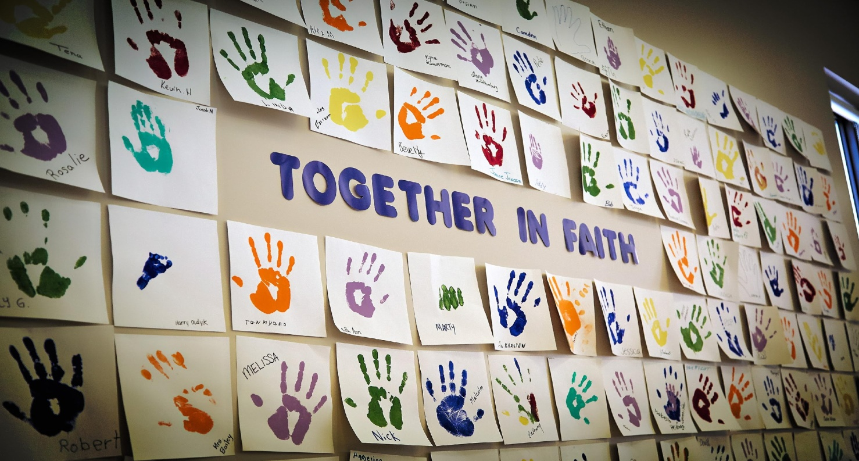

Value Statements

Everyone Prays (Prayer)
We value the spiritual discipline of prayer, both individually and in groups for renewing an intentional relationship with God, and empowering the ministry of His church. (Ephesians 3:14-21, 6:8-20; Acts 4:23-37)

Everyone Worships (Worship)
We value meaningful worship that is historic in faith, contemporary in communication, blended styles of music, and roots people in God’s Word.
(1 Corinthians 11:2-16).

Everyone Uses Their Gifts (Gift-Based Ministry/Stewardship)
We value vision-led ministry that is based on and uses the unique gifts that God has given each one who is a part of Immanuel, helping each other to discover and serve with these gifts of time, talents, and treasures and to care for God’s world. (Romans 12:1-8; 1 Peter 4:10)

Every Youth Participates (Youth)
We value the presence and participation of youth and their gifts in worship, ministry and mission, and desire their involvement in vibrant youth programs. (Psalm 127; Matthew 18:1-6, 19:13-15)

Everyone Connects (Fellowship)
We value fellowship that connects people in new relationships, builds up existing relationships, and has a special concern for those who feel unconnected to the Immanuel church family. (Galatians 6:1-2; Romans 9:12-16)

Everyone Belongs (Small Groups)
We value personal growth and development for each individual, young and old, through a variety of effective small group settings. (Hebrews 10:24-25; Galatians 6:1-2)

Everyone Points to Christ (Mission/Outreach)
We value caring for our community and our world by building relationships with and enfolding those we can, sending others out to those we cannot, and meeting needs in our world through personal involvement. (Matthew 28:16-20; 1 Corinthians 15:35-58)

Everyone Serves Our Vision (Structure)
We value a structure that empowers God’s people in Immanuel for vision-centered ministry internally and externally. (Romans 14:1-8)

Living Out Our Value Statements

Immanuel has an active and vibrant ministry that focuses on building relationships and growing our faith in God. Immanuel uses both of these to engage with members of our local communities. We seek to encourage members of all ages to develop as disciples of Jesus Christ in the church and in the world. Through participation in church education and discipleship opportunities we encourage all members to grow in knowledge and understanding; growing more Christ-like in every aspect of life.
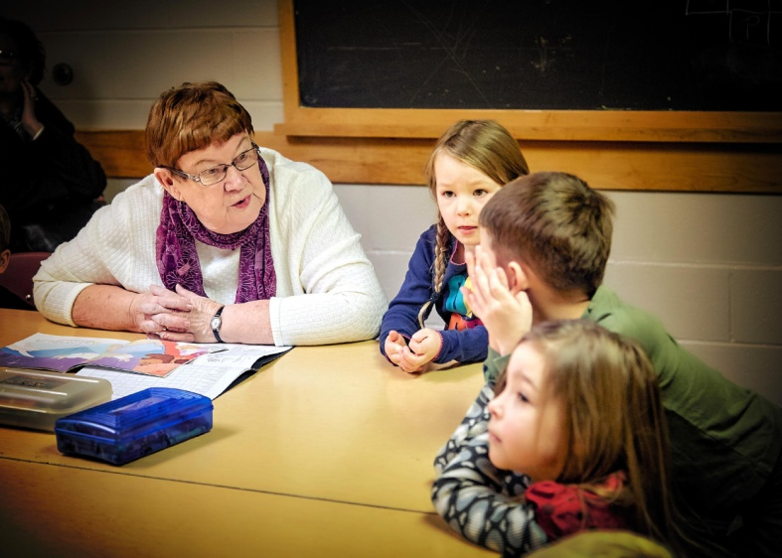
Nursery is available for infants to age 3 during both the morning and evening worship services.

Sunday School (ages 3-5) and Kids Connect (grades 1-4) take place during Sunday morning worship services. Children have a time of worship as a large group followed by a time of Bible stories, crafts, and games that apply their learning to their daily lives. Children leave part way through the worship service following the children’s message.

Compel is for children in grades 5-8 and takes place after the sermon during the Sunday morning service. Discussions are facilitated by dedicated leaders and are based on questions received from the preaching pastor.

Youth Group strives to have a relational youth ministry which is aimed at helping teens build a personal relationship with Jesus Christ. This goal is realized through intentional relationship building, not only within youth group, but with adult members of the congregation through the prayer partner ministry.

Faith Families are small intergenerational groups who gather together several times a month for Bible study and fellowship.

Special Interest Groups gather together based on mutual interests. These groups include those interested in knitting, sewing, walking, cooking, service through maintenance work, book clubs, etc.

Cadets is for boys in grades 2-8 and meet on alternate Wednesday evenings. Boys from the local and church community gather together to learn more about God and His world while developing skills in many areas.

GEMS (Girls Everywhere Meeting Their Saviour) is for girls in grades 2-8 and meet on alternate Tuesday evenings. Girls from the local neighbourhood and church community meet together to develop a dynamic relationship with Jesus Christ. Girls develop important life skills, learn to apply the Bible in their life and participate in service projects.

Inquirer’s Class meets during the church year and is intended to guide interested persons in understanding what the Reformed faith and Immanuel are about. The class looks at the privileges and expectations of membership in the Christian Reformed Church.

Women’s Ministry is an intergenerational group who gathers together for Bible study and fellowship.

Men’s Ministry seeks to help men in the community to know Christ and to provide meaningful and uplifting programs for the men of the church to promote growth in their faith walk.

Moms and Tots is a group of women and their young children gathering together to support, encourage each other in faith and grow in their walk with Christ with informal meetings, discussions and outings.

Senior’s Ministry seeks to connect the older group within the church, lend support to each other, promote fellowship and grow in faith together.

Vacation Bible Summer Camp (VBSC) runs for a week in July. This is an opportunity for us to welcome community members to our church, helping them learn about God through Bible stories, games, and crafts. Over the last few years, we have welcomed children from City Kidz, a local organization that works will children in Hamilton.

Basketball Camp also runs for a week in the summer. This is another place where we welcome community children and build relationships with them while learning basketball skills.

Athens Street Community Garden is a place of community to people in the neighbourhood, giving them an opportunity to grow their own food while interacting with church members, sharing the message of hope through Jesus Christ.

Friendship Group (for those who are differently abled) meets every Thursday evening from September to April. Friendship club meets with the intention of sharing God’s love to those in our community, building relationships and being together as an active part of God’s family.

Engaging with other Christian Communities
Immanuel CRC is also home to the worshiping congregation of the Nasum Korean Presbyterian Church which worships on Sunday afternoons.

Immanuel has a friendship/partnership with three churches in Leon, Nicaragua. The churches share a relationship to engage in mutual prayer, mutual learning, communication, fellowship, and teamwork.

Global/Faith Promise - the congregation supports several missionaries and church plant partnerships. The financial support is raised through faith promise pledges which are
over and above budget and classical/synodical shares.

Service and Ministry Teams
The Fellowship Service Team’s goal is to provide opportunities for fellowship to the congregation and visitors through coffee fellowship after the morning service and various fun nights throughout the year.

The Administration Service Team manages the building facilities and finances. The goal of the team is to manage the church assets in a stewardly manner. Our church has been blessed with the ability to pay 100% of our classical and 88% synodical contributions over the past few years.

The Safe Church Service Team’s goal is to ensure that every person knows and feels that they and their families and friends, especially the most vulnerable, will be well-cared for by people. All adult helpers of our nursery, Sunday School, Kids Connect, and Compel ministries have vulnerable sector checks and have undergone safe church training.

The Personnel Service Team is responsible for giving oversight to the care and well-being of staff and employees of Immanuel.

The Global, Local, Outreach, and Welcoming Ministry Team (GLOWE) encourages us to welcome and enfold those who are seeking God’s love and to seek relationships with those in our own communities and those of our missionaries.

The Worship and Prayer Ministry Team (WPMT)’s goal is to nurture the corporate worship life of the congregation to be inspiring and celebrative, encouraging us to transition from Sunday worship to continued application throughout the week.

The Faith Formation Ministry Team (FFMT) is responsible for guiding programs and ministries from infants to young adults through the concepts of the Building Blocks of Faith model and using that framework within each ministry area.

Participating in Ecumenical Activities
Immanuel is a covenanting member of the True City Network (www.truecity.ca), a network of churches for the good of the city, which means that our pastors meet together with the core leaders of the network three times per year and from time to time in theological dialogues as well. We participate in activities of the network with other evangelical churches throughout Hamilton, such as the True City festival (a conference with worship and workshops), Ride for Refuge fundraiser (we support Micah House), and Cross Culture (a youth day with worship and mission in the downtown core). Our members are involved in True City in ways that go beyond this, some formally as part of Immanuel, others informally on their own.

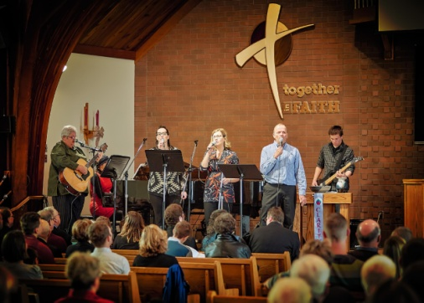
Worship
"Worship the Lord with gladness; come before Him with joyful songs." (Psalm 100: 2).

We worship at Immanuel through celebrative and intergenerational worship services that take place on Sundays at 10:00 am and 6:00 pm. Immanuel sings from the heart through strong congregational singing. This is composed of traditional hymns and contemporary Christian songs, led by a music team or an accompanist on the piano or organ. There is clear emphasis on biblically-based preaching and worship that is glorifying to God.

Church Structure: (also see attached diagram)

Council
Number of Council Members: 26 (17 elders, 9 deacons)
Length of Term 4 years

Congregational Care Teams
The primary purpose of congregational care teams is to provide and coordinate care at a variety of levels. Each team is responsible for a member district, and consists of a ministry elder, pastoral elder, deacon, congregational care worker and hospitality worker. With a team approach, both the work of caring for and the responsibility of looking after the needs of all members is shared.

Elders
Elders are divided into two groups: ministry elders and pastoral elders. Ministry elders are responsible for the spiritual and ministry leadership of the church while the pastoral elders are responsible for the care of the members within their districts.

Deacons
The Diaconate is responsible for disbursing the gifts received in a stewardly manner. The deacons work with many agencies within the CRC denomination and within our local community.

**Full council meets 3 times per year. Consistory and Executive meet monthly. Diaconate and Congregational Care Teams (CCT) meet monthly. Ministry teams meet monthly. Service teams meet sporadically when needed.**

Current Staff Positions

Pastor: Pastoral Care and Outreach
Pastor: Faith Formation and Teaching
Music and Worship Coordinator
Children’s Ministry Coordinator
Administrative Assistant
Custodian

Church Demographics

Profile of church members
(Statistics taken from elder district lists which begin at age 18)
Confessing 383 Inactive Confessing 73
Active Confessing 310 Baptized 70
Inactive Baptized 44 Active Baptized 26

Total inactive membership (baptized and confessing) 117
Total active membership (baptized and confessing) 336
Total membership (baptized and confessing) 453
Non-member included in district lists 29
Total members and non-members 482

General description of membership

Age Number of Members Age Number of Members
0 - 10 89 51—60 105
11 - 20 81 61—70 43
21 - 30 110 71 –80 41
31 - 40 69 81—90 27
41 - 50 50 90+ 8

80% of the congregation have been members for more than 10 years. 9% have been members for 5 - 10 years and 11% have been members for less than 5 years.

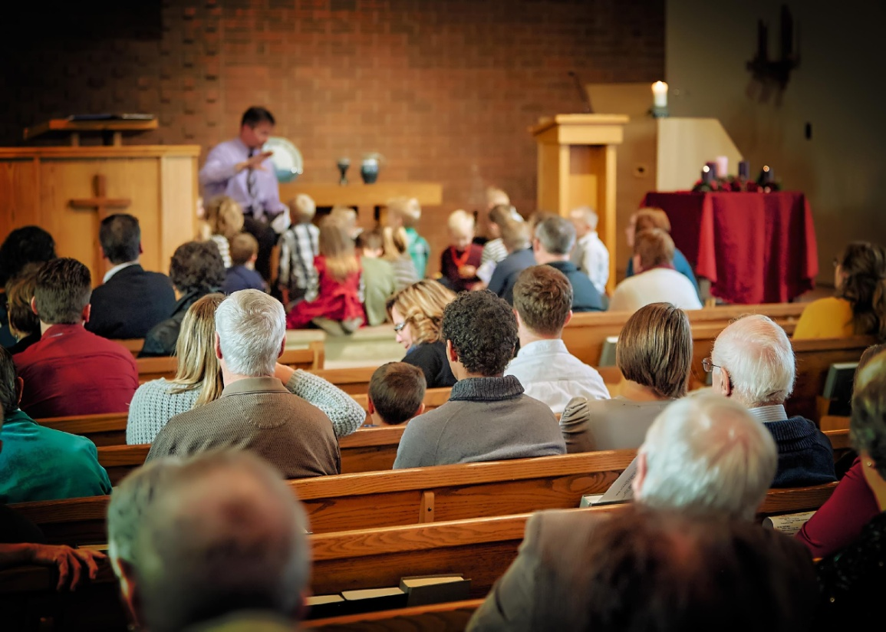

City of Hamilton Demographics

Located about 75 kilometres southwest of Toronto, Hamilton is the third-largest city in Ontario with a population of approximately 535,000 residents, and is the ninth-largest city in Canada with almost 25% of its residents born outside of Canada.
Hamilton is a Canadian port city on the western tip of Lake Ontario. The Niagara Escarpment, a huge, forested ridge known locally as "the mountain" and dotted with conservation areas and waterfalls, divides the city. The long-distance Bruce Trail runs along the escarpment. HMCS Haida, a naval warship rests on the city's lakefront, and the Canadian Warplane Heritage Museum in the south, traces Canada's military past.

Hamilton is well-known for producing steel, but the industry and job market are changing. Today, major industries in Hamilton include manufacturing, bioscience, medicine and agriculture. Situated in the cluster of highways, train lines and airports that service southern Ontario, the city can be reached with ease by way of many different means.

Hamilton boasts a robust education sector, featuring local universities and colleges.

Calvin Christian School (grades JK to Grade 8) is located directly behind the church. Hamilton District Christian High (Grade 9—12) and Redeemer Christian University College are located a few kilometers away from the church.

Immanuel Christian Reformed Church website—immanuelministries.ca
Calvin Christian School—ccshamilton.ca
Hamilton District Christian High— hdch.org
Redeemer University College—www.redeemer.ca
Mohawk College—mohawkcollege.ca
McMaster University—mcmaster.ca
City of Hamilton—hamilton.ca

