Grace CRC Vision Statement:

**As disciples of Christ our purpose is to encourage spiritual growth in ourselves, our family, and our church family so that we will be the presence of Christ to all the world around us in all we say and do.**

A PLAN TO REACH OUR VISION

**1**. We must begin with prayer. Each member should be encouraged to improve their personal prayer life. To effectively become a praying church we should have Prayer Coordinators whose task would be:

(a) develop prayer partners to support those who serve as leaders in our church

(b) develop a sharing, caring network of people who could be called on to pray for each other’s continuing needs and concerns, such as prolonged illness and children who turn their backs on the Lord.

**2.**  Strong families are built on love, acceptance, responsibility and accountability. These are also the ingredients for a strong church family.

To attain this we suggest the following:

(a) Provide an adoptive family for each member or family that joins Grace Church.

(b) Reintroduce the new members and families bulletin board on which pictures and personal information should be displayed prominently in a welcoming way.

(c) Review and investigate our mid week educational and other programs. Incorporate as many as possible into one evening, offering an opportunity for Bible study at that time, and possibly on Sunday mornings before the worship service as well.

(d) Each member needs to be an active member. Faith without works is dead. We should be more imaginative in how members are challenged to contribute to the well-being of the church family, to get involved and to do something for one another.

(e) Recognize and give thanks for the countless acts of love and service that take place in our Church Family.

**3.** The importance of regularly coming into the presence of God, to bring Him our worship and praise, must be emphasized. To be able to do this in a way that honours God, we should be prepared for worship. We need to pray individually, and as families, for a meaningful worship experience. A habit of Sunday morning family breakfast and devotions would set the tone for a more worshipful attitude.

**4.** Each member should focus special attention on an unbeliever or wayward member, pray for them and follow the spirit’s leading into action concerning the subject of their prayers.

**5.** Individually, and as families, we need to pray for Outreach programs such as Coffee Break, Friendship Groups, Jail Ministry or any other evangelism efforts that are created.

**6.** Encourage the Deacons to continue to be pro-active getting the membership involved in meeting some of the needs of the community, such as auto clinics for single mothers or home repair for needy seniors.

**7.** A review of our Vision Statement and plan of action must become a standing item on the Agenda of our annual Spring Membership Meeting.

**8.** Ideally, this plan of action would be in a constant state of flux, to reflect changes that occur in our Church and the surrounding community. By seriously working towards these proposals and achieving them, we feel the Sprit will reveal many other ways to serve Christ, our Lord, in the days to come.

A Brief History:

Grace Christian Reformed Church is located in Chatham, Ontario, a city of about 43,500 people. In 1996 Chatham was amalgamated with several smaller towns and villages and became known as the “Municipality of Chatham-Kent”, with a population of 103,000.

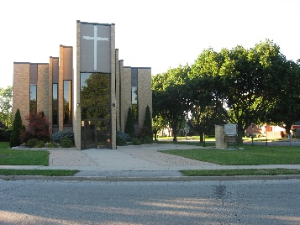

The First Christian Reformed Church of Chatham was organized on July 19, 1926. Since then daughter churches were started in Blenheim, Dresden, and Wallaceburg. Grace Church was formed in 1965 when First Church became too large for one pastor and there was concern for the spiritual welfare of the members. A group of about 60 families left to begin a new congregation.

In 1967, 5 acres of land in a cornfield was purchased as the future site for Grace CRC. The building was dedicated in 1968 and in 1984 a parsonage was built. The parsonage since then has been sold. In 1995 an addition was built onto Grace Church which included nurseries, a council room, offices, and available handicap access through an elevator. Another addition was added begun in 2013 which provided a large Fellowship Hall, new nursery, council room, youth room and additional classroom space.

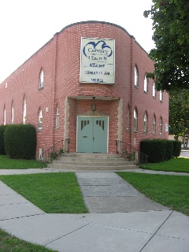Today Grace Church has approximately 143 families for a total membership of 403. First CRC in Chatham has 216 members and Calvary CRC, the third CRC in Chatham, which was organized in 1975, has 204 members.

Other Reformed Churches in Chatham are:

* Canadian Reformed
* Free Reformed
* Reformed Church of America
* Trinity Associate Reformed Presbyterian Church

Grace CRC is part of Classis Chatham. All 28 churches in the classes are within 150 kilometres of Chatham.

**Former Pastors:**

Jacob Vos, 1965 - 1971

Ralph Koops, 1971 - 1983

Peter Kranenburg, 1984 – 1986

Hendrik P. Bruinsma, 1988 - 1992

Peter Nicolai, 1996 – 2002

William Koopmans, 2005-2017

**Current Pastor:**

Our Congregation:

**Elders:**

Grace Church has 8 elders – 5 Pastoral Elders serving a district and 2 administrative on the executive. The Pastor is also an elder and serves as an ex-officio member of the council and executive. Elders serve a three year term – each year 2 or 3 new Elders are chosen in the spring to replace those retiring. The mandate of the Elders is that they are expected to attend council (Elders and Deacons) meetings (usually on the 2nd Wednesday every other month) and Elders meetings (usually scheduled on the 2rd Thursday of the alternate months). The Administrative Elders also meet monthly as part of the Executive (usually on the 1st Wednesday) and annually as combined executive of all three Chatham churches.

Council members are usually assigned, as a full voting member, to one of the committees of Grace Church that requires a Council Representative as a “direct link” between the council and committee. These committees include, but are not limited to, Worship, Board of Trustees, Outreach, Youth, and Education.

The congregation is divided up into 5 districts. Each district contains communicant and baptized members.

**Deacons:**

Grace Church has 6 deacons – each deacon serves a district and the chair of deacons serves on executive. Deacons serve a three-year term – each year, 2 deacons are chosen in the spring to replace those retiring. The mandate of the deacons is to encourage Christian stewardship and promise to manage the resources given to them with wisdom and honesty to the greater glory of God. They provide financial support to those in need within our church, community and the world at large.

**Grace Church’s Member Status Listing:**

|  |  |
| --- | --- |
| Baptized Members Under 18 | 71 |
| Baptized Members 18+ | 41 |
| Confessing Members Under 18 | 0 |
| Confessing Student Members | 13 |
| Active Adult Confessing Members | 242 |
| Inactive Confessing Members | 70 |

**Current Committees at Grace:**

|  |  |
| --- | --- |
| Audio/Visual | Library |
| Board of Trustees | Lord’s Supper |
| CoffeeBreak | Nursery |
| Counting | Outreach |
| Decorating | Prayer |
| Disability Concerns | Reformation Day Service |
| Education | Safe @ Grace |
| Fellowship Club | Small Groups |
| Human Resources | Social Events |
| Joint Refugee Sponsorship Committee | Stewardship |
| Jr. Youth | Worship |
| Kitchen | Youth |

**Board of Trustees:**This committee consists of one Council representative and six members of the congregation. The committee’s mandate is to oversee all property owned by the Church.

**Counting:**This is a 5-person committee whose mandate is to count offerings and make deposits.

**Education:**

The Education Committee consists of at least four (4) members (3 congregation members and 1 council representative). Their mandate is to support and review curriculum and actively maintain quality children’s educational programs, support continuous adult education and assist in co-ordination of leadership, and annually review the “included” groups, and programs to determine effectiveness

**Kitchen:**This committee consists of 3 people and a council rep and their mandate is to prepare and serve refreshments etc. for functions of Grace Church as requested as well as catered events.

**Outreach:**This committee consists of at least 6 members and one Council representative. Our church shall bring the gospel to unbelievers in our own community and worldwide. This task is supported by this committee.

**Prayer:**This committee consists of 3 members and one Council representative. The mandate of the Prayer Committee is to direct and promote growth in Grace CRC’s present prayer ministry and to motivate, train, and develop opportunities for the membership to grow in prayer.

**Safe @ Grace (Abuse Prevention):**This committee consists of a minimum of five members of the congregation, as well as a council representative. The committee’s mandate is to prevent abuse and serve a healthier more Christ-like life in the church, and promote the safety and protection of all involved in our various church programs.

**Stewardship:**This committee consists of two members of the congregation and one Council representative. Their mandate is to encourage the congregational stewardship.

**Worship:**This committee consists of 5 congregation members, the Pastor, the Worship Co-ordinator, the Administrative Assistant and a Council representative. Their mandate is to serve the church by helping to facilitate and co-ordinate worship services that are Christ-centered, Reformed, blended, seeker-sensitive, participatory, creative, and that foster community.

**Youth:**The Youth Team Committee consists of one member of Council, one high school representative, one College & Career representative, a maximum of 4 volunteer leaders and 1 member at large. Their mandate is to oversee the overall youth ministry of Grace CRC.

Worship Style:

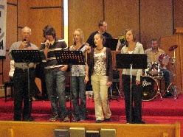Our worship services have a blended style, are pastor-led, with participation in music, readings and prayer by members as appropriate.   
  
The songs we sing are both from the CRC Psalter Hymnal, as well as a range of contemporary music, led by one of the worship teams. Musical accompaniment can range from piano, flute, violin, organ, drums, guitar, and other percussion instruments.

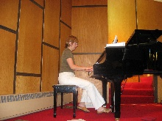Visitors can feel comfortable, at home, and 'non-threatened' in our worship format. After the morning service, a casual coffee social is held and everyone is welcome to come.

Our services are held at 10 am & 5 pm every Sunday, with evening services moving to 6:30 pm during June, July and August. We aim to make each worship service both inspiring and challenging.

Church attendance at Grace is good in the morning with most families attending regularly. The second service is a combined service with First Church, and is attended by about 70 members.

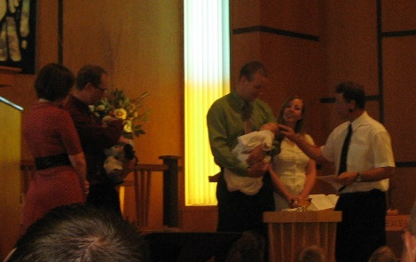**Sacraments:**The sacrament of Holy Communion is celebrated monthly in the morning worship services. It is celebrated every other month in the evening worship services.

The sacrament of Baptism is administered upon request.

**Senior Homes Services:**  
Grace Church members also conduct services in the various senior citizens homes in Chatham.

Outreach:

**Current Outreach Ministries at Grace: Ministry Held:**

|  |  |
| --- | --- |
| Bike Rodeo | occurs every Spring |
| CoffeeBreak | Wednesday mornings/Monday evenings |
| Friendship Bible Hour | Thursday evenings |
| Soccer Camp 4 Christ | occurs every Summer |

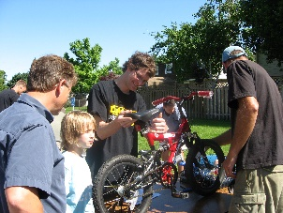**Bike Rodeo:**This program takes place the end of May on a Saturday morning. People from the community bring their bicycles to get fixed and tuned-up for the summer season. There is free food, face painting, an obstacle course to teach bike safety, and other fun activities. Police officers are on hand to participate in this.

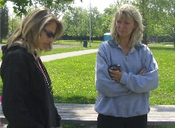**CoffeeBreak/Little Lambs/Story Hour:**Coffee Break is a church-based, community Bible Study for women. Grace Coffee Break offers both Wednesday morning and Monday evening Bible Studies.  The morning Coffee Break meets from 10:00am to 11:30am, beginning the last week of September and goes until the first week of April.

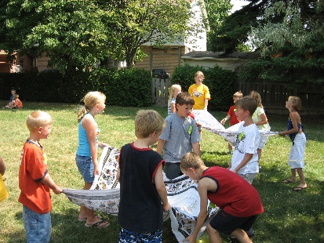**Friendship Bible Hour:**This is a program for those who are mentally or physically challenged within our community, running on Thursday evenings from 7-8pm. A typical evening includes lots of singing, Bible stories, prayer, and crafts.

**Soccer Camp 4 Christ:**This is a summer day camp program for the community children. It usually occurs at the beginning of July and runs for one week. The children learn soccer skills, hear Bible stories and have a snack.

**Missionaries:**We sponsor 4 missionaries at the present time:

* Dan & Teresa Heath (Wycliffe Bible Translators in Cote D’Ivoire)
* Dorothy Meyer (Belize)
* Jono & Janice Barnhoorn (Nigeria, Africa)
* Beth Fellinger (Destination CRC, St. Thomas, ON)

Youth Programs:

**Current Youth Ministries at Grace: Ministry Held:**

|  |  |
| --- | --- |
| 3 & 4’s Program | Sundays during the morning worship service |
| Dwell (Grades SK-5) | Sundays during the morning worship service |
| Church Education Classes (Grades 6-12) | Sundays prior to the morning worship service |
| GEMS | Monday evenings at First CRC |
| Cadets | Monday evenings |
| Jr. Youth | Wednesday evenings, twice a month |
| Youth | Sunday evenings following the evening worship service |

**3 & 4’s and Dwell:**  
Sunday morning, during the worship service, children ages 3&4 through Grade 5 attend the first part of the worship service and then leave with their leaders for their own worship.

**Church Education Classes:**Grade 6 through grade 12 meet on Sunday morning prior to the worship service for church education classes. Pre-confession classes are led by the Pastor and scheduled according to need.

**GEMS:**Girls Everywhere Meeting the Saviour (GEMS) is a Christian club for girls ages 8-14. They do projects, badge work, Bible lessons, fun outings, sleepovers, and more. Through this program the girls acquire new skills 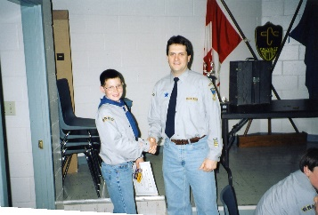and learn about Christ.

**Cadets:**Cadets is a Christian club for boys ages 7-14. They do projects, badge work, Bible lessons, relays, fun outings, campouts, and more. Through this program the boys acquire new skills and learn about Christ.

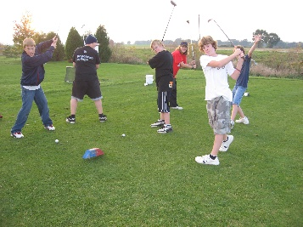**Youth:**

Adult Programs:

**Current Adult Ministries at Grace: Ministry Held:**

|  |  |
| --- | --- |
| Fellowship Club | Meets 3- 4 times a year for a variety of activities |
| Coffee Break | Wednesday morning, Monday evenings |
| Small Groups | anywhere from each week to once a month depending on the group |

**Fellowship Club:**This group is made up of people who meet regularly for social get-togethers.

**Small Groups:**These groups meet at various times for Bible or topical study. They may also get together for fellowship and social times.

Our Community:

Like its namesake in England, Chatham sits along the Thames River and began as a naval dockyard in 1793. Highlights of an interesting past include John Brown’s plotting of a raid on Harper’s Ferry, helping to trigger the American Civil War, and the establishment of the northern terminus of the “Underground Railroad”.

Chatham’s Tecumseh Park commemorates an important part of the area’s history. The park takes its name from Chief Tecumseh, who fought with the British during the War of 1812. Recreational activities, concerts in the park, RibFest and RetroFest are held in the downtown area and Tecumseh Park.

Chatham is located between Windsor and London, just off Hwy 401. Chatham-Kent is accessible to coastlines along Lake Erie and St. Clair with access to family picnic areas, camping facilities, sport fishing, boating, water skiing, or just a day at the beach. Throughout Chatham-Kent there are golf courses, tennis courts, horseback riding, amusement attractions, farm markets, antique shops, and shopping opportunities; a little of everything for everyone. There are many varied opportunities to spend a day touring one of Chatham’s many fine museums, walking the pathways of the Dover Marshland, or hiking through Rondeau Provincial Park’s Carolinian forest.

Chatham’s surrounding area is rich in agriculture. The city has a variety of industries engaged in agriculture and automotive endeavours. A very small percentage of our members are directly involved in farming. Most are into small businesses, professional, or trades.

**Occupations at Grace Church:**

|  |  |
| --- | --- |
| Business | 23% |
| Professional | 11% |
| Trades | 6% |
| Stay At Home Parent | 5% |
| Agriculture | 4% |
| Retired | 45% |
| Other | 6% |

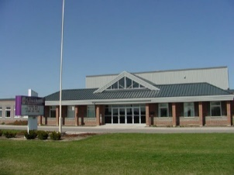Chatham has both an Elementary Christian School (started in 1957) and a Christian High School (started in 1970). Both schools originally met in 2 separate locations. In 1999 a brand new building was opened with the Elementary and High schools in separate wings. The Elementary School has 236 students with 17 teachers, and the High School has 71 students with 11 teachers. Students come from approximately 35 different congregations.

The members of Grace Church are involved in the community through various agencies:

Bibles For Missions Thrift Store

NeighbourLink

Salvation Army

Shepherd’s Way Inn

What We Are Looking For:

**Pastor Characteristics:**

**Based on the needs of Grace Church, we are seeking a Pastor who:**

* is a passionate, inspiring preacher
  + who is dynamic
  + who preaches application
  + who actively participates in the planning of worship services
* is a relationship-builder
  + who has passion for, and is a friend of youth
  + who is a humble shepherd, with a serving spirit, a warm personality, with people skills, and is an encourager
  + who promotes intergenerational worship and relationships
* is in touch with new ideas and is younger generation oriented
* has a Spirit filled passion, is energetic, and has a passion for prayer
* has a passion for outreach

Thank you for allowing us to introduce ourselves to you. Our church profile is also available from the Ministerial Information Services, a part of Pastor-Church Relations in Grand Rapids. Please feel free to contact us with any questions you may have. You may e-mail any enquires to Ron Middel at *themiddels@gmail.com*

May God continue to bless you and your work for His Kingdom!

In Christ,

Bill Dieleman, Chairman Ron Middel, Secretary

Grace CRC Grace CRC

Search Committee Search Committee

(519-350-1546) (519-358-6248)

[*billd@cruiseholidays.com*](mailto:billd@cruiseholidays.com) *themiddels@gmail.com*